MOVING ACADIANA

TRANSPORTATION IMPROVEMENT PROGRAM

TIP 2023 - 2026

TIP For Acadiana Metropolitan Planning Area
Date of Adoption: 09/21/2022
Fiscal Years: 2023, 2024, 2025, & 2026

Prepared by:

Acadiana Metropolitan Planning Organization
101 Jefferson Street
Lafayette, Louisiana 70501
Phone: (337) 806-9365
Fax: (337) 806-9379
Contact: Sara Gary
Email: sgary@planacadiana.org
Website: http://mpo.planacadiana.org

RECORD OF TIP FY2023-2026 ADOPTION

ITEM | Date(s)
Draft Vetted by MPO Transportation Technical Committee (TTC) | 09/14/2022
Draft Vetted by MPO Transportation Policy Committee (TPC) | 09/21/2022
Public Comment Period | 09/06/2022-09/20/2022
Adopted by Resolution: MPO Transportation Policy Committee | 09/21/2022

The preparation of this document was financed through grants from and disseminated under the sponsorship of the Federal Highway Administration and the Federal Transit Administration (US Department of Transportation). The United States Government assumes no liability for its contents or use thereof.

Prepared by Acadiana Planning Commission (APC)
in cooperation with the Federal Highway Administration, the Federal Transit Administration and the Louisiana Department of Transportation and Development

APC Office -101 Jefferson St. - Lafayette, Louisiana 70501

Introduction to the Acadiana MPO Transportation Improvement Program

The development of this document reflects the priorities of projects completion as established by the Acadiana Metropolitan Planning Organization (MPO), its Transportation Policy Committee, Transportation Technical Committee, and District-03/Headquarter offices of the Louisiana Department of Transportation and Development (LADODT). In developing these priorities, the MPO referred to the planning requirements of the recently passed Infrastructure Investment and Jobs Act (IIJA).

The Transportation Improvement Program (TIP) document establishes investments in new construction and development, maintenance of existing facilities, transit operations and capital expenditures, transit maintenance and administrative facility development, enhancement projects, and safety improvements.

The TIP must include a joint-certification by the MPO and respective state Department of Transportation documenting that it was developed through a continuous, cooperative and comprehensive (3C) metropolitan transportation planning process, in conformance with various applicable Federal laws and regulations. A copy of the Joint Cortication of the Metropolitan Transportation Planning Process can be found on the following page.

Joint Certification of the Metropolitan Transportation Planning Process

In accordance with the federal legislation, 23 Code of Federal Regulations 450.336 and the Fixing America's Surface Transportation (FAST) Act, the Louisiana Department of Transportation and Development (LADOTD), and the Acadiana Metropolitan Planning Organization for the Lafayette urbanized area hereby certify that the transpo1iation planning process is addressing the major issues in the metropolitan planning area and is being conducted in accordance with all applicable requirements of:
- 23 U.S.C. 134, 49 U.S.C. 5303, and this subpart;
- In nonattainment and maintenance areas, sections 174 and 176 (c) and (d) of the Clean Air Act, as amended (42 U.S.C. 7504, 7506 (c) and (d) and 40 CFR part 93;
- Title VI of the Civil Rights Act of 1964 as amended (42 U.S.C. 2000d-l) and 49 CFR part 21;
- 49 U.S.C. 5332, prohibiting discrimination on the basis of race, color, creed, national origin, sex, or age in employment or business opportunity;
- Section 1101(6) of the FAST Act (Pub. L. 114-357) and 49 CFR part 26 regarding the involvement of disadvantaged business enterprises in DOT funded projects;
- 23 CFR part 230, regarding the implementation of an equal employment opp01iunity program on Federal and Federal-aid highway construction contracts;
- The provisions of the Americans with Disabilities Act of 1990 (42 U.S.C. 12101 et seq.) and 49 CFR parts 27, 37, and 38;
- The Older Americans Act, as amended (42 U.S.C. 6101), prohibiting discrimination on the basis of age in programs or activities receiving Federal financial assistance;
- Section 324 of title 23 U.S.C. regarding the prohibition of discrimination based on gender; and

- Section 504 of the Rehabilitation Act of 1973 (29 U.S.C. 794) and 49 CFR part 27 regarding discrimination against individuals with disabilities

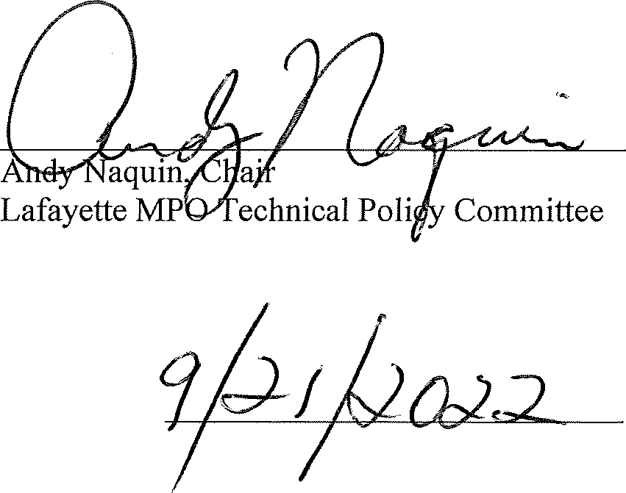
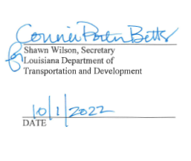
DATE

TIP AMENDMENTS

State Project Number | Project Description | Proposed Improvement | Work Status | Project Cost ($) | Total Cost  (w/CE&I+IDC) ($) | Federal Share ($) | Funding | Fiscal Year | Amendment Number | Explanation of Modification | Parish
N/A | Transit Changes | N/A | N/A | N/A | N/A | N/A | N/A | FY22 | #1 | Capital and Operating for  FY 22 have been received | Lafayette
H.012792 | LA 675 @ Airport Rd. Roundabout | Roundabout Construction | Right of Way | 580,000.00 | 580,000.00 | 464,000.00 | STP>200k | FY23 | #1 | ROW Phase increases to $580,000 in FY23 | Iberia
H.015354 | Grand PT Sidewalk: Poydras-Doyle Melancon | Sidewalk | Engineering & Construction | 500,000.00 | 540,000.00 | 432,000.00 | CRP>200k | FY25 FY26 | #2 | Project adopted through 2021 project call. Received project number from DOTD. | St Martin
H.015427 | LA 92: Left Turn Lane @US167 | Left Turn Addition | Environmental  R/W Acquisition  Construction  CE & I | 1,000,000 | 1,093,000 | 874,400 | STP>200K | FY25 FY26 | #2 | Project adopted through 2021 project call. Received project number from DOTD. | Vermilion
H.015488 | Hector Connoly Improvements Phase II | Lanes, Sidewalk & Signal Addition | Environmental  R/W Acquisition  Construction  CE & I | 4,065,811.37 | 4,398,201.37 | 3,518,561.10 | STP>200k | FY26 FY27  FY28 | #2 | Project adopted through 2021 project call. Received project number from DOTD. | Lafayette
H.009629 | US 90: RR JCT - Pinhook, LA 92 - LA 88 | Pavement Rehabilitation | Construction | 19,400,000.00 | 21,340,000.00 | 10,384,000.00 | NHPP & STCASH | FY23 | #2 | Add construction phase of $11.8M in NHPP and $7.6M in STCASH FY23 | Lafayette  St Martin  Iberia
H.014415 | LA 352 Drainage Improvement | Drainage Improvements | Construction | 4,700,000.00 | 5,170,000.00 | 4,136,000.00 | STPFLEX | FY23 | #2 | Add construction phase of $4.7M in STPFLEX FY23 | St Martin
H.009997 | US167 Johnston St. Improvements | Access Management & Other Safety Counter Measures | Right of Way  Utility Relocation  Construction | 16,817,883.67 | 17,557,316.13 | 15,336,960.14 | HSIPPEN NHPP STPFLEX | FY23  FY24 | #2 | LCG requested to move $1,809,292.46 out of STP>200k funds | Lafayette
H.015018 | Lafayette Parish Non-State Pavement Markings | Pavement Markings | Construction | 2,194,811.33 | 2,414,292.46 | 1,931,433.97 | STP>200k | FY24 | #2 | LCG requested to move $1,809,292.46 from H.009997 US167 Johnston St. Improvements into Lafayette Parish Non-State Pavement Markings | Lafayette
H.013517 | E St Peter St and N Church St Sidewalks | Sidewalk Construction | Construction | 2,390,000.00 | 2,629,000.00 | 959,200.00 | CRP>200k  STP>200k | FY23 | #3 | Project name changed to “E St Peter St and N Church St Sidewalks”  Adding fund $1.3M Local, and $60K STP>200k | Lafayette
H.012618 | LA 347 Drainage Improvements | Raise Road x-section and/or replace subdrainage structures | Engineering  Construction | 1,457,000.00 | 1,542,000.00 | 1,233,600.00 | PROTECT | FY23 FY25 | #4 | Add Engineering phase at $607k in PROTECT in FY23; Change construction phase from $540k in STCASH in FY23 to $850k in PROTECT FY25 | St Martin
H.014537 | LA 182: LAFAYETTE P/L - LA 754 | Patching and/or Rehabilitation and A Bike Lane | Construction | 7,365,000.00 | 8,101,500.00 | 6,554,900.00 | STP>200k  STPFLEX | FY23 | #4 | Change construction from $1,379,975 in STP>200k and $2,460,025 in COVID>200k in FY24 to $4M in STPFLEX, $3.03M in STP>200k and $335k in STPFLEX in FY23 | St Landry
H.015639 | LA 95 @ Lexington Dr Roundabout | Roundabout Construction | Environmental  Right of Way  Utility Relocation  Construction  CE&I | $5,764,815.00 | $6,248,845.00 | $4,680,650.04 | Local  STBOND  STP>200K  HSIP | FY 23-26 | #5 | Project adopted through 2021 project call. Received project number from DOTD. | Acadia
H.014516 | Mills St Extension | Road Extension | Traffic Study  Engineering  Right of Way  Construction | 4,097,280.00 | 4,394,508.00 | 3,515,606.40 | STP>200K | FY 24-26 | #6 | Remove Environmental phase; Add Traffic Study phase of 520,000.00 in STP>200k FY24; Moved ENG from FY23 to FY24; Moved ROW from FY24 to FY25; Moved CONST from FY25 to FY26 | St Martin
H.012870 | LA93: I-10 Ramp-Renaud | Addition of a Turn Lane | Right of Way  Construction | 5,174,000.00 | 5,631,400.00 | 4,505,120.00 | STP>200K | FY25-26 | #6 | Remove ENG phase; Add $400,000.00 from ENG to Right of Way; Moved ROW $600,00.00 from FY24 to FY25 | Lafayette
H.014509 | Doucet Rd. Sidewalks | Add Sidewalks and Striped Crosswalks | Engineering  Construction | 1,500,000.00 | 1,631,559.00 | 1,305,247.20 | STP>200k  CRP>200k | FY24-25 | #6 | Change ENG phase from $375,000.00 to $184,410.00 in STP>200k FY24; Change CONST from $95,000.00 STP>200k FY24 to $285,590.00 STP>200k FY25; Change Construction $1,030,000.00 CRP>200k from FY24 to FY25 | Lafayette
n/a | Transit Changes | n/a | n/a | n/a | n/a | n/a | n/a | FY24 | #6 | Capital and operating for FY24 have been received. | Lafayette
H.015964 | Carmel Drive Sidewalk Phase III | Sidewalk Construction | Environmental  Engineering  Construction | 1,700,000.00 | 1,849,500.00 | 1,479,600.00 | CRP>200k  STP>200k  STP<200k | FY25-27 | #7 | Project adopted through 2021 project call. Received project number from DOTD. | Lafayette
H.012868 | Fortune Rd. Pavement Preservation | Overlay | Construction | $602,000.00 | $662,200.00 | $529,760.00 | STP>200K | FY24 | #8 | Change Construction $1,020,000 to $602,000 | Lafayette
H.014622 | St. Nazaire Rd. Ext: LA 96 Corne Rd. Ph 1 | New Road and Roundabout | Environmental  Engineering | $1,148,000.00 | $1,148,000.00 | $918,400.00 | STP>200K | FY24  FY25 | #8 | Add Environmental for FY24 at $605,000. Move Engineering from FY24 to FY25 | Lafayette
H.015308 | I-49: Pont Des Mouton -St Landry P/L | Patch, Mill, Overlay | Construction | $21,000,000.00 | $23,100,000.00 | $20,790,000.00 | NHPP | FY25 | #8 | Add Construction phase of $21M in NHPP in FY25 | Lafayette
H.015934 | E. Kaliste Saloom Rd Interchange @ US 90 | New Interchange | Engineering | $16,200,000.00 | $16,200,000.00 | $12,960,000.00 | STCASH | FY24 | #8 | Adding Engineering phase of $16.2M in FY24 | Lafayette
H.015427 | LA 92: Left Turn Lane @ US167 | Left Turn Lane Addition | CE&I | $60,000 | $66,000 | $52,800 | STP>200K | FY26 | #8 | Remove CE&I Phase | Vermilion
H.015488 | Hector Connoly Improvements Phase II | Lanes, Sidewalk and Signal Addition | CE&I | $141,600.00 | $155,760.00 | $124,608.00 | STP>200k | FY28 | #8 | Remove CE&I Phase | Lafayette
H.015639 | LA 95 @ Lexington Dr Roundabout | Roundabout Construction | CE&I | $274,515.00 | $274,515.00 | $0.00 | Local | FY26 | #8 | Remove CE&I Phase | Acadia
H.015964 | Carmel Drive Sidewalk Phase III | Sidewalk Construction | CE&I | $195,000.00 | $214,500.00 | $171,600.00 | STP<200k | FY27 | #8 | Remove CE&I Phase | Lafayette
N/A | Project Transfer – City of Youngsville | Improvements on S. Larriviere Rd | N/A | $4,987,630 | $5,486,393.00 | $4,389,114.40 | STP>200k | FY25 | #8 | Transfer Construction funding of $4,987,630 in STP>200k from H.014983 LA89 Widening: Iberia-Ambassador Caffery to H.012867 S. Larriviere Rd: LA92-Chemin Metairie to cover construction overage | Lafayette
H.012867 | S. Larriviere Rd.: LA 92-Chemin Metairie | Addition of a Center Turn Lane | Construction | 8,800,000.00 | 9,680,000.00 | 7,744,000.00 | STP>200k | FY24 | #8 | Construction increase from $3,562,000.00 to $8,800,000.00 | Lafayette
 | Young Street Intersection Safety Improvements | New Roundabout | Construction | $3,652,719.00 | $3,793,219.00 | $3,034,575.20.00 | SS4A | FY25 | #9 | Adding New Project | Lafayette
H.016215 | LA 339/Verot @ Savoy Roundabout | New Roundabout | Engineering  R/W  Construction | $7,000,000.00 | $7,600,000.00 | $7,600,000.00 | STP>200k | FY25  FY26  FY28 | #9 | Adding New Project | Lafayette
H.011990 | LA 92: Vermillion RVR MB RH (Milton) (HBI) | Movable Bridge Rehabilitation | Construction | $8,000,000.00 | $8,800,000.00 | $7,040,000.00 | STPFLEX | FY28 | #9 | Change Construction from FY25 to FY 28 | Lafayette
H.011991 | LA 86: BYU Teche MB Rehab (Daspit)(HBI) | Movable Bridge Rehabilitation | Engineering  Construction | $ 6,455,000.00 | $ 7,055,000.00 | $ 5,644,000.00 | STPFLEX | FY25  FY29 | #9 | Add Engineering of $455,000.00 in STPFLEX in FY25: Change Construction from FY24 to FY29 | Iberia
H.011995 | LA 96: B Teche MB RH (St Martinville) (HBI) | Movable Bridge Rehabilitation | Construction | $8,000,000.00 | $8,800,000.00 | $7,040,000.00 | STPFLEX | FY29 | #9 | Change Construction from FY25 to FY 29 | St Martin
H.016226 | LA 3156 LA 182(W St Peter St) Fulton St | Pavement Preservation | Engineering  Construction | $127,680.00 | $137,798.90 | $110,239.12 | STP>200k | FY27  FY28 | #9 | Adding New Project | Iberia
H.016240 | LA 86/Duperier Avenue: LA 182/E Main St – LA 86/Loreauville Rd | Pavement Preservation | Engineering  Construction | $191,730.00 | $197,824.50 | $158,259.60 | STP>200k | FY27  FY28 | #9 | Adding New Project | Iberia
Transit Change | N/A | N/A | N/A | N/A | N/A | N/A | N/A | FY25 | #9 | Capital And Operating For 5310 & 5311 for FY25 Have Been Received | Lafayette
H.009892 | US 90 FR: Extension to LA 329 | Extend US 90 Frontage Road to LA 329 | Right of Way  Construction | $1,180,000.00 | $1,290,000.00 | $1,032,000.00 | STP>200k | FY25  FY27 | #10 | Change Utility Relocation of $80,000.00 to Right of Way;  Change Construction from FY25 to FY27 | Iberia
H.012870 | LA93: I-10 Ramp-Renaud | Addition of a Turn Lane | Construction | $4,574,000.00 | $5,031,400.00 | $4,025,120.00 | STP>200k | FY27 | #10 | Change Construction from FY26 to FY27 | Lafayette
H.011235 | I-49 South @ Verot School Road | Construct New Intersection | Right of Way  Utility Relocation  Construction | $248,000,000.00 | $268,050,000.00 | $47,500,000.00 | ARPA  STCASH | FY24 FY25  FY26 | #10 | Add New Project | Lafayette
H.011988 | LA 86: BYU Teche MB Rehab (DUPERIER)(HBI) | Movable Bridge Rehabilitation | Construction | $8,000,000.00 | $8,800,000.00 | $7,040,000.00 | STPFLEX | FY28 | #10 | Remove Construction | Iberia
H.012866 | South College Rd (LA 3025) Sidewalks | Sidewalk Construction | Right of Way | $200,000.00 | $200,000.00 | $160,000.00 | STP>200k | FY25 | #10 | Add Right of Way of $200,000.00 in STP>200k in FY25 | Lafayette
H.014516 | Mills Ave & Rees St Intersection IMP | Road Extension | Construction | $2,972,280.00 | $3,269,508.00 | $2,615,606.40 | STP>200k | FY27 | #10 | Change Construction from FY25 to FY27 | St Martin
H.012869 | LA 182 (UNIV) @ LA 723 (Renaud) Roundabout | Roundabout Construction | Construction | $3,300,000.00 | $3,630,000.00 | $2,904,000.00 | STP>200k | FY27 | #11 | Move Construction Phase from FY26 to FY27 | Lafayette
H.016215 | LA 339/Verot @ Savoy Roundabout | LA 339/Verot @ Savoy Roundabout | Right of Way | $250,000.00 | $250,000.00 | $250,000.00 | STP>200k | FY27 | #11 | Move ROW from FY 26 to FY 27 | Lafayette
H.009892 | US 90 FR: Extension to LA 329 | Extend US 90 Frontage Road to LA 329 | Construction | $1,100,000.00 | $1,210,000.00 | $968,000.00 | STP>200k | FY27 | #11 | Move Construction from FY 25 to FY 27 | Iberia
H.016240 | LA 86/Duperier Avenue: LA 182/E Main St – LA 86/Loreauville Rd | Pavement Preservation | Construction | $670,388.00 | $737,426.80 | $589,941.44 | STP>200k | FY28 | #11 | Correct construction Cost | Iberia
H.015639 | LA 95 @ Lexington Rd Roundabout | Roundabout Construction | Construction | $4,840,300.00 | $5,324,330.00 | $2,633,930.20 | STBOND  STP>200K  HSIP | FY27 | #11 | Move all Construction phase from FY26 to FY27 | Acadia
H.014622 | St. Nazaire Rd. EXT: LA 96 Corne Rd Ph 1 | New Road and Roundabout | Right of Way  Construction | $4,646,267.00 | $5,087,893.70 | $4,070,314.96 | STP>200k | FY27  FY28 | #11 | Move ROW from FY25 to FY27, Move Construction from FY26 to FY28 | Lafayette
H.014516 | Mills Ave & Rees St Intersection IMP | Road Extension | Right of Way  Construction | $3,292,280.00 | $3,589,508.00 | $2,871,606.40 | STP>200k | FY27  FY28 | #11 | Move ROW from FY26 to FY27, Move Construction from FY27 to FY28 | St Martin
H.015427 | LA 92: Left Turn Lane @ US 167 | LA 92: Left Turn Lane @ US167 | Construction | $870,000.00 | $957,000.00 | $765,600.00 | STP>200K | FY27 | #11 | Move Construction from FY26 to FY27 | Vermillion
H.013522 | South Lewis St. Widening | Continuous Turn Lane | Construction | $1,800,000.00 | $1,980,000.00 | $1,584,000.00 | STP>200k | FY27 | #11 | CONST from FY26 to FY27 | Iberia
H.012866 | S. College Rd. Sidewalks | Sidewalk Construction | Construction | $650,575.00 | $715,632.50 | $572,506.00 | STP>200k | FY27 | #11 | CONST from FY26 to FY27 | Lafayette
H.014449 | Bonin Rd. Widening | Roadway Reconstruction and Widening | Construction | $3,586,275.00 | $3,944,902.50 | $3,155,922.00 | STP>200k | FY27 | #11 | CONST from FY26 to FY27 | Lafayette
H.012792 | LA 675 @ Airport Rd. Roundabout | Roundabout Construction | Utility Relocation  Construction | $6,930,000.00 | $7,595,000.00 | $3,084,000.00 | STP>200k  Local | FY25 | #11 | Add Utility of $280,000.00 FY25; Change CONST from $2,500,000.00 to 3,250,000.00 in STP>200k FY25, and $3,400,000.00 in Local FY25 | Iberia
H.012864 | LA 94/Carmel Dr. Sidewalks | Sidewalk Construction | Right of Way  Construction | $1,450,000.00 | $1,570,000.00 | $1,256,000.00 | STP>200k | FY26 | #11 | Add ROW of $250,000.00 in STP>200K FY26; Change CONST from $522,000.00 to $1,200,000.00 | Lafayette
H.015308 | I-49: I-10 - St Landry P/L | Patch, Mill, Overlay | Engineering | $389,300.00 | $389,300.00 | $225,000.00 | STCASH  NHPP | FY25 | #11 | Add Engineering of $139,300.00 in STCASH FY25 and $250,000.00 in NHPP FY25 | Lafayette
H.015964 | Carmel Drive Sidewalk Phase III | Sidewalk Construction | Construction | $750,542.00 | $825,596.20 | $660,476.96 | CRP>200k | FY27 | #12 | Transfer Construction $750,542.00 to H.012864 LA 94/Carmel Dr. Sidewalks | Lafayette
H.012864 | LA 94/Carmel Dr. Sidewalks | Sidewalk Construction | Construction | $1,200,000.00 | $1,320,000.00 | $1,056,000.00 | STP>200k  CRP>200k | FY26  FY27 | #12 | Change Construction $1,200,000.00 to $449,458.00 STP>200k FY26; Adding Construction $750,542.00 CRP>200k FY27 from H.015964 | Lafayette
H.012738 | LA 344: Bayou Teche MB RH (Morbihan) (HBI) | Movable Bridge Rehabilitation | Construction | $6,000,000.00 | $6,600,000.00 | $5,280,000.00 | STPFLEX | FY32 | #12 | Remove Construction phase $6,000,000.00 STPFLEX FY26 (Phase is moving to FY32) | Iberia
H.013819 | LA 350: BAYOU TECHE MB RH (PARKS)(HBI) | Movable Bridge Rehabilitation | Construction | $8,000,000.00 | $8,800,000.00 | $7,040,000.00 | STPFLEX | FY34 | #12 | Remove Construction phase at $8,000,000.00 STPFLEX FY26 (Phase is moving to FY34) | St Martin
H.014842 | LA 3184: LA 3025 - I-10 | Concrete Pavement Rehab, Asphalt Shoulders & Related Work | Construction | $11,800,000.00 | $12,980,000.00 | $10,384,000.00 | NHPP | FY26 | #12 | Add Construction phase $11,800,000.00 NHPP in F26 | Lafayette
H.015823 | US 90: LA 83 - LA 85 | PCCP, Patch, Class II Base Course, and Asphalt Overlay | Construction | $26,750,000.00 | $29,425,000.00 | $23,540,000.00 | NHPP | FY26 | #12 | Add Project and Construction phase $26,750,000.00 NHPP in FY26 | Iberia
 | Charity St. Vulnerable User Safety Study and Demonstration | Bridge and Pedestrian Corridor Plan | Planning/Demonstration | $200,000.00 | $200,000.00 | $160,000.00 | SS4A | FY24 | #12 | SS4A Demonstration Award | Vermillion
H.014449 | Bonin Road Widening | Roadway Reconstruction and Widening | Environmental  Design Construction | $0.00 | $0.00 | $0.00 | N/A | N/A | #13 | Remove project and funding | Lafayette
H.015639 | LA 95 @ Lexington Dr Roundabout | Roundabout Construction | Construction  Construction  Construction | $4,840,300.00 | $5,324,330.00 | $2,633,930.20 | STBOND  STP>200K  HSIP | FY28  FY28  FY28 | #13 | Move Construction of $2,325,818.00 from FY27 to FY28; Move Construction of $600,000.00 from FY27 to FY28; Move Construction of $1,914,482.00 from FY27 to FY28; | Acadia
H.009892 | US 90 FR: Extension to LA 329 | Extend US 90 Frontage Road to LA 329 | Utility Relocation  Construction | $1,400,000.00 | $1,510,000.00 | $1,208,000.00 | STP>200k  STP>200k | FY27  FY28 | 13 | Move Utility Relocation from FY26 to FY27;  Move Construction from FY27 to FY28 | Iberia
H.009997 | US167 Johnston St. Improvements | Access Management & Other Safety Counter Measures | Right of Way  Right of Way  Right of Way  Utility Relocation  Utility Relocation  Utility Relocation  Construction  Construction  Construction | $16,817,883.67 | $17,557,316.13 | $15,336,960.14 | HSIPPEN  NHPP  STPFLEX  HSIPPEN  NHPP  STPFLEX  HSIPPEN  NHPP  STPFLEX | FY27  FY27  FY27  FY27  FY27  FY27  FY28  FY28  FY28 | 13 | Move Right of Way of $1,391,186.33 from FY23 to FY27; Move Right of Way of $1,391,186.34 from FY23 to FY27; Move Right of Way of $1,391,186.33 from FY23 to FY27;  Move Utility Relocation of $1,750,000.00 from FY23 to FY27; Move Utility Relocation of $1,750,000.00 from FY23 to FY27; Move Utility Relocation of $1,750,000.00 from FY23 to FY27;  Move Construction of $3,013,045.33 from FY24 to FY28; Move Construction of $3,013,045.34 from FY24 to FY28; Move Construction of $1,368,234.00 from FY24 to FY28 | Lafayette
H.012864 | LA 94/Carmel Dr. Sidewalks | Sidewalk Construction | Construction | $449,458.00 | $494,403.80 | $395,523.04 | STP>200k | FY27 | 13 | Move Construction of $449,458.00 from FY26 to FY27 | Lafayette
H.015488 | Hector Connoly Improvements Phase II | Lanes, Sidewalk and Signal Addition | Right of Way  Utility Relocation  Construction | $3,606,011.37 | $3,924,241.37 | $3,139,393.10 | STP>200k STP>200k STP>200k | FY28  FY29  FY30 | 13 | Move Right of Way of $391,911.37 from FY27 to FY28;  Move Utility Relocation of $31,800.00 from FY28 to FY29;  Move Construction of $3,182,300.00 from FY28 to FY30 | Lafayette
H.011235 | I-49 South @ Verot School Road | Construct New Intersection | Construction | $200,500,000.00 | $220,550,000.00 | $0.00.00 | STCASH | FY28 | #13 | Move Construction of $200,500,000.00 from FY26 to FY28 | Lafayette
H.015354 | Grand PT Sidewalk: Poydras-Doyle Melancon | Sidewalks | Construction | $400,000.00 | $440,000.00 | $352,000.00 | CRP>200k | FY27 | 13 | Move Construction of $400,000.00 from FY26 to FY27 | St Martin
N/A | Transit Changes | N/A | N/A | N/A | N/A | N/A | 5307 | FY25 | 13 | Added Planning funding to 5307 Formula Grant | Lafayette
N/A | Transit Changes | N/A | N/A | N/A | N/A | N/A | 5310 & 5311 | FY26 | 13 | Capital & Operating for 5310 & 5311 have been received
 | Connecting Johnston-A Safer Street for Families and Futures | Shared Use Path, High Visibility Crosswalks, pavement markings | NEPA/Design/Construction | $9,987,690 | $9,987,690 | $7,986,192 | SS4A | FY26 | 13 | SS4A Construction Award | Lafayette
N/A | Transit Changes | N/A | N/A | N/A | N/A | N/A | 5307 | FY26 | 13 | Revise Operating Assistance from $3,503,023 to $3,472,000 | Lafayette
N/A | Transit Changes | N/A | N/A | N/A | N/A | N/A | 5307 | FY26 | 13 | Revise Bus Replacement from $1,683,367 to $1,358,824 | Lafayette
N/A | Transit Changes | N/A | N/A | N/A | N/A | N/A | 5307 | FY26 | 13 | Revise Non-Fixed ADA Paratransit from $283,333 to $500,000 | Lafayette
N/A | Transit Changes | N/A | N/A | N/A | N/A | N/A | 5307 | FY26 | 13 | Revise Terminal, Preventive Maintenance from $360,605 to $500,000 | Lafayette
N/A | Transit Changes | N/A | N/A | N/A | N/A | N/A | 5307 | FY26 | 13 | Revise Passenger Amenities from $25,758 to $25,000 | Lafayette
N/A | Transit Changes | N/A | N/A | N/A | N/A | N/A | 5307 | FY26 | 13 | Add planning as a line item in the amount of $31,250 | Lafayette
N/A | Transit Changes | N/A | N/A | N/A | N/A | N/A | 5339 Rural Section Bus & Bus Facilities | FY25 | 14 | Add ADA Vehicles at $250,000 | Lafayette
N/A | Transit Changes | N/A | N/A | N/A | N/A | N/A | 5339 Rural Section Bus & Bus Facilities | FY25 | 14 | Add Bus Replacement at $1,850,000 | Lafayette
N/A | Transit Changes | N/A | N/A | N/A | N/A | N/A | 5307 | FY26 | 14 | Change Bus Replacement From $1,358,824 to $765,526 | Lafayette
N/A | Transit Changes | N/A | N/A | N/A | N/A | N/A | 5339 Capital Assistance | FY26 | 14 | Change Bus Replacement to Bus Rehabilitation From $311,765 to $324,861 | Lafayette
H.012618 | LA 347 Drainage Improvements | Raise Road x-section and/or replace subdrainage structures | Utility Relocation | $100,000.00 | $100,000.00 | $80,000.00 | PROTECT | FY26 | 15 | Add Utility Relocation phase of $100,000.00 of PROTECT FY26 | St. Martin
H.015427 | LA 92: Left Turn Lane @ US167 | Mill, Base Stabilization, Overlay, & Turn Lane | Environmental  Construction | $1,500,000.00 | $1,650,000.00 | $1,320,000.00 | STP>200K | FY26 | 15 | Remove Environmental phase of $10,000.00 of STP>200K FY25;  Change Construction from $870,000.00 to $1,500,000.00 in STP>200K, from FY27 to FY26 | Vermillion
H.016937 | St. Mary Street Overlay | Pavement Preservation | Engineering Design,  Construction | $676,720.00 | $770,008.00 | $616,006.00 | STP>200K | FY29  FY30 | 15 | Add Project from 2026 Project Call | Lafayette
H.016939 | LA 98 Road Improvements | Pavement Preservation | Engineering Design,  Construction | $2,208,300.00 | $2,508,300.00 | $2,006,640.00 | STP>200K | FY29  FY30 | 15 | Add Project from 2026 Project Call | Lafayette
H.016981 | Kirk Rd: LA 92 to the River | Pavement Preservation | Engineering Design,  Construction | $2,265,500.00 | $2,582,825.00 | $2,066,260.00 | STP>200K | FY29  FY30 | 15 | Add Project from 2026 Project Call | Vermillion
H.016983 | Rees St & Poydras St Sidewalk Improv. | Pavement Preservation and Sidewalk Improvement | Engineering Design,  Construction | $340,000.00 | $385,000.00 | $308,000.00 | STP>200K | FY28  FY29 | 15 | Add Project from 2026 Project Call | St Martin
N/A | Transit Changes | N/A | N/A | N/A | N/A | N/A | 5307 | FY26 | 15 | Change Terminal, Preventative Maint. from $500,000 to $1,687,500 | Lafayette
N/A | Transit Changes | N/A | N/A | N/A | N/A | N/A | 5307 | FY26 | 15 | Change Passenger Amenities from $25,000 to $337,500 | Lafayette

TIP MODIFICATIONS

State Project Number | Project Description | Proposed Improvement | Work Status | Project Cost ($) | Total Cost  (w/CE&I+IDC) ($) | Federal Share ($) | Funding | Fiscal Year | Modification  Number | Explanation of Modification | Parish
H.014415 | LA 352 Drainage Improvement | Drainage Improvements | Construction | $5,700,000.00 | $6,270,000.00 | $5,016,000.00 | STPFLEX | FY23 | #1 | Construction Phase Increased From $4.7M to $5.7M | St Martin
H.014415 | LA 352 Drainage Improvement | Drainage Improvements | Construction | $5,700,000.00 | $6,270,000.00 | $5,016,000.00 | PROTECT | FY23 | #2 | Change construction phase from $5.7M in STPFLEX to $5.7M in PROTECT | St Martin
H.015018 | Lafayette Parish Non-State Pavement Markings | Pavement Markings | Construction | $1,700,000.00 | $1,870,000.00 | $1,496,000.00 | STP>200k | FY23 | #3 | Change fiscal year from FY24 to FY23, change construction phase from 2.2M to 1.7M | Lafayette
H.012792 | LA 675 @ Airport Rd. Roundabout | Roundabout Construction | Right of Way  Construction | 3,080,000.00 | 3,330,000.00 | 2,664,000.00 | STP>200k | FY24-25 | #6 | Moved Row from FY23 to FY24; Moved CONST from FY24 to FY25 | Iberia
H.013522 | S Lewis St Widening | Continuous Turn Lane | Right of Way  Utility Relocation  Construction | 2,102,232.00 | 2,301,455.20 | 1,841,164.16 | STP>200k | FY25-26 | #6 | Moved ROW from FY23 to FY25; Moved Utility Relocation from FY23 to FY25; Moved CONST from FY24 to FY26 | Iberia
H.011833 | St. Mary Street Sidewalks | Sidewalk Construction | Construction | 1,782,000.00 | 1,960,200.00 | 1,568,160.00 | STP>200k  CRP>200k | FY25 | #6 | Moved CONST from FY23 to FY25 | Lafayette
H.012864 | LA 94/Carmel Dr. Sidewalks | Sidewalk Construction | Construction | 493,636.00 | 542,999.60 | 434,399.68 | STP>200k | FY25 | #6 | Moved CONST from FY24 to FY25 | Lafayette
H.012866 | South College Rd (LA 3025) Sidewalks | Sidewalk Construction | Engineering  Construction | $852,592.00 | $917,649.50 | $734,119.60 | STP>200k | FY24-25 | #6 | Moved CONST from FY24 to FY25 | Lafayette
H.012867 | S. Larriviere Rd.: LA 92-Chemin Metairie | Addition of a Center Turn Lane | Construction | $3,562,000.00 | $3,918,200.00 | $3,134,560.00 | STP>200k | FY24 | #6 | Moved Const from FY23 to FY24 | Lafayette
H.012869 | LA 182 (UNIV) @ LA 723 (Renaud) Roundabout | Roundabout Construction | Right of Way  Construction | $3,796,200.00 | $4,159,200.00 | $3,327,360.00 | STP>200k | FY24-25 | #6 | Moved ROW from FY23 to FY25; Moved CONST from FY24 to FY26 | Lafayette
H.014449 | Bonin Road Widening | Roadway Reconstruction and Widening | Environmental Engineering | $4,043,253.00 | $4,401,880.50 | $3,521,504.40 | STP>200k | FY24  FY26 | #6 | Moved ENVIRO from FY23 to FY24; Moved ENG from FY23 to FY24 | Lafayette
H.014943 | LA 89 Widening: Iberia-Ambassador Caffery | Addition of Two-Way Turn Lane and 8-Foot Shoulders | Environmental Engineering Construction | $6,554,630.25 | $7,112,515.35 | $4,389,114.40 | STBONDS  STP>200k | FY23  FY25 | #6 | Moved CONST from FY24 to FY25 | Lafayette
H.014622 | St. Nazaire Rd. Ext: LA 96 Corne Rd. Ph 1 | New Road and Roundabout | Engineering  Right of Way  Construction | $5,189,267.00 | $5,630,893.70 | $4,504,714.96 | STP>200k | FY24-26 | #6 | Move ENG from FY23 to FY24; Move ROW from FY24 to FY25; Moved CONST from FY25 to FY26 | Lafayette
H.014516 | Mills St Extension to Mills Ave & Rees St Intersection Imp | Road Extension | Traffic Study  Engineering  Right of Way  Construction | 4,097,280.00 | 4,394,508.00 | 3,515,606.40 | STP>200K | FY 24-26 | #6 | Change Name from Mills St Extension to Mills Ave & Rees St Intersection Imp | St Martin
H.014510 | Iberia St Pavement Preserv and Bike Impr | Rehabilitation of Road Surface and Bike Improvements | Engineering Construction | $1,253,872.00 | $1,353,872.00 | $1,083,097.60 | STP>200K | FY24 | #6 | change Engineering phase from $100K in STP>200k at 80/20 in FFY 2023 to $253,872 in STP>200k at 80/20 in FFY 2024 | Iberia
H.009892 | US 90 FR: Extension to LA 329 | Extend US 90 Frontage Road to LA 329 | Engineering  Utility  Construction | 1,480,000.00 | 1,590,000.00 | 1,272,000.00 | STP>200k | FY24-25 | #7 | Moved ENG from FY23 to FY24; Moved Utility from FY23 to FY24; Moved CONST from FY24 to FY25 | Iberia
H.014510 | Iberia St Pavement Preserv and Bike Impr | Rehabilitation of Road Surface and Bike Improvements | Construction | 1,000,000.00 | 1,100,000.00 | 880,000.00 | STP>200k | FY24-25 | #7 | Moved CONST from FY24 to FY25 | Iberia
H.014516 | Mills Ave & Rees St Intersection IMP | Road Extension | Engineering | 133,000.00 | 133,000.00 | 106,400.00 | STP>200k | FY24 | #7 | Change Engineering phase from $285K to $133K | Breaux Bridge
H.012868 | Fortune Rd. Pavement Preservation | Overlay | Construction | $602,000.00 | $662,200.00 | $529,760.00 | STP>200K | FY24 | #8 | Change Construction $1,020,000 to $602,000 | Lafayette
H.009892 | US 90 FR: Extension to LA 329 | Extend US 90 Frontage Road to LA 329 | Utility | 380,000.00 | 380,000.00 | 364,000.00 | STP>200k | FY25 | #8 | Change Utilities from $300K in STP>200K at 80/20 in FY24 to $300K in STP>200K at 100% and $80K in STP>200K at 80/20 in FY25 | Iberia
N/A | Transit Changes | N/A | N/A | N/A | N/A | N/A | N/A | FY24 | #8 | Changes to funding in Operating and Bus & Bus Related Activities | Lafayette
H.012867 | S Larriviere Rd: LA 92 - Chemin Metairie | Addition of a Center Turn Lane | Construction | 9,050,000.00 | 9,955,000.00 | 7,964,000.00 | STP>200k | FY25 | #8 | Change Construction from $8.8M in FY24 to $9.05M in FY25 | Lafayette
H.014509 | Doucet Rd Sidewalks | Doucet Rd. Sidewalks | Design (Eng.)  Construction | 1,500,000.00 | 1,631,559.00 | 1,305,247.20 | STP>200k  CRP>200k | FY25  FY26 | #8 | Change Design from FY24 to FY25;  Change Construction from FY25 to FY26 | Lafayette
H.014510 | Iberia St Pavement Preserv and Bike Impr | Rehabilitation of Road Surface and Bike Improvements | Design (Eng.)  Construction | 1,253,872.00 | 1,353,872.00 | 1,083,097.60 | STP>200k | FY25  FY26 | #8 | Change Design from FY24 to FY25;  Change Construction from FY25 to FY26 | Iberia
H.014516 | Mills Ave & Rees St Intersection Imp | Road Extension | Design (Eng.)  Right of Way  Construction | 3,425,280.00 | 3,722,508.00 | 2,978,006.40 | STP>200k | FY25  FY26  FY27 | #8 | Change Design from FY24 to FY25;  Change Right of Way from FY25 to FY26;  Change Construction from FY25 to FY27 | St Martin
H.011988 | LA 86: BYU Teche MB Rehab (DUPERIER)(HBI) | Movable Bridge Rehabilitation | Engineering | $600,000.00 | $600,000.00 | $480,000.00 | STPFLEX | FY24 | #8 | Change Engineering from $1,200,000.00 to $600,000.00 | Iberia
H.011995 | LA 96: B Teche MB RH (St Martinville) (HBI) | Movable Bridge Rehabilitation | Engineering | $540,000.00 | $540,000.00 | $432,000.00 | STPFLEX | FY25 | #8 | Change Engineering from $1,200,000.00 in FY23 to $540,000.00 in FY25 | St Martin
H.012738 | LA 344: Bayou Teche MB RH (Morbihan) (HBI) | Movable Bridge Rehabilitation | Engineering | $461,000.00 | $461,000.00 | $368,800.00 | STPFLEX | FY24 | #8 | Change Engineering from $1,100,000.00 to $461,000.00 | Iberia
H.011990 | LA 92: Vermillion RVR MB RH (Milton) (HBI) | Movable Bridge Rehabilitation | Engineering | $406,000.00 | $406,000.00 | $324,800.00 | STPFLEX | FY25 | #8 | Change Engineering from $1,200,000.0 in FY23 to $406,000.00 in FY25 | Lafayette
H.013819 | LA 350: Bayou Teche MB RH (Parks) (HBI) | Movable Bridge Rehabilitation | Engineering | $405,000.00 | $405,000.00 | $324,000.00 | STPFLEX | FY24 | #8 | Change Engineering from $1,200,000.00 to $405,000.00 | St Martin
H.011988 | LA 86: BYU Teche MB Rehab (DUPERIER)(HBI) | Movable Bridge Rehabilitation | Engineering | $600,000.00 | $600,000.00 | $480,000.00 | STPFLEX | FY25 | #9 | Change Engineering from FY24 to FY25 | Iberia
H.012738 | LA 344: Bayou Teche MB RH (Morbihan) (HBI) | Movable Bridge Rehabilitation | Engineering | $461,000.00 | $461,000.00 | $368,800.00 | STPFLEX | FY25 | #9 | Change Engineering from FY24 to FY25 | Iberia
H.013819 | LA 350: Bayou Teche MB RH (Parks) (HBI) | Movable Bridge Rehabilitation | Engineering | $405,000.00 | $405,000.00 | $324,000.00 | STPFLEX | FY25 | #9 | Change Engineering from FY24 to FY25 | St Martin
H.015308 | I-49: I-10 - St. Landry P/L | Patch, Mill, Overlay | Construction | $21,000,000.00 | $23,100,000.00 | $20,7900,000.00 | NHPP | FY25 | #9 | Change project name from I-49: Pont Des Mouton - St Landry P/L to I-49: I-10 - St. Landry P/L | Lafayette
H.009892 | US 90 FR: Extension to LA 329 | Extend US 90 Frontage Road to LA 329 | Utility Relocation | $300,000.00 | $300,000.00 | $300,000.00 | STP>200k | FY26 | #10 | Change Utility Relocation of $300,000.00 from FY24 to FY26 | Iberia
H.012866 | South College Rd (LA 3025) Sidewalks | Sidewalk Construction | Construction | $650,575.00 | $715,632.50 | $572,506.00 | STP>200k | FY26 | #10 | Change Construction from FY25 to FY26 | Lafayette
H.012870 | LA93: I-10 Ramp-Renaud | Addition of a Turn Lane | Right of Way  Construction | $600,000.00 | $600,000.00 | $480,000.00 | STP>200k | FY26 | #10 | Change Right of Way from FY25 to FY26 | Lafayette
H.012866 | South College Rd Sidewalks | Sidewalk Construction | Engineering  Right of Way  Construction | $1,052,592.00 | $1,117,649.50 | $894,119.60 | STP>200k | FY23  FY25  FY26 | #10 | Changed name to remove “LA 3025” from Project Description | Lafayette
H.011235 | I-49 South @ Verot School Road | Construct New Intersection | Right of Way  Utility Relocation  Construction | $248,000.00 | $268,050.00 | $0.00 | ARPA  ARPA  STCASH | FY24  FY25  FY26 | #10 | Remove federal share | Lafayette
H.012864 | LA 94/Carmel Dr. Sidewalks | Sidewalk Construction | Construction | $522,000.00 | $574,200.00 | $459,360.00 | STP>200k | FY26 | #10 | Change Construction Phase from $493,636.00 FY25 to $522,000.00 in FY26 | Lafayette
H.012869 | LA 182 (UNIV) @ LA 723 (Renaud) Roundabout | Roundabout Construction | Right of Way  Construction | $3,467,000.00 | $3,797,000.00 | $3,037,600.00 | STP>200k | FY26 | #10 | Change Right of Way Phase from $166,200.00 FY25 to $167,000.00 in FY26; Change Construction Phase from $3,630,000.00 to $3,300,000.00 | Lafayette
H.013522 | S Lewis St Widening | Continuous Turn Lane | Construction | $1,800,000.00 | $1,980,000.00 | $1,584,000.00 | STP>200k | FY26 | #10 | Change Construction Phase from $1,992,232.00 to $1,800,000.00 | Iberia
H.015308 | I-49: I-10 - St Landry P/L | Patch, Mill, Overlay | Construction | $21,000,000.00 | $23,100,000.00 | $20,790,000.00 | NHPP | FY25 | #10 | Correct the typo in funding amount of federal share | Lafayette
H.016215 | LA 339/Verot @ Savoy Roundabout | LA 339/Verot @ Savoy Roundabout | Engineering | $750,000.00 | $750,000.00 | $750,000.00 | STP>200k | FY26 | #10 | Move Engineering from FY 25 to FY 26 | Lafayette
H.009892 | US 90 FR: Extension to LA 329 | Extend US 90 Frontage Road to LA 329 | Utility Relocation | $300,000.00 | $300,000.00 | $240,000.00 | STP>200k | FY26 | #10 | Correct the Federal Share on Utility Relocation from $300,000 to $240,000, Move Utility Relocation from FY 24 to FY 26, | Iberia
H.015427 | LA 92: Left Turn Lane @ US 167 | LA 92: Left Turn Lane @ US167 | R/W Acquisition | $70,000.00 | $70,000.00 | $56,000.00 | STP>200K | FY26 | #10 | Remove the Environmental Phase and move the $10,000 to ROW, Move ROW from FY25 to FY26 | Vermillion
H.013522 | South Lewis St. Widening | Continuous Turn Lane | Right of Way | $50,000.00 | $50,000.00 | $40,000.00 | STP>200k | FY26 | #10 | Move ROW from FY 25 to FY 26 | Iberia
H.012866 | S. College Rd. Sidewalks | Sidewalk Construction | Right of Way | $200,000.00 | $200,000.00 | $160,000.00 | STP>200k | FY26 | #10 | Move ROW from FY25 to FY26 | Lafayette
H.014449 | Bonin Rd. Widening | Roadway Reconstruction and Widening | Environmental  Engineering | $456,978.00 | $456,978.00 | $365,582.40 | STP>200k | FY26 | #10 | Move Enviro from FY24 to FY26, DESIGN form FY24 to FY 26 | Lafayette
H.015308 | I-49: I-10 - St Landry P/L | Patch, Mill, Overlay | $21,000,000.00 | $23,100,000.00 | $20,790,000.00 | $21,000,000.00 | FREIGHT-HY | FY25 | #11 | Change CONST from NHPP to FREIGHT-HY at 90/10 | Lafayette
H.015308 | I-49: I-10 - St Landry P/L | Patch, Mill, Overlay | Construction | $26,250,000 | $28,875,000 | $20,790,000 | FREIGHT-HY  STCASH | FY25 | #12 | Change the Construction phase from $21,000,000.00 in FREIGHT-HY FY25 to $21,000,000.00 in FREIGHT-HY and $5,250,000.00 in STCASH in FY25 | Lafayette
H.011235 | I-49 South @ Verot School Road | Construct New Intersection | Right of Way  Utility Relocation | $47,500,000 | $47,500,000 | $0.00 | ARPA | FY26 | #12 | Move Right of Way from FY24 to FY26; Move Utility Relocation from FY25 to FY26 | Lafayette
H.015934 | E. Kaliste Saloom Rd Interchange @ US 90 | New Interchange | Engineering | $16,200,000.00 | $16,200,000.00 | $0.00 | STCASH | FY24 | #12 | Adding Remark: H.015934 is a project of independent utility that is also a segment of the H.004273 Lafayette I-49 Connector project | Lafayette
H.015639 | LA 95 @ Lexington Dr Roundabout | Roundabout Construction | Right of Way  Utility Relocation | $300,000.00 | $300,000.00 | $0.00 | Local | FY26  FY26 | 13 | Move Right of Way from FY25 to FY26; Move Utility Relocation from FY25 to FY26 | Acadia
H.009892 | US 90 FR: Extension to LA 329 | Extend US 90 Frontage Road to LA 329 | Right of Way | $80,000.00 | $80,000.00 | $64,000.00 | STP>200k | FY26 | 13 | Move Right of Way from FY25 to FY26; | Iberia
H.013522 | S Lewis St Widening | Continuous Turn Lane | Utility Relocation | $60,000.00 | $60,000.00 | $48,000.00 | STP>200k | FY26 | 13 | Move Utility Relocation of $60,000.00 from FY25 to FY26 | Iberia
H.011833 | St. Mary Street Sidewalks | Sidewalk Construction | Construction  Construction | $1,782,000.00 | $1,960,200.00 | $1,568,160.00 | STP>200k  CRP>200k | FY26  FY26 | 13 | Move Construction of $752,000.00 from FY25 to FY26;  Move Construction of $1,030,000.00 from FY25 to FY26 | Lafayette
H.012618 | LA 347 Drainage Improvements | Raise Road x-section and/or replace subdrainage structures | Construction | $850,000.00 | $935,000.00 | $748,000.00 | PROTECT | FY26 | 13 | Move Construction of $850,000.00 from FY25 to FY26 | St Martin
H.015354 | Grand PT Sidewalk: Poydras-Doyle Melancon | Sidewalks | Engineering | $100,000.00 | $100,000.00 | $80,000.00 | CRP>200k | FY26 | 13 | Move Engineering of $100,000.00 from FY25 to FY26 | St Martin
H.015427 | LA 92: Left Turn Lane @ US167 | Mill, Base Stabilization, Overlay, & Turn Lane | Right of Way | $210,000.00 | $210,000.00 | $168,000.00 | STP>200K | FY26 | 14 | Change Right of Way from $70,000.00 to $210,000.00 | Vermilion

TABLE OF CONTENTS

TIP AMENDEMENTS 6
TIP MODIFICATIONS 18
TABLE OF CONTENTS 25
SECTION 1: TIP OVERVIEW, DEFINITIONS AND TECHNICAL TERMS 27
1.1 TIP PURPOSE AND OVERVIEW OF THE TIP DOCUMENT 27
1.2 DEFINITIONS 28
1.3 ABBREVIATIONS 30
1.4 TECHNICAL TERMS 31
1.5 TIP LISTING ITEMS 32
SECTION 2: ACADIANA MPO PROFILE AND PURPOSE 35
2.1 ACADIANA MPO PROFILE AND PARTICIPATION 35
2.2 ACADIANA MPO DEMOGRAPHIC DATA 37
SECTION 3: PERFORMANCE BASED PLANNING WITHIN THE TIP 38
3.1 PERFORMANCE BASED PLANNING 38
3.2 PROGRESS OF PERFORMANCE MEASURES AND TARGETS 39
3.3 TRANSIT PERFORMANCE 43
SECTION 4: TIP DEVELOPMENT PROCESS 45
4.1 IIJA REQUIREMENTS AND PROVISIONS FOR PUBLIC INVOLVEMENT 45
4.2 ACADIANA MPO PROJECT SELECTION PROCESS 45
4.3 CONSISTENCY WITH OTHER PLANNING PROCESSES 46
4.4 TIP CONFORMITY WITH CLEAN AIR ACT 46
4.5 PUBLIC INVOLVEMENT ACTIVITIES 47
4.6 DISTRIBUTION OF TIP DOCUMENT 47
4.7 ADOPTION OF THE TIP AND PROJECT LISTINGS 47
4.8 TIP AMENDMENT PROCESS 47
4.9 TRANSIT 52
SECTION 5: TIP FUNDING 52
5.1 COMPLIANCE WITH FINANCIAL PLAN REQUIREMENT 52
5.2 TIP PROJECTS LISTING 52
5.3 TRANSIT PROGRAM 80
5.4 DODT LINE-ITEM ELEMENT 84
Appendix A: TPC Resolutions 107
Appendix B: TPC and TTC Membership 109
Appendix C: TIP Projects Performance Targets Connection 122
Appendix D: Funding Programs 144

SECTION 1: TIP OVERVIEW, DEFINITIONS AND TECHNICAL TERMS

1.1 TIP PURPOSE AND OVERVIEW OF THE TIP DOCUMENT

    - TIP Purpose

The Transportation Improvement Program (TIP) is a staged, multi-year program of improvements scheduled for the Acadiana Metropolitan Planning Area. The Acadiana Metropolitan Planning Organization, being the state designated MPO for the Acadiana Metropolitan Area, is responsible for the development of this document. This document is a cooperative effort between the LADOTD and the Acadiana MPO. The State Transportation Improvement Program (STIP) is the statewide counterpart to the TIP. The TIP serves as a planning tool to ensure the most effective use of limited funding for transportation improvements. The FFY 2023-2026 TIP identifies transportation improvements recommended for advancement during the program period, groups the projects into appropriate staging periods and includes realistic estimates of total costs and anticipated funding sources.

The TIP is intended to fulfill the following purposes:

- To serve as a short-range implementation tool to achieve compliance with the established regional goals within the MPO’s long range transportation plan – Acadiana Metropolitan Transportation Plan.
- To identify transportation projects recommended for implementation by transportation mode, type of improvement, funding sources, geographic area and which are consistent with the recommendations of other transportation planning efforts.
- To estimate the costs of projects proposed for federal funding. The total federal share of project costs is to be consistent with the federal funds reasonably anticipated to be available for such projects in the area.
- To prioritize projects to effectively utilize federal funds as they become available through the adopted project selection process.
- To identify and implement transportation improvements which will reduce congestion, increase mobility and safety, and enhance the region's quality of life.

A TIP is a requirement of the transportation planning process as mandated through the IIJA (Infrastructure Investment and Jobs Act). Further, a transportation improvement is not eligible for federal funding unless it is documented within the TIP. The TIP is a priority list of proposed projects to be carried out within each 4-year period. Each project listed in the TIP must be consistent with the Metropolitan Transportation Plan. The cost of projects are limited to the amount of federal money expected to be available for the four-year period.

1.1.2 TIP Document Overview

The entire TIP document is composed of various individual documents and reports and collectively forming a document that meets the guidelines for Transportation Improvement Program (TIP) reporting as federally mandated through the IIJA.
The first section of this document includes two components. The introduction gives a brief look at the TIP objectives, and the joint certification shows the required endorsements.
Section 1 provides a summary of the TIP purpose, and listing definitions, abbreviations, technical terms that are found throughout the report.

Section 2 profiles the Acadiana MPO, as well as the TIP process.

Section 3 details the IIJA requirements of Performance Based Planning requirements within the TIP development.

Section 4 outlines the TIP development process, including funding, financial constraint, priority establishment, and the public involvement process.

Section 5 describes the current funding sources and guidelines as set out in IIJA. First, the highway funding component summarizes the IIJA funding codes, as well as, the overall urban area funding allocations. Second, the transit funding program, along with its program allocations, is detailed. lists specific highway and transit projects in the FY 2023-2026 TIP. The highway section includes highway and bridge projects programmed for FY 2023-2026, and a financial plan that demonstrates financial constraints. The transit section includes the transit projects proposed for fiscal years 2023 to 2026.

1.2 DEFINITIONS

Arterial Street – A major street, primarily for through traffic, characterized by a high traffic volume capacity coupled with unlimited access to adjacent streets, not designed as a highway.

Area Source – Small stationary and non-transportation pollution sources that are too small and numerous to be included as point sources but may collectively contribute to air pollution.

CAAA: Clean Air Act Amendments of 1990 – Legislation that identifies mobile sources as a major source of pollution and calls for stringent new requirements in metropolitan areas and states where attainment of the NAAQS is contested.

Carbon Monoxide (CO) – A colorless, odorless, tasteless gas formed in a large part by the incomplete combustion of fuel.

Carbon Reduction Program (CRP) - The IIJA established the Carbon Reduction Program (CRP), which provides funds for projects designed to reduce transportation emissions, defined as carbon dioxide (CO2) emissions from on-road highway sources.

Emission Inventory – A complete list of sources and amounts of pollution within a specific area and time interval.

EPA: The Environmental Protection Agency – Federal agency created in the Environmental Protection Act of 1970 that is responsible for enforcing, monitoring, and maintaining federal environmental laws.

Federal Aid Urbanized Area – An area that contains at least 50,000 people and has sufficient population density to be classified as urban by the Federal Highway Administration.

IIJA – the Infrastructure Investment and Jobs Act, passed by the United States Congress and signed into law by the President on November 15th, 2021, requires that each MPO adopt a short-range work program that consists of the federally funded and/or regionally significant transportation projects within the metropolitan area.

FHWA: The Federal Highway Administration – An agency of the U.S. Department of Transportation with jurisdiction over highway and bridges. FHWA administers the Federal Lands Highway program.

FTA (Federal Transit Administration) – An agency of the US Department of Transportation with jurisdiction over public transportation.

ISTEA (Intermodal Surface Transportation Efficiency) Act of 1991 A major piece of Federal legislation that implements broad changes in the way transportation decisions are made. ISTEA emphasizes diversity and balance of modes and the preservation of existing systems. It imposes a series of environmental, social and energy factors that must be considered in planning, programming, and selection of projects.

LA DEQ: The Louisiana Department of Environmental Quality – The State of Louisiana agency with jurisdiction over environmental regulation.

LA DOTD: Louisiana Department of Transportation and Development – The State of Louisiana agency with jurisdiction over transportation.

Level of Service (LOS) – A combination of operating conditions of a given facility that allows it to accommodate Traffic Volumes.

Metropolitan Boundaries – The area represented by the existing urbanized area and the contiguous area forecasted to be urbanized in a 20-year horizon for the region. The area may include the entire metropolitan statistical area as designated by the Bureau of the Census or another area as agreed upon by the governor and MPO. Unless agreed upon by the metropolitan organization and the governor, the area must also include the area of nonattainment of the NAAQS as defined by the CAAA.

Metropolitan Area – An area with a population of at least 50,000 as defined by the Bureau of the Census.

MPO: The Metropolitan Planning Organization – An organization established by the Governor and units of local government which represent 75% of the affected population to carry out the transportation planning process as required in the Section 134 of Title 23 of the United States Code as defined by Moving ahead for Progress in the 21st century (MAP-21).

Mobile Source – Mobile sources include motor vehicles, aircraft, seagoing vessels, and other transportation modes. The mobile source related pollutants are carbon monoxide (CO), hydrocarbon (HC), oxides of nitrogen (NOx), and small particulate matter (PM10).

National Ambient Air Quality Standards (NAAQS) – Federal standards that set allowable concentrations and exposure limits for various pollutants. The standards are developed by the Environmental Protection Agency (EPA) in response to the requirements of the Clean Air Act and subsequent amendments.

Non-attainment Area – A geographic region of the United States that has been designated not complying with the NAAQS by the EPA.

Ozone (O3) – Ozone is a colorless gas with a sweet odor. It is not a direct emission from transportation sources. Ozone is a secondary pollutant formed when hydrocarbons and oxides of nitrogen combine in sunlight. The ozone is associated with smog and haze conditions. Although the ozone in the upper atmosphere protects us from harmful ultraviolet sunlight, ground level ozone produces an unhealthy environment in which to live.

Stage II Vapor Recovery System – A program designed to reduce hydrocarbon emissions during refueling.

State Implementation Plan (SIP) – A plan mandated by the Clean Air Act and subsequent amendments that contains procedures to monitor, control, maintain, and enforce compliance with NAAQS.

Transportation Control Measures (TCM) – Specific measures that reduce emissions by reducing vehicle use and/or controlling traffic flow.

Transportation Demand Management (TDM) – Specific measures that reduce demand for transportation demand by promoting transit and/or utilizing work hours.

Transportation Enhancement Program (TEP) – TEP is a federally funded program administered through the LA DOTD. It aims to build a more balanced transportation system that includes sidewalks for pedestrians and bike-path for bicyclists and any mobility impaired person using a wheelchair. It can include safety and educational activities for pedestrians and bicyclists, landscaping and other scenic beautification, historic preservation, acquisition of scenic easements and scenic or historic sites, preservation of abandoned railway corridors, scenic or historic highway programs including the provision of tourist and welcome center facilities, archaeological planning and research, control and removal of outdoor advertising, environmental mitigation and establishment of transportation museums.

To simplify the reading of this document, a following list of the commonly used abbreviations is provided in 1.3.

1.3 ABBREVIATIONS

ADA | American with Disabilities Act
AQ | Air Quality
CAAA | Clean Air Act Amendments of 1990
CMP | Congestion Management Process
CRP  DOT | Carbon Reduction Program  US Department of Transportation
EPA | Environmental Protection Agency
FBR | Federal Bridge Replacement Program
Fed/State/Local | Funds likely provided by a combination of Federal State and Local Funds
FHWA | Federal Highway Administration
FTA | Federal Transit Administration
HPMS | Highway Performance Monitoring System
IM | Interstate Maintenance Funds
ISTEA | Intermodal Surface Transportation Efficiency Act of 1991
LADOTD | Louisiana Department of Transportation and Development
LDEQ | Louisiana Department of Environmental Quality
MAP-21 | Moving Ahead for Progress in the 21st Century (New Trans–FY13-14)
MTP | Metropolitan Transportation Plan
MPO | Metropolitan Planning Organization
NHS | National Highway System or National Highway System Funds
PBP | Performance Based Planning
SAFETEA-LU | Safe, Accountable, Flexible, Efficient Transportation Equity Act: A Legacy for Users
SIP | State Implementation Plan
STP | Surface Transportation Program Funds
STIP | State Transportation Improvement Program STPFLEX
STP >200K | Surface Transportation Program attributable funds for areas of over 200k population
STCASH | State Cash and/or State Bonds
TEA-21 | Transportation Equity Act for the 21st Century
TIP | Transportation Improvement Program
TMA | Transportation Management Area
TPM | Transportation Performance Management
UPWP | Unified Planning Work Program
VMT | Vehicle Miles Traveled

1.4 TECHNICAL TERMS

Project Number | The Louisiana Department of Transportation and Development state transportation project number
Route | The Federal State or Parish route number on which the improvement is located.
Description | The general project name with brief description often referenced by a local street, road, or highway.
Length | The length, in miles, of a project.
Parish | The parish in which the project is to be constructed
Improvement | The general type of improvement implemented by the project
Phase | The identification as to what phase the project is in. All improvements are implemented through a phase or staged process.
Total Cost | The total cost for the project and/or phase of the project (e.g. Design).
Federal/State | The total funds to be provided through federal or state programs for the projects given phase.
Match Funds | The total funds to be provided as match support for the projects given phase.
Funding Category | The category or funding source for the primary source of funds.
Let Date | The anticipated or actual letting date for the projects given phase
Match Support | Identifies who will provide the match funds for the projects given phase.
FFY | The Federal Fiscal Year in which the project is to be let
Comments | General comments or notes pertaining to the project.

1.5 TIP LISTING ITEMS

Improvements listed in this TIP are defined by the following:

- Improvement Name: Generally, the name of the improvement is referenced by a local street, road, or highway. State Projects may include a “Route Number.”

- Improvement Description: Describes the transportation improvement.

- Improvement State: All improvements are implemented through a staged process that has a beginning and an end. This reference identifies the stages of the project that are federally funded.

- Improvement Length: Most transportation improvements reflect linear measurements or the distance (length) of the project from point A to point B. When applicable, this reference identifies the distance in miles.

- Federal/State/Local Funds: Federal, State, and Local transportation improvement agencies have different funding categories available through various programs. This reference helps identify the specific program fund source for the project.

- Stage Cost/Total Cost: Transportation improvement projects can take several years to complete. This reference identifies the estimated or projected cost for the entire project and the budget funding allocation for the improvement staged in the current transportation program year.

- Federal/State/Local: The three primary financial sources for funding the Total Cost of transportation improvements that are Transportation Funding identified with the dollar amounts contributed. Private contributions are included under the local column.

- Sponsoring Agency: Every transportation improvement has a coordinating or sponsoring agency. Several funding sources may be involved, but there is one primary agency responsible for a transportation improvement at any given time.

- LA DOTD ID Number: The Louisiana Department of Transportation and Development requires a state transportation project number on all improvements with state funding participation.

- Federal ID Number: The Louisiana Department of Transportation and Development requires a federal transportation project number on all improvements with federal funding participation.

SECTION 2: ACADIANA MPO PROFILE AND PURPOSE

2.1 ACADIANA MPO PROFILE AND PARTICIPATION

2010 census data delineated Acadiana MPO study area to include 650 sq. miles and a population of 340,389. In 2013 the United States Department of Transportation designated the Lafayette MPO as a Transportation Management Area (TMA). A Transportation Management Area (TMA) is an area designated by the US Secretary of Transportation, having an urbanized area population of over 200,000. In addition to meeting all the federal requirements for an urbanized area and MPO, TMAs are also responsible for developing congestion management systems, TIP project selection, and are subject to a joint federal certification review of the planning process at least every four years. The TMA status imposes more stringent requirements on the MPO, and impacts the sources of funds available for transportation projects in the urbanized area.

On the following page, Figure 1 is a map that depicts Acadiana MPO Metropolitan Planning Area (MPA). All projects programmed through the TIP process concerning highway or transit system improvements are located within the Metropolitan Planning Area (MPA).

Two committees oversee the planning process: Transportation Technical Committee (TTC) and the Transportation Policy Committee (TPC). TTC consists of individuals whose skills, training and professional status qualify them to take an active role in helping to shape and to oversee the transportation planning program for the region. In addition to local planning and public works professionals, the Transportation Technical Committee consists of representatives from modal agencies, including airport and public transit officials. TTC meets bi-monthly; among other duties and obligations, the TTC is responsible for making recommendations to the TPC with respect to the adoption of transportation plans, programs, projects and policies and procedures to be enacted by the MPO; and provides guidance to MPO staff on various transportation planning activities. TPC also meets bi-monthly for the purpose of reviewing/adopting transportation planning and programming issues as they affect regional transportation planning goals and objectives. Among other duties and obligations, TPC is responsible for the adoption of a Unified Planning Work Program (UPWP), TIP, Metropolitan Transportation Plan and Congestion Management Plan and for establishing policies and procedural guidelines that comply with federal regulations. The TPC is guided through recommendations presented by TTC. TTC and TPC Memberships is listed in Appendix B.

The MPO's role is to develop and maintain the necessary transportation plan to assure that federal funds support these locally developed plans. Transportation legislation, namely ISTEA, TEA-21, SAFETEA-LU, MAP-21 and the current authorization, IIJA, have strengthened the role MPOs play in rationally developed transportation programs.

The IIJA establishes a streamlined, performance-based, and multi-modal program to address U.S. transportation infrastructure challenges. The IIJA modifies and consolidates many previously established highway, transit, bicycle, and pedestrian programs and policies. Therefore, the IIJA fundamentally changes metropolitan and statewide transportation planning, establishing a performance-based planning framework that did not previously exist as an explicit requirement. This change requires state departments of transportation (DOTs) and MPOs to align transportation investments with national goals and performance targets.

Figure 1: Acadiana MPO Planning Area

2.2 ACADIANA MPO DEMOGRAPHIC DATA

The demographics are the backbone of the transportation model. Robust, sustained growth is expected in the Acadiana Metropolitan Area Study Region through the year 2040.

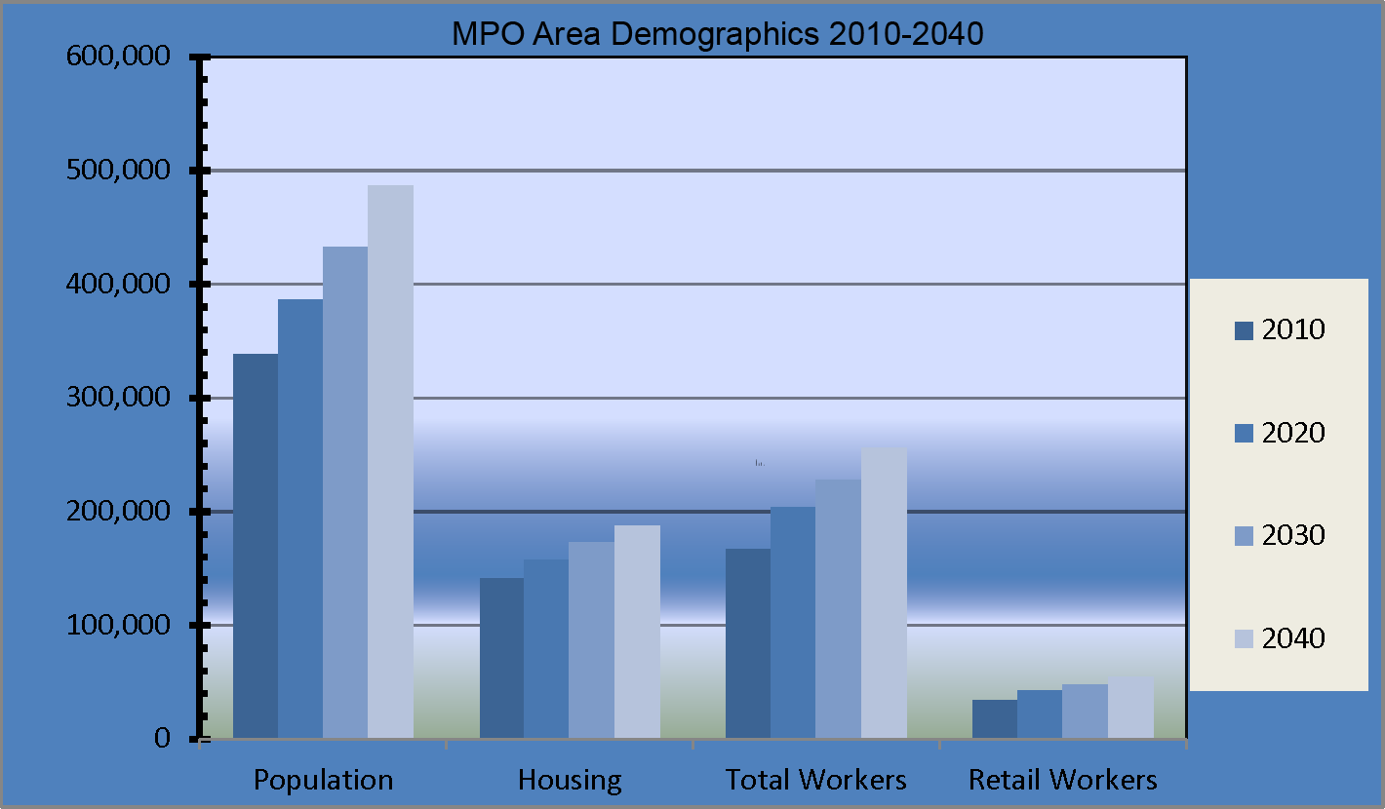
Figure 2: Acadiana MPO Planning Area Population Growth 2010-2040

Table 1. Acadiana Metropolitan Planning Organization
Population Count in 2010 and Estimates by Ten Year Intervals
PARISH |  | YEAR |  |  | GROWTH
PARISH | 2010 | 2020 | 2030 | 2040 | 30 YEAR  GROWTH | 30 YEAR  GROWTH RATE
Acadia | 2,659 | 3,452 | 4,283 | 5,297 | 2,638 | 99%
Iberia | 60,368 | 67,273 | 73,983 | 82,196 | 21,828 | 36%
Lafayette | 221,524 | 255,231 | 282,500 | 314,060 | 92,536 | 41%
St Landry | 7,690 | 9,349 | 11,200 | 13,613 | 5,923 | 77%
St Martin | 41,233 | 47,656 | 54,026 | 61,544 | 20,321 | 49%
Vermilion | 4,851 | 6,366 | 8,024 | 10,168 | 5,317 | 1.10%
TOTAL | 338,325 | 389,328 | 434,015 | 486,878 | 148,553 | 38.3%
** Source MTP 2040 Plan

SECTION 3: PERFORMANCE BASED PLANNING WITHIN THE TIP

3.1 PERFORMANCE BASED PLANNING

3.1.1 National Performance Goals
A key feature of the IIJA is the establishment of a performance-and-outcome-based program, originally introduced through the Moving Ahead for Progress in the 21st Century (MAP-21) Act. The objective of this performance-and-outcome-based program is for States and Metropolitan Planning Organizations to invest resources in projects that collectively will make progress toward the achievement of the national goals as identified below:

Table 2. IIJA National Performance Goal
Goal Area | National Goal
Safety | To achieve a significant reduction in traffic fatalities and serious injuries on all public roads
Infrastructure condition | To maintain the highway infrastructure asset system in a state of good repair
Congestion reduction | To achieve a significant reduction in congestion on the National Highway System
System reliability | To improve the efficiency of the surface transportation system
Freight movement and economic vitality | To improve the national freight network, strengthen the ability of rural communities to access national and international trade markets, and support regional economic development
Environmental sustainability | To enhance the performance of the transportation system while protecting and enhancing the natural environment
Reduced project delivery delays | To reduce project costs, promote jobs and the economy, and expedite the movement of people and goods by accelerating project completion through eliminating delays in the project development and delivery process, including reducing regulatory burdens and improving agencies’ work practices

3.1.2 MPO Target Setting

§1203; 23 USC 150(c): Requires the Secretary, in consultation with States, MPOs, and other stakeholders, to establish performance measures in the areas listed below. Provides for DOT to establish such measures within 18 months of enactment and prohibits DOT from establishing additional performance measures.
- Pavement condition on the Interstate System and on remainder of the National Highway System (NHS)
- Performance of the Interstate System and the remainder of the NHS
- Bridge condition on the NHS
- Fatalities and serious injuries—both number and rate per vehicle mile traveled--on all public roads
- Traffic congestion
- On-road mobile source emissions
- Freight movement on the Interstate System

§1202; 23 USC 135(d)(2)(B): Coordinate with an MPO when setting performance targets for the area represented by that MPO; and coordinate with public transportation providers when setting performance targets in an urbanized area not represented by an MPO.

§1201; 23 USC 134(h): Within 180 days of States or providers of public transportation setting performance targets, requires MPOs to set performance targets in relation to the performance measures (where applicable). To ensure consistency, each MPO must, to the maximum extent practicable, coordinate with the relevant State and public transportation providers when setting performance targets.

3.1.3 Adopted MPO Performance Measures

The TIP is a critical component of the Performance Based Planning Process because it commits transportation funding to specific improvement projects and operational strategies. Through this process, MPOs link planning to programming by prioritizing projects and allocating funding for projects within the TIP that are consistent with the goals established in the Metropolitan Transportation Plan (MTP). The Acadiana MPO has now adopted all three of the required Performance measures. PM-1 (Safety), PM-2 (Bridge condition and Pavement condition) and PM-3 (Travel time reliability (freight and passenger vehicle)).

3.2 PROGRESS OF PERFORMANCE MEASURES AND TARGETS

3.2.1 PM-1 (Safety)

The MPO sets Safety Performance Targets on an annual basis. In 2018, the MPO set the statewide targets, but in subsequent years utilized a tool that allowed the MPO to set a local target for each performance measure. The targets are a 1% reduction in the previous 5 year rolling average. The MPO has met each of the targets set for 2019 and 2020 with the exception of the rate measure for Serious Injuries per 100 million miles and the overall Serious Injury Crash number for the MPO area. The MPO evaluates each project for the incorporation of proven safety countermeasures by documenting the crashes at the project location and analyzing the crash types for applicable countermeasures to reduce fatal and serious injury crashes. The MPO works with the Acadiana Regional Transportation Safety Coalition to review and develop Highway Safety Improvement Projects and Local Road Safety Projects to address fatal and serious injury crashes outside of the STP program.

See Figure 3 for the Acadiana MPO Safety Performance Targets Year 2023

Figure 3 Acadiana MPO Safety Performance Targets Year 2023

    - PM-2 (Bridge Condition and Pavement Condition)

The MPO set the 2 and 4-year Bridge and Pavement Condition performance measures utilizing the targets set by the state. The 2-year target is set for 2024 and the 4-year is set for 2026. Data provided by DOTD on road and bridge condition provide the basis for STP project development by the MPO and local officials to ensure that the MPO makes progress towards reaching the targets.

Figure 4 on next page shows the bridge and pavement conditions.

Figure 4. Bridge and Pavement Condition

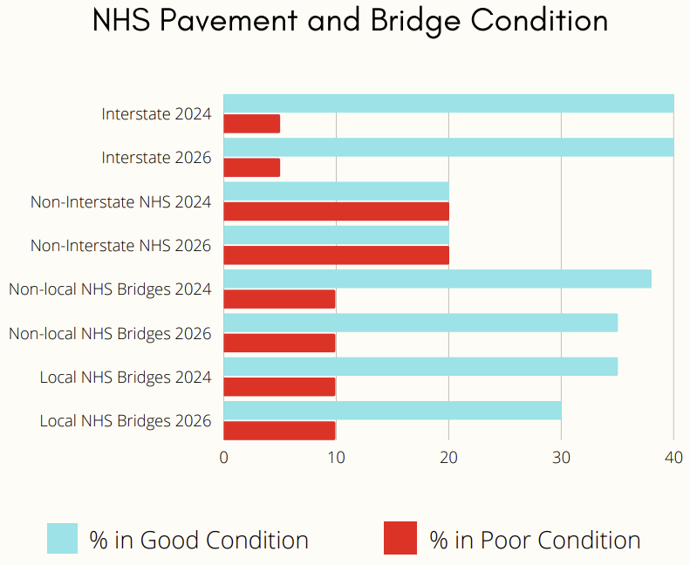

    - PM-3 (Travel Time Reliability and Freight Mobility)

The Travel Time Reliability targets were developed by the MPO for the Acadiana region due to the high performance of the region when contrasted with the state. The MPO utilizes NPMRDS data and recommendations from the Congestion Management Process in the STP project development process to ensure the continuation of reliable travel in the MPO area.

See Figure 5 on the next page for performance measures on travel time reliability and freight mobility.

Figure 5. Travel Time Reliability and Freight Mobility

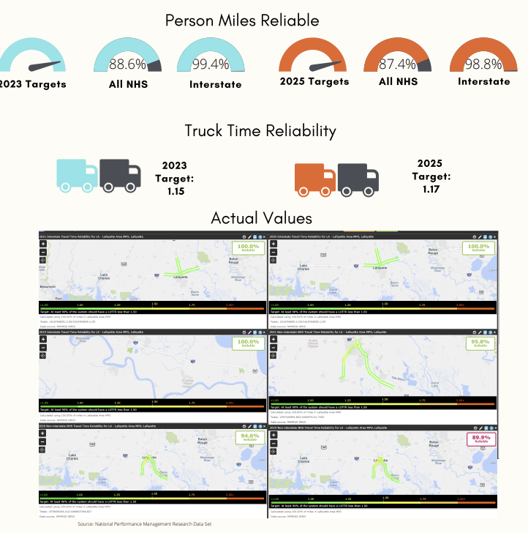

Table 3 on next page shows the targets set for 2023-2026 TIP. The MPO targets are based on MPO data projection.

Table 3. 2023-2026 TIP Travel Time Reliability (Passenger and freight) and Mobility Index

 | 2023 Target (MPO) | 2023 Actual (MPO) | 2025 Target (MPO) | 2025 Actual (MPO) | 2023 Target (DOTD) | 2023 Actual (DOTD) | 2025 Target (DOTD) | 2025 Actual (DOTD)
Travel Time Reliability Interstates (Percentage in person miles) | 99.4 | N/A | 98.8 | N/A | 88.7 | N/A | 88.4 | N/A
Travel Time Reliability Non-Interstates (Percentage in person miles) | 88.6 | N/A | 87.4 | N/A | 88.7 | N/A | 87.5 | N/A
Truck Travel Time Reliability index (index) | 1.15 | N/A | 1.17 | N/A | 1.38 | N/A | 1.41 | N/A

3.3 TRANSIT PERFORMANCE

See Figure 6 and Figure 7 for transit related performance measures.

Figure 6. Transit Asset Management Performance Measures

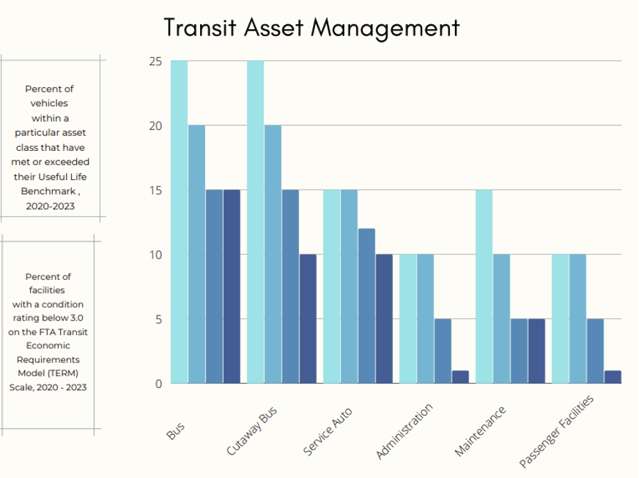

Figure 7. Transit Safety Plan Performance Measures

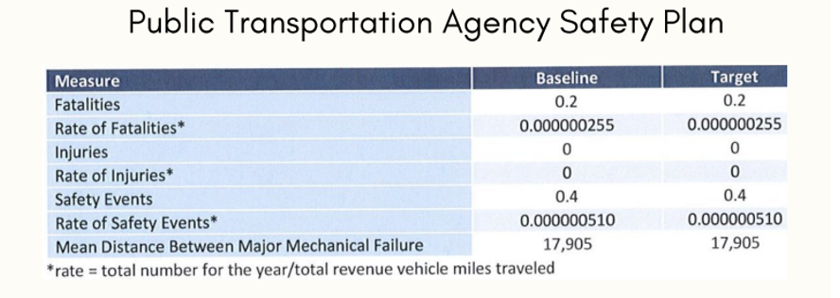

SECTION 4: TIP DEVELOPMENT PROCESS

4.1 IIJA REQUIREMENTS AND PROVISIONS FOR PUBLIC INVOLVEMENT

The IIJA reemphasized the importance of comprehensive planning for transportation improvements through the requirement of a Financially Constrained Transportation Plan. The Transportation Improvement Program (TIP) is the financial realization of the MTP. While the MTP establishes the goals and framework, the TIP serves as a tool for program and project implementation.

During the TIP development, MPOs must develop and utilize a “participation plan” that provides reasonable opportunities for interested parties to comment on the metropolitan transportation plan, as well as, the TIP. Further, this participation plan must be developed “in consultation with all interested parties,” and the public must have input on the participation plan. A participation plan must be in place prior to MPO adoption of transportation plans and TIPs. FTA and FHWA expect governmental and nonprofit organizations that receive Federal assistance from sources other than the Department of Transportation to be involved in the planning process. In addition to preparing their plans, MPOs and States must employ visualization techniques to the maximum extent practicable and otherwise make MTPs and TIPs available for public review in electronic formats.

4.2 ACADIANA MPO PROJECT SELECTION PROCESS

The Acadiana MPO's TIP Project Selection Process Handbook (TIP Handbook) has been created since the MPO's transition to >200K, and has been used as instructions for project submission and selection. The MPO receives approximately $6,000,000 per year under the STP > 200K funding source. The funding is allocated to projects that qualify and are selected through a defined project selection process. The MPO accepts applications for federal funds from Local Public Agencies (LPA).

Solicitation letters and project applications were sent to the jurisdictions within the MPO area in July of 2021, thus an adequate amount of time is given to process the applications and return. After returning the application, the projects will be graded according to the matrix in the TIP Handbook. This matrix includes qualifiable measures such as pavement quality, safety, transit access, and others to assist the MPO in reaching performance measure targets. The recommendations of the MPO will be reviewed through the Project Evaluation Subcommittee and adopted through normal MPO Process. Local Public Agencies will be responsible for the management and approval of the projects as the projects progress through the DOTD process. The TIP and these LPA projects will be reviewed semi-annually for reasonableness. If projects do not move forward in the development process, then they will be removed from the TIP or pushed back into a later fiscal year.

The Acadiana MPO, in close consultation and cooperation with LADOTD, prepares a draft of the TIP document whenever it is amended. This amended document is widely distributed for public review and comments (see 4.5 Public Involvement Activities) and is presented to the MPO’s transportation committees for review, comment, and concurrence. Projects contained in the TIP document are organized in accordance with the federal fiscal year that begins October 1, 2014. The TIP covers the four-year period: FY 2022-2023; FY2023-2024; FY2024-2025; and FY 2025-2026.

Federal funding authorization dates are shown to advise local officials and the public as to when is the construction phase is planned to begin. The Acadiana MPO staff works very closely with LADOTD staff and other vested entities to establish realistic project priorities, based on where the project rests in the implementation pipeline. Meetings are held on an annual basis with LADOTD to review the status of TIP projects and scheduled letting dates. This review considers important factors such as the status of environmental clearances, survey work, preliminary plans, right-of-way, utilities, advance checkpoints, and final plan preparation. The draft TIP is also presented to the TTC and TPC for review and input, along with any citizens’ comments received prior to finalization of priorities.

4.3 CONSISTENCY WITH OTHER PLANNING PROCESSES

Projects contained in the TIP have evolved through the regions planning process as outlined above. This analysis process is based on the planning factors as continued in the IIJA. These factors and the resulting analysis are utilized by the Planning Staff in the development of an integrated transportation plan and TIP for the Acadiana Metropolitan Planning Area. The 2040 Financially Constrained Transportation Plan (FCTP), contains comprehensive discussions as to how these factors are being specifically applied in the Urban Area to develop a transportation system that facilitates the efficient, economic movement of people and goods. Projects in the 2023-2026 TIP are drawn directly from the MTP and are consistent with its goals and objectives. The results of this planning process are a coordinated, comprehensive, multi-modal transportation plan for the Acadiana MPO parishes.

4.3.1 Congestion Management Process (CMP)

The IIJA mandates Transportation Management Areas (TMAs) to have a Congestion Management Process (CMP) that provides for effective management and operation to combat congestion. The findings of the CMP analysis were presented to TTC and TPC for their review and resolution regarding TIP inclusion, as part of the integrated planning process.

4.3.2 Intelligent Transportation System Plan

In 2014, the Acadiana MPO adopted the Lafyette Regional ITS Architecture. The plan lays out existing ITS infrastructure, deficits in the current system, and recommends new strategy for implementing management and operations programs. The plan is consistent with the MPO’s current TIP and Congestion Management System (CMS) and is intended to address transportation system deficiencies within the region.

4.4 TIP CONFORMITY WITH CLEAN AIR ACT

The Clean Air Act requires EPA to review and, if necessary, revise air quality standards every five years to ensure that they protect public health with an adequate margin of safety. Following a change in standards, EPA works with states and tribes as appropriate to identify areas that do not meet the standards and establish plans to improve air quality.

On October 14, 1994, the Acadiana Urbanized Area was re-designated as an Air Quality (ozone) Attainment with Minimal Maintenance area by the U.S. Environmental Protection Agency. This designation reflects the fact that the Acadiana Metropolitan Area suffered some ozone problems in the 1970 and 80’s but has met the National Ambient Air Quality Standards (NAAQS) in recent years, therefore it is not subject to the conformity analysis process, and the Acadiana MPO has determined that the FY2023-2026 TIP is substantially identical to Long Range Plan (the MTP) in the Air Quality Conformity Analysis, and in conformity with the STIP.

4.5 PUBLIC INVOLVEMENT ACTIVITIES

A primary goal of IIJA is to bring citizen and community involvement to the transportation and development table. In support of this Acadiana MPO conducts regular meetings with its TPC and TTC. To expand upon the public involvement process, the MPO also meets periodically with various civic and neighborhood associations to keep them abreast of transportation issues in the region. The Acadiana MPO has made use of the MPO website, social media, library, a citizen email list to inform citizens regarding the planning process, the transportation plans, and important projects. Meetings are broadcast on the MPO Facebook page, and TIP amendments and other items for public comment are posted on social media, the MPO website, and distributed to local libraries for the public to review.

4.6 DISTRIBUTION OF TIP DOCUMENT

For public review, the TIP was posted on the MPO website and on the MPO’s social media page with directions on how to submit public comment online and distributed to libraries throughout the metropolitan area at least 15 days prior to adoption by the Transportation Policy Committee for citizen review, input and comment. A public comment period is held for each agenda item at Transportation Technical Committee (TTC) and Transportation Policy Committee (TPC) meetings when the TIP document is up for committee approval; No public comment was submitted for the adoption of this TIP.

4.7 ADOPTION OF THE TIP AND PROJECT LISTINGS

Public meetings were held to adopt the 2023-2026 TIP. These meetings were standard MPO TTC and TPC meetings which are open to the public. The TTC adopted the TIP on 05/04/2022 and the TPC adopted on 05/18/2022.

The selected projects are organized in a project-by-project format in the alphabetic sequence of parishes, then by DOTD project number within each parish, starting on Page 36. The tables starting on Page 48 represent both the Highway Element, and the Transit Element, all covering the same period for the TIP.

4.8 TIP AMENDMENT PROCESS

4.8.1 Procedures to Amend or to Administratively Modify the TIP

The following procedures are applicable for processing amendments or administrative modifications to the Statewide (STIP) or Metropolitan Transportation Improvement Programs (TIPs). In accordance with the provisions of 23 CFR 450.218 (b), the STIP shall be developed in cooperation with the MPO

designated for the metropolitan area. Each metropolitan Transportation Improvement Program (TIP) shall be included without change in the STIP, directly or by reference, after approval of the TIP by the MPO and the Governor. A metropolitan TIP in a nonattainment or maintenance area is subject to a FHWA/FTA conformity finding before inclusion in the STIP. In areas outside a metropolitan planning area but within an air quality nonattainment or maintenance area containing any part of a metropolitan area, projects must be included in the regional emissions analysis that supported the conformity determination of the associated metropolitan TIP before they are added to the STIP.

In accordance with 23 CFR 450.218(n), projects in any of the first four years of the STIP may be moved to any other of the first four years of the STIP subject to the project selection requirements of 23 CFR 450.222. Such modifications do not require formal approval, provided expedited project selection procedures have been adopted in accordance with 23 CFR 450.222 and the required interagency consultation or coordination is accomplished and documented.

An Administrative Modification is a minor revision to a long-range statewide or metropolitan transportation plan, Transportation Improvement Program (TIP), or Statewide Transportation Improvement Program (STIP) that includes minor changes to project phase costs, funding sources of previously included projects and project phase initiation dates. An administrative modification is a revision that does not require public review and comment, re-demonstration of fiscal constraint or a conformity determination (in nonattainment and maintenance areas).

Administrative Modification thresholds include:

- Revisions to a project description without changing the project scope or which do not conflict with the pertinent environmental document;
- Minor changes to the cost of a project phase (Feasibility, Environmental, R/W, Utility Relocation, Engineering, Construction);
- Funding changes are limited to $1,250,000 for project phases ≤$5,000,000;
- For project phases >$5,000,000, an administrative modification is limited to budget changes of less than 25% in funding;
- Minor changes to funding sources of previously included project phases that do not affect fiscal constraint of the STIP or the ability to complete the project as initially described;
- Minor changes to project phase initiation dates as long as the project stays within the approved STIP/TIP timeframe and do not affect fiscal constraint of the STIP or the ability to complete the project as initially described. 23 CFR 450,.218(n);
- A change in the project or implementing agency;
- A split or combination of individually listed projects; as long as cost, schedule, and scope remain unchanged;
- The addition or deletion of projects from grouped project (line item) listings as long as the line-item total funding amounts stay within the guidelines in number two above.

Administrative modifications can be processed in accordance with these procedures provided that: It does not affect the air quality conformity determination, including timely implementation of Transportation Control Measures (TCMs), and it does not impact financial constraint of the STIP or the ability to complete the projects as described.

The LADOTD will immediately notify the MPO, FHWA, and FTA of any approved administrative modification(s).
For projects in a rural area, once approved by the LADOTD, on behalf of the Governor, the administrative modification will be incorporated into Louisiana’s STIP. The LADOTD will immediately notify the MPO, FHWA, and FTA of any approved administrative modification(s).

An Amendment is a revision to a long-range statewide or metropolitan transportation plan, TIP, or STIP that involves a major change to a project or project phase included in a metropolitan transportation plan, TIP, or STIP, including the addition or deletion of a project or a project phase, a major change in project/project phase cost or a major change in design concept or changes to projects that are included only for illustrative purposes do not require an amendment. An amendment is a revision that requires public review and comment, re-demonstration of fiscal constraint. TIP amendments with proof of action must be posted on the respective MPO website within 30 days. In the context of a long-range statewide transportation plan, an amendment is a revision approved by the State in accordance with its public involvement process.

If a project affected by an amendment is located within the planning boundaries of an MPO, it must first be amended in the TIP before it can be amended in the STIP. Once approved by the LADOTD, on behalf of the Governor, the amendment will be incorporated into Louisiana’s STIP. The LADOTD will immediately notify the MPO, FHWA, and FTA of any approved amendment(s).

Amendments: are all other changes to STIP/TIPs that are outside of the administrative modification listed above.

Timeline for Amendment Approval

When an amendment is sent to the FHWA, it will take a maximum of two weeks to be processed. The FHWA can partially approve an amendment on a project-by-project basis. Any project or phase of a project not approved will be resubmitted once questions and/or concerns have been resolved.

Dispute Resolution

If a question arises regarding the interpretation of an administrative modification or an amendment; the LADOTD, FHWA, FTA and MPO, as appropriate, will work to resolve the issue in coordination with each other. If after consultation, the parties disagree on the definition of what constitutes an administrative modification or an amendment, the final decision rests with the FTA for transit projects and FHWA for highway projects.

4.8.2 Amendments and Administrative Modifications to a Line Item

Line Items are evaluated per phase, per fund, per year. Adding a new funding source to a phase of a line in a particular FFY would require a STIP amendment if it affected fiscal constraint (i.e. the current STIP includes $10,000,000 or NHPP in FFY 2023 on Phase 6 of L.000000; by adding $5,000,000 in STPFLEX to that line item in that year and phase so that after approved, the current STIP will include $10,000,000 in NHPP and $5,000,000 in STPFLEX in FFY 2023 on Phase 6 of L.000000).

Adding a phase to a line item also requires a STIP amendment. For a line-item phase, fund, year combination with a cost >$5,000,000, changing the amount by more than 25% on that fund, in that phase and in that year requires a STIP amendment. For a line-item phase, fund, year combination with a cost >5,000,000, changing the amount less than 25% on that fund, in that phase and in that year can be done by a STIP administrative modification.

For a line-item phase, fund, year combination with a cost ≤$5,000,000, the amount can be changed up to $1,250,000 by a STIP administrative modification; changing the amount by more than $1,250,000 requires a STIP amendment.

Adjusting existing amounts on funds within a phase and within a particular FFY of a line item that does not affect fiscal constraint of the STIP can be done by a STIP administrative modification (i.e. changing $10,000,000 of NHPP and $20,000,000 of STPFLEX in FFY 2023 on Phase 6 of L.000000 to $3,000,000 of NHPP and $27,000,000 of STPFLEX in FFY 2023 on Phase 6 of L.000000).

Adding a fund within a phase and within a particular FFY of a line item that does not affect fiscal constraint of the STIP can be done by a STIP administrative modification (i.e. adding STCASH or NFA or STBONDS or STGEN or LOCAL because additional funding sources have been identified on a project or it has been decided that projects need to be authorized as an advanced construction project).

Splitting an existing fund into multiple funds within a phase and within a particular FFY of a line item which does not affect fiscal constraint of the STIP can be done by a STIP administrative modification (i.e. splitting $10,000,000 of NHPP in FFY 2023 on Phase 6 of L.000000into $2,000,000 of NHPP and $8,000,000 of STPFLEX in FFY 2023 on Phase 6 of L.000000; total remains $10,000,000).

Quick Reference Chart for Amendments vs. Modifications
Administrative Modification | Amendment
Revision of a project description that does not significantly change the project design concept and/or scope | Major changes to a project including the addition or deletion of a project
Minor changes to project/project phase cost; applies to feasibility, environmental, R/W, utility relocation, engineering, construction  Funding changes are limited to $1,250,000 for projects for ≤$5,000,000  For projects >$5,000,000 an administrative modification is classified as a change of less than 25% in funding | Major changes in project costs, project/project phase initiation dates, or a major change in design concept or design scope  Funding changes that are greater than $1,250,000 for projects ≤$5,000,000  Change of 25% or more in funding
Minor changes to funding sources of previously included projects that do not affect fiscal constraint | Major changes to funding sources, such as adding a new federal funding source for a project not previously federally funded
Minor changes to project/project phase initiation dates as long as the project stays within the approved STIP timeframe and does not affect fiscal constraint
A change in the project implementing agency
A split or combination of individually listed projects; as long as cost, schedule, and scope remain unchanged
The addition or deletion of projects from grouped project (line item) listings as long as the total funding amounts stay within the guidelines

4.9 TRANSIT

The MPO serves as the primary forum where State DOTs, transit providers, local agencies, and the public develop local transportation plans and programs that address a metropolitan area's needs. For Lafayette Transit System, Discretionary capital grant (Section 5339 FTA Discretionary) is almost exclusively used to contribute to the bus replacement project. All match funds are from the Lafayette City General Fund.

SECTION 5: TIP FUNDING

5.1 COMPLIANCE WITH FINANCIAL PLAN REQUIREMENT

Federal guidelines mandate the Transportation Improvement Program (TIP) must be financially constrained. In essence, the cost of projects selected in the overall program schedule must be equal to or less than the estimated funding available to complete these projects. Available funds include federal, state, and local funding revenue streams of which the federal funds are the primary source of funding per respective programmed project.

All the projects listed within this FY 2023-2026 TIP program, with exception of transportation enhancements, have identified sources of federal, state, or local revenues. Transportation Enhancement projects are included within this document in response to application requirements which establish listing of projects in the adopted TIP as a prerequisite to consideration for funding.

The TIP has been financially constrained to reflect realistic and available levels of project funding. All projects contained in the TIP are derived from Acadiana’s Metropolitan Transportation Plan, they were fully discussed with the TTC and the TPC. State and federally funded projects were mutually agreed upon with LADOTD as to overall merit and funding availability for inclusion in the State TIP (STIP).

Projects shown for urban systems greater than “200 k” (areas greater than 200,000 population) funding are also financially constrained, reflecting the annual attributable amount (approximately $6,400,000 in FY23-26). This $6,400,000 requires a 20% local match. If the project in question is a State project sometimes the state will provide the local match. In all other projects is in incumbent upon the MPO to find the local match.

5.2 TIP PROJECTS LISTING

The selected projects are organized in a project-by-project format in the alphabetic sequence of parishes, then by DOTD project number within each parish. The following pages in Section 5.2 list the selected TIP projects.

ACADIA PARISH

Acadia Parish
Project No | Project Description |  | Performance Measures
H.015639 | LA 95 @ Lexington Dr Roundabout |  | PM 1 – Safety & PM 3 – System Performance
Route | Control Section | Beg Log Mile | End Log Mile |  | Non-State Rd: | Parish:
LA 95 | 801-41 | 0.84 | 0.59 |  |  | Acadia
Remarks | Type Improvement |  |  |  | Work Type
Local Match | Roundabout Construction |  |  |  | Urban Systems
Project Phase | Project Cost | Tot Cost (w/CE&I+IDC) |  | Federal Share | Fund | Year | Sponsor
Environmental | $100,000.00 | $100,000.00 |  | $0.00 | Local | FY24 | Acadia Parish/Duson
Engineering Design | $250,000.00 | $250,000.00 |  | $0.00 | Local | FY23 | Acadia Parish/Duson
Right of Way | $100,000.00 | $100,000.00 |  | $0.00 | Local | FY26 | Acadia Parish/Duson
Utility Relocations | $200,000.00 | $200,000.00 |  | $0.00 | Local | FY26 | Acadia Parish/Duson
Construction | $2,325,818.00 | $2,558,399.80 |  | $0.00 | STBOND | FY28 | Acadia Parish/Duson
Construction | $600,000.00 | $660,000.00 |  | $528,000.00 | STP>200K | FY28 | Acadia Parish/Duson
Construction | $1,914,482.00 | $2,105,930.20 |  | $2,105,930.20 | HSIP | FY28
Total Cost | $5,490,300.00 | $5,974,330.00 |  | $2,633,930.20

IBERIA PARISH

Iberia Parish
Project No | Project Description |  | Performance Measures
H.009892 | US 90 FR: Extension to LA 329 |  | PM 3 – System Performance
Route | Control Section | Beg Log Mile | End Log Mile |  | Non-State Rd: | Parish:
US 90 | 424-04 | 8.600 | 8.600 |  |  | Iberia
Remarks | Type Improvement |  |  |  | Work Type
Local Match | Extend US 90 Frontage Road to LA 329 |  |  |  | Urban Systems
Project Phase | Project Cost | Tot Cost (w/CE&I+IDC) |  | Federal Share | Fund | Year | Sponsor
Engineering | $80,000.00 | $80,000.00 |  | $64,000.00 | STP>200k | FY24 | New Iberia
Right of Way | $80,000.00 | $80,000.00 |  | $64,000.00 | STP>200k | FY26 | New Iberia
Utility Relocation | $300,000.00 | $300,000.00 |  | $240,000.00 | STP>200k | FY27 | New Iberia
Construction | $1,100,000.00 | $1,210,000.00 |  | $968,000.00 | STP>200k | FY28 | New Iberia
Total Cost | $1,560,000.00 | $1,670,000.00 |  | $1,336,000.00

Iberia Parish
Project No | Project Description |  | Performance Measures
H.011988 | LA 86: BYU Teche MB Rehab (DUPERIER)(HBI) |  | PM 2 – Bridge Condition
Route | Control Section | Beg Log Mile | End Log Mile |  | Non-State Rd: | Parish:
LA 86 | 237-01 | 0.000 | 0.200 |  |  | Iberia
Remarks | Type Improvement |  |  |  | Work Type
Historic Bridge Improvement | Movable Bridge Rehabilitation |  |  |  | Preservation, Bridge (on system)
Project Phase | Project Cost | Tot Cost (w/CE&I+IDC) |  | Federal Share | Fund | Year | Sponsor
Engineering | $600,000.00 | $600,000.00 |  | $480,000.00 | STPFLEX | FY25 | DOTD
Total Cost | $600,000.00 | $600,000.00 |  | $480,000.00

Iberia Parish
Project No | Project Description |  | Performance Measures
H.011991 | LA 86: BYU Teche MB Rehab (Daspit)(HBI) |  | PM 2 – Bridge Condition
Route | Control Section | Beg Log Mile | End Log Mile |  | Non-State Rd: | Parish:
LA 86 | 400-31 | 0.000 | 0.500 |  |  | Iberia
Remarks | Type Improvement |  |  |  | Work Type
Historic Bridge Improvement | Movable Bridge Rehabilitation |  |  |  | Preservation, Bridge (on system)
Project Phase | Project Cost | Tot Cost (w/CE&I+IDC) |  | Federal Share | Fund | Year | Sponsor
Engineering | $455,000.00 | $455,000.00 |  | $364,000.00 | STPFLEX | FY25 | DOTD
Construction | $6,000,000.00 | $6,600,000.00 |  | $5,280,000.00 | STPFLEX | FY29 | DOTD
Total Cost | $ 6,455,000.00 | $ 7,055,000.00 |  | $ 5,644,000.00

Iberia Parish
Project No | Project Description |  | Performance Measures
H.012738 | LA 344: Bayou Teche MB RH (Morbihan) (HBI) |  | PM 2 – Bridge Condition
Route | Control Section | Beg Log Mile | End Log Mile |  | Non-State Rd: | Parish:
LA 344 | 823-14 | 0.200 | 0.400 |  | Iberia
Remarks | Type Improvement |  |  |  | Work Type
Historic Bridge Improvement | Movable Bridge Rehabilitation |  |  |  | Preservation, Bridge (on system)
Project Phase | Project Cost | Tot Cost (w/CE&I+IDC) |  | Federal Share | Fund | Year | Sponsor
Engineering | $461,000.00 | $461,000.00 |  | $368,800.00 | STPFLEX | FY25 | DOTD
Total Cost | $461,000.00 | $461,000.00 |  | $368,800.00

Iberia Parish
Project No | Project Description |  | Performance Measures
H.012792 | LA 675 @ Airport Rd. Roundabout |  | PM 1 – Safety and PM 3 – System Performance
Route | Control Section | Beg Log Mile | End Log Mile |  | Non-State Rd: | Parish:
LA 675 | 823-02 | 0.300 | 0.400 |  |  | Iberia
US 90 | 424-04 | 6.200 | 6.300 |  |  | Iberia
Remarks | Type Improvement |  |  |  | Work Type
Local Match | Roundabout Construction |  |  |  | Urban Systems
Project Phase | Project Cost | Tot Cost (w/CE&I+IDC) |  | Federal Share | Fund | Year | Sponsor
Right of Way | $580,000.00 | $580,000.00 |  | $464,000.00 | STP>200k | FY24 | Iberia Parish
Utility Relocation | $280,000.00 | $280,000.00 |  | $224,000.00 | STP>200k | FY25 | Iberia Parish
Construction | $3,250,000.00 | $3,575,000.00 |  | $2,860,000.00 | STP>200k | FY25 | Iberia Parish
Construction | $3,400,000.00 | $3,740,000.00 |  | $0.00 | Local | FY25 | Iberia Parish
Total Cost | $7,510,000.00 | $8,175,000.00 |  | $3,548,000.00

Iberia Parish
Project No | Project Description |  | Performance Measures
H.013522 | S Lewis St Widening |  | PM 1 – Safety and PM 3 – System Performance
Route | Control Section | Beg Log Mile | End Log Mile |  | Non-State Rd: | Parish:
 | 000-23 | 0.000 | 0.000 |  | S. Lewis St. | Iberia
Remarks | Type Improvement |  |  |  | Work Type
Local Match | Continuous Turn Lane |  |  |  | Urban Systems
Project Phase | Project Cost | Tot Cost (w/CE&I+IDC) |  | Federal Share | Fund | Year | Sponsor
Right of Way | $50,000.00 | $50,000.00 |  | $40,000.00 | STP>200k | FY26 | Iberia Parish
Utility Relocation | $60,000.00 | $60,000.00 |  | $48,000.00 | STP>200k | FY26 | Iberia Parish
Construction | $1,800,000.00 | $1,980,000.00 |  | $1,584,000.00 | STP>200k | FY27 | Iberia Parish
Total Cost | $1,910,000.00 | $2,090,000.00 |  | $1,672,000.00

Iberia Parish
Project No | Project Description |  | Performance Measures
H.014510 | Iberia St Pavement Preserv and Bike Impr |  | PM 1 – Safety and PM 2 – Pavement Condition
Route | Control Section | Beg Log Mile | End Log Mile |  | Non-State Rd: | Parish:
 | 000-23 | 0.000 | 0.000 |  | Iberia St. | Iberia
Remarks | Type Improvement |  |  |  | Work Type
Local Match | Rehabilitation of Road Surface and Bike Improvements |  |  |  | Urban Systems
Project Phase | Project Cost | Tot Cost (w/CE&I+IDC) |  | Federal Share | Fund | Year | Sponsor
Design (Engineering) | $ 253,872.00 | $ 253,872.00 |  | $203,097.60 | STP>200k | FY25 | New Iberia
Construction | $1,000,000.00 | $1,100,000.00 |  | $880,000.00 | STP>200k | FY26 | New Iberia
Total Cost | $1,253,872.00 | $1,353,872.00 |  | $1,083,097.60

Iberia Parish
Project No | Project Description |  | Performance Measures
H.016226 | LA 3156 LA 182(W St Peter St) Fulton St |  | PM 2 – Pavement Condition
Route | Control Section | Beg Log Mile | End Log Mile |  | Non-State Rd: | Parish:
LA 3156 | 823-42 | 0.000 | 0.135 |  |  | Iberia
Remarks | Type Improvement |  |  |  | Work Type
Local Match | Pavement Preservation |  |  |  | Urban Systems
Project Phase | Project Cost | Tot Cost (w/CE&I+IDC) |  | Federal Share | Fund | Year | Sponsor
Design (Engineering) | $ 26,491.00 | $ 26,491.00 |  | $21,192.80 | STP>200k | FY27 | New Iberia
Construction | $101,189.00 | $111,307.90 |  | $89,046.32 | STP>200k | FY28 | New Iberia
Total Cost | $127,680.00 | $137,798.90 |  | $110,239.12

Iberia Parish
Project No | Project Description |  | Performance Measures
H.016240 | LA 86/Duperier Avenue: LA 182/E Main St – LA 86/Loreauville Rd |  | PM 2 – Pavement Condition
Route | Control Section | Beg Log Mile | End Log Mile |  | Non-State Rd: | Parish:
LA 86 | 237-01 | 0.000 | 0.874 |  |  | Iberia
Remarks | Type Improvement |  |  |  | Work Type
Local Match | Pavement Preservation |  |  |  | Urban Systems
Project Phase | Project Cost | Tot Cost (w/CE&I+IDC) |  | Federal Share | Fund | Year | Sponsor
Design (Engineering) | $130,785.00 | $130,785.00 |  | $104,628.00 | STP>200k | FY27 | New Iberia
Construction | $670,388.00 | $737,426.80 |  | $589,941.44 | STP>200k | FY28 | New Iberia
Total Cost | $801,173.00 | $868,211.80 |  | $694,569.44

Iberia Parish
Project No | Project Description |  | Performance Measures
H.015823 | US 90: LA 83 - LA 85 |  | PM 2 – Pavement and Bridge Condition
Route | Control Section | Beg Log Mile | End Log Mile |  | Non-State Rd: | Parish:
US 90 | 424-04 | 14.750 | 16.690 |  |  | Iberia
US 90 | 424-04 | 14.090 | 14.750 |  |  | Iberia
US 90 | 424-04 | 11.340 | 14.090 |  |  | Iberia
Remarks | Type Improvement |  |  |  | Work Type
 | PCCP, Patch, Class II Base Course, and Asphalt Overlay |  |  |  | Preservation, Non-INTERST NHS
Project Phase | Project Cost | Tot Cost (w/CE&I+IDC) |  | Federal Share | Fund | Year | Sponsor
Construction | $26,750,000.00 | $29,425,000.00 |  | $23,540,000.00 | NHPP | FY26 | DOTD
Total Cost | $26,750,000.00 | $29,425,000.00 |  | $23,540,000.00

LAFAYETTE PARISH

Lafayette Parish
Project No | Project Description |  | Performance Measures
H.009629 | US 90: RR JCT - Pinhook, LA 92 - LA 88 |  | PM 2 – Pavement and Bridge Condition
Route | Control Section | Beg Log Mile | End Log Mile |  | Non-State Rd: | Parish:
US 167 | 424-02 | 1.207 | 1.940 |  |  | Lafayette
US 90 | 424-02 | 1.940 | 2.757 |  |  | Lafayette
US 90 | 424-02 | 12.204 | 12.379 |  |  | Lafayette
US 90 | 424-03 | 0.000 | 1.842 |  |  | St. Martin
US 90 | 424-04 | 0.000 | 1.622 |  |  | Iberia
Remarks | Type Improvement |  |  |  | Work Type
DOTD Match | Pavement Rehabilitation |  |  |  | Urban Systems
Project Phase | Project Cost | Tot Cost (w/CE&I+IDC) |  | Federal Share | Fund | Year | Sponsor
Construction | $11,800,000.00 | $12,980,000.00 |  | $10,384,000.00 | NHPP | FY23 | DOTD
Construction | $7,600,000.00 | $8,360,000.00 |  | $0.00 | STCASH | FY23 | DOTD
Total Cost | $ 19,400,000.00 | $21,340,000.00 |  | $ 10,384,000.00

Lafayette Parish
Project No | Project Description |  | Performance Measures
H.009997 | US167 Johnston St. Improvements |  | PM 1 - Safety
Route | Control Section | Beg Log Mile | End Log Mile |  | Non-State Rd: | Parish:
US 167 | 080-02 | 7.150 | 8.140 |  |  | Lafayette
Remarks | Type Improvement |  |  |  | Work Type
DOTD Match | Access Management & Other Safety Counter Measures |  |  |  | Urban Systems
Project Phase | Project Cost | Tot Cost (w/CE&I+IDC) |  | Federal Share | Fund | Year | Sponsor
Right of Way | $1,391,186.33 | $1,391,186.33 |  | $1,391,186.33 | HSIPPEN | FY27 | DOTD
Right of Way | $1,391,186.34 | $1,391,186.34 |  | $1,112,949.07 | NHPP | FY27 | DOTD
Right of Way | $1,391,186.33 | $1,391,186.33 |  | $1,112,949.06 | STPFLEX | FY27 | DOTD
Utility Relocation | $1,750,000.00 | $1,750,000.00 |  | $1,750,000.00 | HSIPPEN | FY27 | DOTD
Utility Relocation | $1,750,000.00 | $1,750,000.00 |  | $1,400,000.00 | NHPP | FY27 | DOTD
Utility Relocation | $1,750,000.00 | $1,750,000.00 |  | $1,400,000.00 | STPFLEX | FY27 | DOTD
Construction | $3,013,045.33 | $3,314,349.86 |  | $3,314,349.86 | HSIPPEN | FY28 | DOTD
Construction | $3,013,045.34 | $3,314,349.87 |  | $2,651,479.90 | NHPP | FY28 | DOTD
Construction | $1,368,234.00 | $1,505,057.40 |  | $1,204,045.92 | STPFLEX | FY28 | DOTD
Total Cost | $16,817,883.67 | $17,557,316.13 |  | $15,336,960.14

Lafayette Parish
Project No | Project Description |  | Performance Measures
H.011833 | St. Mary Street Sidewalks |  | PM 1 - Safety
Route | Control Section | Beg Log Mile | End Log Mile |  | Non-State Rd: | Parish:
 | 000-28 | 0.000 | 0.000 |  | St. Mary St. | Lafayette
Remarks | Type Improvement |  |  |  | Work Type
Local Match | Sidewalk Construction |  |  |  | Urban Systems
Project Phase | Project Cost | Tot Cost (w/CE&I+IDC) |  | Federal Share | Fund | Year | Sponsor
Construction | $752,000.00 | $827,200.00 |  | $661,760.00 | STP>200k | FY26 | Scott
Construction | $1,030,000.00 | $1,133,000.00 |  | $906,400.00 | CRP>200k | FY26 | Scott
Total Cost | $1,782,000.00 | $1,960,200.00 |  | $1,568,160.00

Lafayette Parish
Project No | Project Description |  | Performance Measures
H.011990 | LA 92: Vermillion RVR MB RH (Milton) (HBI) |  | PM 2 – Bridge Condition
Route | Control Section | Beg Log Mile | End Log Mile |  | Non-State Rd: | Parish:
LA 92 | 213-05 | 0.000 | 0.300 |  |  | Lafayette
Remarks | Type Improvement |  |  |  | Work Type
Historic Bridge Improvement | Movable Bridge Rehabilitation |  |  |  | Preservation, Bridge (on system)
Project Phase | Project Cost | Tot Cost (w/CE&I+IDC) |  | Federal Share | Fund | Year | Sponsor
Engineering | $406,000.00 | $406,000.00 |  | $324,800.00 | STPFLEX | FY25 | DOTD
Construction | $8,000,000.00 | $8,800,000.00 |  | $7,040,000.00 | STPFLEX | FY28 | DOTD
Total Cost | $8,406,000.00 | $9,206,000.00 |  | $7,364,800.00

Lafayette Parish
Project No | Project Description |  | Performance Measures
H.012864 | LA 94/Carmel Dr. Sidewalks |  | PM 1 - Safety
Route | Control Section | Beg Log Mile | End Log Mile | Non-State Rd: | Parish:
LA 94 | 080-03 | 0.312 | 1.760 |  | Lafayette
Remarks | Type Improvement |  |  | Work Type
Local Match | Sidewalk Construction |  |  | Urban Systems
Project Phase | Project Cost | Tot Cost (w/CE&I+IDC) | Federal Share | Fund | Year | Sponsor
Right of Way | $250,000.00 | $250,000.00 | $200,000.00 | STP>200k | FY26 | LCG
Construction | $449,458.00 | $494,403.80 | $395,523.04 | STP>200k | FY27 | LCG
Construction | $750,542.00 | $825,596.20 | $660,476.96 | CRP>200k | FY27 | Lafayette Parish
Total Cost | $1,450,000.00 | $1,570,000.00 | $1,256,000.00

Lafayette Parish
Project No | Project Description |  | Performance Measures
H.012866 | South College Rd Sidewalks |  | PM 1 - Safety
Route | Control Section | Beg Log Mile | End Log Mile |  | Non-State Rd: | Parish:
LA 3025 | 828-23 | 0.000 | 1.630 |  |  | Lafayette
Remarks | Type Improvement |  |  |  | Work Type |  |  |  | Benoit Rd
Local Match | Sidewalk Construction |  |  |  | Urban Systems
Project Phase | Project Cost | Tot Cost (w/CE&I+IDC) |  | Federal Share | Fund | Year | Sponsor
Engineering | $202,017.00 | $202,017.00 |  | $161,613.60 | STP>200k | FY23 | LCG
Right of Way | $200,000.00 | $200,000.00 |  | $160,000.00 | STP>200k | FY26 | LCG
Construction | $650,575.00 | $715,632.50 |  | $572,506.00 | STP>200k | FY27 | LCG
Total Cost | $1,052,592.00 | $1,117,649.50 |  | $894,119.60

Lafayette Parish
Project No | Project Description |  | Performance Measures
H.012867 | S. Larriviere Rd.: LA 92-Chemin Metairie |  | PM 3 – System Performance
Route | Control Section | Beg Log Mile | End Log Mile | Non-State Rd: | Parish:
 | 000-28 | 0.000 | 0.000 | S. Larriviere Rd. | Lafayette
Remarks | Type Improvement |  |  | Work Type
Local Match | Addition of a Center Turn Lane |  |  | Urban Systems
Project Phase | Project Cost | Tot Cost (w/CE&I+IDC) | Federal Share | Fund | Year | Sponsor
Construction | $9,050,000.00 | $9,955,000.00 | $7,964,000.00 | STP>200k | FY25 | Youngsville
Total Cost | $9,050,000.00 | $9,955,000.00 | $7,964,000.00

Lafayette Parish
Project No | Project Description |  | Performance Measures
H.012868 | Fortune Rd. Pavement Preservation |  | PM 2 – Pavement Condition
Route | Control Section | Beg Log Mile | End Log Mile |  | Non-State Rd: | Parish:
 | 000-28 | 0.000 | 0.000 |  | Fortune Rd. | Lafayette
Remarks | Type Improvement |  |  |  | Work Type
Local Match | Overlay |  |  |  | Urban Systems
Project Phase | Project Cost | Tot Cost (w/CE&I+IDC) |  | Federal Share | Fund | Year | Sponsor
Engineering | $133,031.00 | $133,031.00 |  | $106,424.80 | STP>200k | FY23 | Youngsville
Construction | $602,000.00 | $662,200.00 |  | $529,760.00 | STP>200k | FY24 | Youngsville
Total Cost | $735,031.00 | $795,231.00 |  | $636,184.80

Lafayette Parish
Project No | Project Description |  | Performance Measures
H.012869 | LA 182 (UNIV) @ LA 723 (Renaud) Roundabout |  | PM 1 – Safety and PM 3 – System Performance
Route | Control Section | Beg Log Mile | End Log Mile |  | Non-State Rd: | Parish:
LA 182 | 032-01 | 1.560 | 1.600 |  |  | Lafayette
LA 723 | 828-03 | 6.060 | 6.080 |  |  | Lafayette
Remarks | Type Improvement |  |  |  | Work Type
Local Match | Roundabout Construction |  |  |  | Urban Systems
Project Phase | Project Cost | Tot Cost (w/CE&I+IDC) |  | Federal Share | Fund | Year | Sponsor
Right of Way | $167,000.00 | $167,000.00 |  | $133,600.00 | STP>200k | FY26 | LCG
Construction | $3,300,000.00 | $3,630,000.00 |  | $2,904,000.00 | STP>200k | FY27 | LCG
Total Cost | $3,467,000.00 | $3,797,000.00 |  | $3,037,600.00

Lafayette Parish
Project No | Project Description |  | Performance Measures
H.012870 | LA93: I-10 Ramp-Renaud |  | PM 3 – System Performance
Route | Control Section | Beg Log Mile | End Log Mile |  | Non-State Rd: | Parish:
LA 93 | 217-01 | 0.560 | 0.860 |  |  | Lafayette
Remarks | Type Improvement |  |  |  | Work Type
Local Match | Addition of a Turn Lane |  |  |  | Urban Systems
Project Phase | Project Cost | Tot Cost (w/CE&I+IDC) |  | Federal Share | Fund | Year | Sponsor
Right of Way | $600,000.00 | $600,000.00 |  | $480,000.00 | STP>200k | FY26 | Scott
Construction | $4,574,000.00 | $5,031,400.00 |  | $4,025,120.00 | STP>200k | FY27 | Scott
Total Cost | $5,174,000.00 | $5,631,400.00 |  | $4,505,120.00

Lafayette Parish
Project No | Project Description |  | Performance Measures
H.013517 | E St Peter St and N Church St Sidewalks |  | PM 1 - Safety
Route | Control Section | Beg Log Mile | End Log Mile |  | Non-State Rd: | Parish:
 | 000-28 | 0.000 | 0.000 |  | E. St. Peter St. | Lafayette
Remarks | Type Improvement |  |  |  | Work Type
Local Match | Sidewalk Construction |  |  |  | Urban Systems
Project Phase | Project Cost | Tot Cost (w/CE&I+IDC) |  | Federal Share | Fund | Year | Sponsor
Construction | $1,030,000.00 | $1,133,000.00 |  | $906,400.00 | CRP>200k | FY23 | Carencro
Construction | $60,000.00 | $66,000.00 |  | $52,800 | STP>200k | FY23 | Carencro
Construction | $1,300,000.00 | $1,430,000.00 |  | $0.00 | Local | FY23 | Carencro
Total Cost | $2,390,000.00 | $2,629,000.00 |  | $959,200.00

Lafayette Parish
Project No | Project Description |  | Performance Measures
H.014509 | Doucet Rd. Sidewalks |  | PM 1 - Safety
Route | Control Section | Beg Log Mile | End Log Mile |  | Non-State Rd: | Parish:
 | 000-28 | 0.000 | 0.000 |  | Doucet Rd. | Lafayette
Remarks | Type Improvement |  |  |  | Work Type
Local Match | Add Sidewalks and Striped Crosswalks |  |  |  | Urban Systems
Project Phase | Project Cost | Tot Cost (w/CE&I+IDC) |  | Federal Share | Fund | Year | Sponsor
Design (Engineering) | $184,410.00 | $184,410.00 |  | $147,528.00 | STP>200k | FY25 | LCG
Construction | $285,590.00 | $314,149.00 |  | $251,319.20 | STP>200k | FY26 | LCG
Construction | $1,030,000.00 | $1,133,000.00 |  | $906,400.00 | CRP>200k | FY26 | LCG
Total Cost | $1,500,000.00 | $1,631,559.00 |  | $1,305,247.20

Lafayette Parish
Project No | Project Description |  | Performance Measures
H.014622 | St. Nazaire Rd. Ext: LA 96 Corne Rd. Ph 1 |  | PM 3 – System Performance
Route | Control Section | Beg Log Mile | End Log Mile |  | Non-State Rd: | Parish:
 | 000-28 | 0.000 | 0.000 |  | St. Nazaire | Lafayette
Remarks | Type Improvement |  |  |  | Work Type
Local Match | New Road and Roundabout |  |  |  | Urban Systems
Project Phase | Project Cost | Tot Cost (w/CE&I+IDC) |  | Federal Share | Fund | Year | Sponsor
Environmental | $605,000.00 | $605,000.00 |  | $484,000.00 | STP>200k | FY24 | City of Broussard
Design (Engineering) | $543,000.00 | $543,000.00 |  | $434,400.00 | STP>200k | FY25 | City of Broussard
Right of Way | $230,000.00 | $230,000.00 |  | $184,000.00 | STP>200k | FY27 | City of Broussard
Construction | $4,416,267.00 | $4,857,893.70 |  | $3,886,314.96 | STP>200k | FY28 | City of Broussard
Total Cost | $5,794,267.00 | $6,235,893.70 |  | $4,988,714.96

Lafayette Parish
Project No | Project Description |  | Performance Measures
H.014943 | LA 89 Widening: Iberia-Ambassador Caffery |  | PM 3 – System Performance
Route | Control Section | Beg Log Mile | End Log Mile |  | Non-State Rd: | Parish:
LA 89-1 | 216-03 | 0.000 | 2.246 |  |  | Lafayette
Remarks | Type Improvement |  |  |  | Work Type
Local Match | Addition of Two-Way Turn Lane and 8-Foot Shoulders |  |  |  | Urban Systems
Project Phase | Project Cost | Tot Cost (w/CE&I+IDC) |  | Federal Share | Fund | Year | Sponsor
Environmental | $139,471.25 | $139,471.25 |  | $0.00 | STBONDS | FY23 | City of Youngsville
Design (Engineering) | $836,308.00 | $836,308.00 |  | $0.00 | STBONDS | FY23 | City of Youngsville
Construction | $591,221.00 | $650,343.10 |  | $0.00 | STBONDS | FY25 | City of Youngsville
Total Cost | $1,567,000.25 | $1,626,122.35 |  | $0.00

Lafayette Parish
Project No | Project Description |  | Performance Measures
H.015018 | Lafayette Parish Non-State Pavement Markings |  | PM 1 - Safety
Route | Control Section | Beg Log Mile | End Log Mile |  | Non-State Rd: | Parish:
LA 726 | 000-28 | 0.000 | 0.000 |  |  | Lafayette
Remarks | Type Improvement |  |  |  | Work Type
Local Match | Pavement Markings |  |  |  | Urban Systems
Project Phase | Project Cost | Tot Cost (w/CE&I+IDC) |  | Federal Share | Fund | Year | Sponsor
Construction | $1,700,000.00 | $1,870,000.00 |  | $1,496,000.00 | STP>200k | FY23 | LCG
Total Cost | $1,700,000.00 | $1,870,000.00 |  | $1,496,000.00

Lafayette Parish
Project No | Project Description |  | Performance Measures
H.015488 | Hector Connoly Improvements Phase II |  | PM 1 - Safety
Route | Control Section | Beg Log Mile | End Log Mile |  | Non-State Rd: | Parish:
 | 828-44 455-01 | 0.130 | 1.847 |  |  | Lafayette
Remarks | Type Improvement |  |  |  | Work Type
Local Match | Lanes, Sidewalk and Signal Addition |  |  |  | Urban Systems
Project Phase | Project Cost | Tot Cost (w/CE&I+IDC) |  | Federal Share | Fund | Year | Sponsor
Environmental | $63,600.00 | $63,600.00 |  | $50,880.00 | STP>200k | FY26 | City of Carencro
Engineering Design | $254,600.00 | $254,600.00 |  | $203,680.00 | STP>200k | FY27 | City of Carencro
R/W Acquisition | $391,911.37 | $391,911.37 |  | $313,529.10 | STP>200k | FY28 | City of Carencro
Utility Relocation | $31,800.00 | $31,800.00 |  | $25,440.00 | STP>200k | FY29 | City of Carencro
Construction | $3,182,300.00 | $3,500,530.00 |  | $2,800,424.00 | STP>200k | FY30 | City of Carencro
Total Cost | $3,924,211.37 | $4,242,441.37 |  | $3,393,953.10

Lafayette Parish
Project No | Project Description |  | Performance Measures
H.015964 | Carmel Drive Sidewalk Phase III |  | PM 1 – Safety
Route | Control Section | Beg Log Mile | End Log Mile |  | Non-State Rd: | Parish:
 | 080-03 | 0.880 | 2.000 |  |  | Lafayette
Remarks | Type Improvement |  |  |  | Work Type
Local Match | Sidewalk Construction |  |  |  | Urban Systems
Project Phase | Project Cost | Tot Cost (w/CE&I+IDC) |  | Federal Share | Fund | Year | Sponsor
Environmental | $75,000.00 | $75,000.00 |  | $60,000.00 | CRP>200k | FY26 | Lafayette Parish
Engineering Design | $130,000.00 | $130,000.00 |  | $104,000.00 | CRP>200k | FY26 | Lafayette Parish
Construction | $549,458.00 | $604,403.80 |  | $483,523.04 | STP>200k | FY27
Total Cost | $754,458.00 | $809,403.80 |  | $647,523.04

Lafayette Parish
Project No | Project Description |  | Performance Measures
H.015308 | I-49: I-10 - St Landry P/L |  | PM 1 - Safety
Route | Control Section | Beg Log Mile | End Log Mile |  | Non-State Rd: | Parish:
I-49 | 455-01 | 0.007 | 8.830 |  |  | Lafayette
I-49 | 455-02 | 0.000 | 0.091 |  |  | St Landry
Remarks | Type Improvement |  |  |  | Work Type
 | Patch, Mill, Overlay |  |  |  | Preservation Interstate
Project Phase | Project Cost | Tot Cost (w/CE&I+IDC) |  | Federal Share | Fund | Year | Sponsor
Design (Engineering)-1 | $139,300.00 | $139,300.00 |  | $0.00 | STCASH | FY25 | LADOTD
Design (Engineering)-2 | $250,000.00 | $250,000.00 |  | $225,000.00 | NHPP | FY25 | LADOTD
Construction | $21,000,000.00 | $23,100,000.00 |  | $20,790,000.00 | FREIGHT-HY | FY25 | DOTD
Construction | $5,250,000.00 | $5,775,000.00 |  | $0.00 | STCASH | FY25 | DOTD
Total Cost | $26,639,300.00 | $29,264,300.00 |  | $21,015,000.00

Lafayette Parish
Project No | Project Description |  | Performance Measures
H.015934 | E. Kaliste Saloom Rd Interchange @ US 90 |  | PM 3 – System Performance
Route | Control Section | Beg Log Mile | End Log Mile |  | Non-State Rd: | Parish:
 | 000-28 | 0.000 | 0.000 |  |  | Lafayette
 | 000-28 | 0.000 | 0.000 |  |  | Lafayette
US 90 | 424-02 | 3.600 | 5.250 |  |  | Lafayette
LA 728-2 | 828-37 | 0.000 | 0.364 |  |  | Lafayette
Remarks | Type Improvement |  |  |  | Work Type
H.015934 is a project of independent utility that is also a segment of the H.004273 Lafayette I-49 Connector project | New Interchange |  |  |  | Urban Systems
Project Phase | Project Cost | Tot Cost (w/CE&I+IDC) |  | Federal Share | Fund | Year | Sponsor
Engineering | $16,200,000.00 | $16,200,000.00 |  | $0.00 | STCASH | FY24 | DOTD
Total Cost | $16,200,000.00 | $16,200,000.00 |  | $0.00

Lafayette Parish
Project No | Project Description |  | Performance Measures
 | Young Street Intersection Safety Improvements |  | PM 3 – System Performance
Route | Control Section | Beg Log Mile | End Log Mile |  | Non-State Rd: | Parish:
LA 92 (Young St) | 055-10 | 0.000 | 0.002 |  | Larrievere Rd | Lafayette
Remarks | Type Improvement |  |  |  | Work Type
SS4A Implementation Award | New Roundabout |  |  |  | SS4A
Project Phase | Project Cost | Tot Cost (w/CE&I+IDC) |  | Federal Share | Fund | Year | Sponsor
Construction | $3,652,719.00 | $3,793,219.00 |  | $3,034,575.20 | SS4A | FY25 | Youngsville
Total Cost | $3,652,719.00 | $3,793,219.00 |  | $3,034,575.20

Lafayette Parish
Project No | Project Description |  | Performance Measures
H.016215 | LA 339/Verot @ Savoy Roundabout |  | PM 1 – Safety
Route | Control Section | Beg Log Mile | End Log Mile |  | Non-State Rd: | Parish:
339 | 828-11 | 2.300 | 2.600 |  | Savoy | Lafayette
Remarks | Type Improvement |  |  |  | Work Type
100% Federal Share | New Roundabout |  |  |  | Urban Systems
Project Phase | Project Cost | Tot Cost (w/CE&I+IDC) |  | Federal Share | Fund | Year | Sponsor
Engineering (Design) | $750,000.00 | $750,000.00 |  | $750,000.00 | STP>200k | FY26 | Lafayette Parish
R/W Acquisitions | $250,000.00 | $250,000.00 |  | $250,000.00 | STP>200k | FY27 | Lafayette Parish
Construction | $6,000,000.00 | $6,600,000.00 |  | $6,600,000.00 | STP>200k | FY28 | Lafayette Parish
Total Cost | $7,000,000.00 | $7,600,000.00 |  | $7,600,000.00

Lafayette Parish
Project No | Project Description |  | Performance Measures
H.011235 | I-49 South @ Verot School Road |  | PM 3 – Travel Time Reliability
Route | Control Section | Beg Log Mile | End Log Mile |  | Non-State Rd: | Parish:
US 90 | 424-02 | 3.714 | 6.819 |  | Verot School Road | Lafayette
Remarks | Type Improvement |  |  |  | Work Type
 | Construct New Intersection
Project Phase | Project Cost | Tot Cost (w/CE&I+IDC) |  | Federal Share | Fund | Year | Sponsor
Right of Way | $40,500,000.00 | $40,500,000.00 |  | $0.00 | ARPA | FY26 | DOTD
Utility Relocation | $7,000,000.00 | $7,000,000.00 |  | $0.00 | ARPA | FY26 | DOTD
Construction | $200,500,000.00 | $220,550,000.00 |  | $0.00 | STCASH | FY28 | DOTD
Total Cost | $248,000,000.00 | $268,050,000.00 |  | $0.00

Lafayette Parish
Project No | Project Description |  | Performance Measures
H.014842 | LA 3184: LA 3025 - I-10 |  | PM 2 – Pavement and Bridge Condition
Route | Control Section | Beg Log Mile | End Log Mile |  | Non-State Rd: | Parish:
LA 3184 | 828-45 | 0.000 | 2.290 |  |  | Lafayette
Remarks | Type Improvement |  |  |  | Work Type
 | Concrete Pavement Rehab, Asphalt Shoulders & Related Work |  |  |  | Preservation, Non-INTERST NHS
Project Phase | Project Cost | Tot Cost (w/CE&I+IDC) |  | Federal Share | Fund | Year | Sponsor
Construction | $11,800,000.00 | $12,980,000.00 |  | $10,384,000.00 | NHPP | FY26 | DOTD
Total Cost | $11,800,000.00 | $12,980,000.00 |  | $10,384,000.00

Lafayette Parish
Project No | Project Description |  | Performance Measures
 | Connecting Johnston-A Safer Street for Families & Futures |  | PM 3 – System Performance
Route | Control Section | Beg Log Mile | End Log Mile |  | Non-State Rd: | Parish:
 |  |  |  |  | Johnston St | Lafayette
Remarks | Type Improvement |  |  |  | Work Type
SS4A Implementation Award | Shared use path, High Visibility Crosswalks, Pavement Markings |  |  |  | SS4A
Project Phase | Project Cost | Tot Cost (w/CE&I+IDC) |  | Federal Share | Fund | Year | Sponsor
Construction | $9,987,690 | $9,987,690 |  | $7,986,192 | SS4A | FY26 | Lafayette
Total Cost | $9,987,690 | $9,987,690 |  | $7,986,192

Lafayette Parish
Project No | Project Description |  | Performance Measures
H.016937 | St. Mary Street Overlay |  | PM 2 – Pavement and Bridge Condition
Route | Control Section | Beg Log Mile | End Log Mile |  | Non-State Rd: | Parish:
 |  |  |  |  | St. Mary Street | Lafayette
Remarks | Type Improvement |  |  |  | Work Type
Local Match | Pavement Preservation |  |  |  | Urban System
Project Phase | Project Cost | Tot Cost (w/CE&I+IDC) |  | Federal Share | Fund | Year | Sponsor
Engineering Design | $54,800.00 | $54,800.00 |  | $43,840.00 | STP>200K | FY29 | City of Scott
Construction | $621,920.00 | $715,208.00 |  | $572,166.00 | STP>200K | FY30 | City of Scott
Total Cost | $676,720.00 | $770,008.00 |  | $616,006.00

Lafayette Parish
Project No | Project Description |  | Performance Measures
H.016939 | LA 98 Road Improvements |  | PM 2 – Pavement and Bridge Condition
Route | Control Section | Beg Log Mile | End Log Mile |  | Non-State Rd: | Parish:
West and East Gloria Switch | 391-02 | 5.588 | 6.955 |  |  | Lafayette
West and East Gloria Switch | 391-02 | 7.337 | 8.236 |  |  | Lafayette
Remarks | Type Improvement |  |  |  | Work Type
Local Match | Pavement Preservation |  |  |  | Urban System
Project Phase | Project Cost | Tot Cost (w/CE&I+IDC) |  | Federal Share | Fund | Year | Sponsor
Engineering Design | $208,300.00 | $208,300.00 |  | $166,640.00 | STP>200K | FY29 | City of Carencro
Construction | $2,000,000.00 | $2,300,000.00 |  | $1,840,000.00 | STP>200K | FY30 | City of Carencro
Total Cost | $2,208,300.00 | $2,508,300.00 |  | $2,006,640.00

St Landry Parish

St Landry Parish
Project No | Project Description |  | Performance Measures
H.014537 | LA 182: LAFAYETTE P/L - LA 754 |  | PM 2 – Pavement Condition
Route | Control Section | Beg Log Mile | End Log Mile |  | Non-State Rd: | Parish:
LA 182 | 032-02 | 0.000 | 5.400 |  | Napolean Ave | St Landry
Remarks | Type Improvement |  |  |  | Work Type
DOTD to Provide Match | Patching and/or Rehabilitation and A Bike Lane |  |  |  | Urban Systems
Project Phase | Project Cost | Tot Cost (w/CE&I+IDC) |  | Federal Share | Fund | Year | Sponsor
Construction | $3,030,000.00 | $ 3,333,000.00 |  | $2,666,400.00 | STP>200k | FY23 | St. Landry
Construction | $4,000,000.00 | $4,400,000.00 |  | $3,520,000.00 | STPFLEX | FY23 | St. Landry
Construction | $335,000.00 | $368,500.00 |  | $368,500.00 | STPFLEX | FY23 | St. Landry
Total Cost | $7,365,000.00 | $8,101,500.00 |  | $6,554,900.00

St Martin Parish

St Martin Parish
Project No | Project Description |  | Performance Measures
H.011995 | LA 96: B Teche MB RH (St Martinville) (HBI) |  | PM 2 – Bridge Condition
Route | Control Section | Beg Log Mile | End Log Mile |  | Non-State Rd: | Parish:
LA 96 | 238-03 | 0.050 | 0.250 |  |  | St Martin
Remarks | Type Improvement |  |  |  | Work Type
Historic Bridge Improvement | Movable Bridge Rehabilitation |  |  |  | Preservation, Bridge (on system)
Project Phase | Project Cost | Tot Cost (w/CE&I+IDC) |  | Federal Share | Fund | Year | Sponsor
Engineering | $540,000.00 | $540,000.00 |  | $432,000.00 | STPFLEX | FY25
Construction | $8,000,000.00 | $8,800,000.00 |  | $7,040,000.00 | STPFLEX | FY29
Total Cost | $8,540,000.00 | $9,340,000.00 |  | $7,472,000.00

St Martin Parish
Project No | Project Description |  | Performance Measures
H.012618 | LA 347 Drainage Improvements |  | PM 2 – Pavement Condition and PM 3 – System Performance
Route | Control Section | Beg Log Mile | End Log Mile |  | Non-State Rd: | Parish:
LA 347 | 056-04 | 7.300 | 8.300 |  |  | St Martin
Remarks | Type Improvement |  |  |  | Work Type
 | Raise Road x-section and/or replace subdrainage structures |  |  |  | Oper Efficiency/Motorist Assistance, Roadway Flooding
Project Phase | Project Cost | Tot Cost (w/CE&I+IDC) |  | Federal Share | Fund | Year | Sponsor
Engineering | $607,000.00 | $607,000.00 |  | $485,600.00 | PROTECT | FY23 | DOTD
Construction | $850,000.00 | $935,000.00 |  | $748,000.00 | PROTECT | FY26 | DOTD
Utility Relocation | $100,000.00 | $100,000.00 |  | $80,000.00 | PROTECT | FY26 | DOTD
Total Cost | $1,557,000.00 | $1,642,000.00 |  | $1,313,600.00

St Martin Parish
Project No | Project Description |  | Performance Measures
H.013819 | LA 350: Bayou Teche MB RH (Parks) (HBI) |  | PM 2 – Bridge Condition
Route | Control Section | Beg Log Mile | End Log Mile |  | Non-State Rd: | Parish:
LA 350 | 400-30 | 0.000 | 0.400 |  |  | St Martin
Remarks | Type Improvement |  |  |  | Work Type
Historic Bridge Improvement | Movable Bridge Rehabilitation |  |  |  | Preservation, Bridge (on system)
Project Phase | Project Cost | Tot Cost (w/CE&I+IDC) |  | Federal Share | Fund | Year | Sponsor
Engineering | $405,000.00 | $405,000.00 |  | $324,000.00 | STPFLEX | FY25
Total Cost | $405,000.00 | $405,000.00 |  | $324,000.00

St Martin Parish
Project No | Project Description |  | Performance Measures
H.014415 | LA 352 Drainage Improvement |  | PM 3 – System Performance
Route | Control Section | Beg Log Mile | End Log Mile |  | Non-State Rd: | Parish:
LA 352 | 850-08 | 0.000 | 0.000 |  |  | St Martin
Remarks | Type Improvement |  |  |  | Work Type
DODT Match | Drainage Improvements |  |  |  | Urban Systems
Project Phase | Project Cost | Tot Cost (w/CE&I+IDC) |  | Federal Share | Fund | Year | Sponsor
Construction | $5,700,000.00 | $6,270,000.00 |  | $5,016,000.00 | PROTECT | FY23 | DOTD
Total Cost | $5,700,000.00 | $6,270,000.00 |  | $5,016,000.00

St Martin Parish
Project No | Project Description |  | Performance Measures
H.014516 | Mills Ave & Rees St Intersection IMP |  | PM 3 – System Performance
Route | Control Section | Beg Log Mile | End Log Mile |  | Non-State Rd: | Parish:
 | 000-50 | 0.000 | 0.000 |  | Mills Street Extension in Breaux Bridge | St Martin
Remarks | Type Improvement |  |  |  | Work Type
Local Match | Road Extension |  |  |  | Urban Systems
Project Phase | Project Cost | Tot Cost (w/CE&I+IDC) |  | Federal Share | Fund | Year | Sponsor
Traffic Study | $520,000.00 | $520,000.00 |  | $416,000.00 | STP>200k | FY24 | Breaux Bridge
Design (Engineering) | $133,000.00 | $133,000.00 |  | $106,400.00 | STP>200k | FY25 | Breaux Bridge
Right of Way | $320,000.00 | $320,000.00 |  | $256,000.00 | STP>200k | FY27 | Breaux Bridge
Construction | $2,972,280.00 | $3,269,508.00 |  | $2,615,606.40 | STP>200k | FY28 | Breaux Bridge
Total Cost | $3,945,280.00 | $4,242,508.00 |  | $3,394,006.40

St Martin Parish
Project No | Project Description |  | Performance Measures
H.015354 | Grand PT Sidewalk: Poydras-Doyle Melancon |  | PM 1 - Safety
Route | Control Section | Begin Log Mile | End Log Mile |  | Non-State Rd: | Parish:
LA 347 | 056-04 | 0.518 | 1.791 |  |  | St Martin
Remarks | Type Improvement |  |  |  | Work Type
Local Match | Sidewalks |  |  |  | Urban Systems
Project Phase | Project Cost | Tot Cost (w/CE&I+IDC) |  | Federal Share | Fund | Year | Sponsor
Engineering | $100,000.00 | $100,000.00 |  | $80,000.00 | CRP>200k | FY26 | Breaux Bridge
Construction | $400,000.00 | $440,000.00 |  | $352,000.00 | CRP>200k | FY27 | Breaux Bridge
Total Cost | $500,000.00 | $540,000.00 |  | $432,000.00

St Martin Parish
Project No | Project Description |  | Performance Measures
H.016983 | Rees St & Poydras St Sidewalk Improv. |  | PM 1 – Safety
Route | Control Section | Beg Log Mile | End Log Mile |  | Non-State Rd: | Parish:
LA328 | 056-04 | 0.355 | 0.500 |  |  | St Martin
LA347 | 404-01 | 2.780 | 2.836 |  |  | St Martin
LA347 | 404-02 | 0.000 | 0.470 |  |  | St Martin
Remarks | Type Improvement |  |  |  | Work Type
Local Match | Sidewalk Construction |  |  |  | Urban System
Project Phase | Project Cost | Tot Cost (w/CE&I+IDC) |  | Federal Share | Fund | Year | Sponsor
Engineering Design | $40,000.00 | $40,000.00 |  | $32,000.00 | STP>200K | FY28 | Breaux Bridge
Construction | $300,000.00 | $345,000.00 |  | $276,000.00 | STP>200K | FY29 | Breaux Bridge
Total Cost | $340,000.00 | $385,000.00 |  | $308,000.00

Vermilion Parish

Vermilion Parish
Project No | Project Description |  | Performance Measures
H.015427 | LA 92: Left Turn Lane @ US167 |  | PM 3 – System Performance
Route | Control Section | Beg Log Mile | End Log Mile |  | Non-State Rd: | Parish:
LA 92 | 213-03 | 6.94 | 7.05 |  |  | Vermilion
Remarks | Type Improvement |  |  |  | Work Type
DOTD Match | Mill, Base Stabilization, Overlay, & Turn Lane |  |  |  | Urban Systems
Project Phase | Project Cost | Tot Cost (w/CE&I+IDC) |  | Federal Share | Fund | Year | Sponsor
R/W Acquisition | $210,000.00 | $210,000.00 |  | $168,000.00 | STP>200K | FY26 | DOTD
Construction | $1,500,000.00 | $1,650,000.00 |  | $1,320,000.00 | STP>200K | FY26 | DOTD
Total Cost | $1,710,000.00 | $1,860,000.00 |  | $1,488,000.00

Vermilion Parish
Project No | Project Description |  | Performance Measures
 | Charity St. Vulnerable User Safety Study and Demonstration |  | PM 1 – Safety
Route | Control Section | Beg Log Mile | End Log Mile |  | Non-State Rd: | Parish:
LA 14 |  |  |  |  | Charity St. | Vermilion
Remarks | Type Improvement |  |  |  | Work Type
SS4A Demonstration Award | Bicycle and Pedestrian Corridor Plan |  |  |  | SS4A
Project Phase | Project Cost | Tot Cost (w/CE&I+IDC) |  | Federal Share | Fund | Year | Sponsor
Planning/Demo | $200,000.00 | $200,000.00 |  | $160,000.00 | SS4A | FY24 | City of Abbeville
Total Cost | $200,000.00 | $200,000.00 |  | $160,000.00

Vermilion Parish
Project No | Project Description |  | Performance Measures
H.016981 | Kirk Rd: LA 92 to the River |  | PM 2 – Pavement and Bridge Condition
Route | Control Section | Beg Log Mile | End Log Mile |  | Non-State Rd: | Parish:
 |  |  |  |  | Kirk Road | Vermilion
Remarks | Type Improvement |  |  |  | Work Type
Local Match | Pavement Preservation |  |  |  | Urban System
Project Phase | Project Cost | Tot Cost (w/CE&I+IDC) |  | Federal Share | Fund | Year | Sponsor
Engineering Design | $150,000.00 | $150,000.00 |  | $120,000.00 | STP>200K | FY29 | Vermilion Parish
Construction | $2,115,500.00 | $2,432,825.00 |  | $1,946,260.00 | STP>200K | FY30 | Vermilion Parish
Total Cost | $2,265,500.00 | $2,582,825.00 |  | $2,066,260.00

5.3 TRANSIT PROGRAM

Projects contained in the TIP are organized in accordance with the Federal Fiscal Year (FFY), which begins October 1st of each year. The TIP cycle covers Federal Fiscal years 2023-2026 for Transit Projects. This document satisfies the public notice Program of Project requirements of the Section 5307, 5339, 5310 & 5310 Urbanized Area Formula Program.

TRANSIT ELEMENT

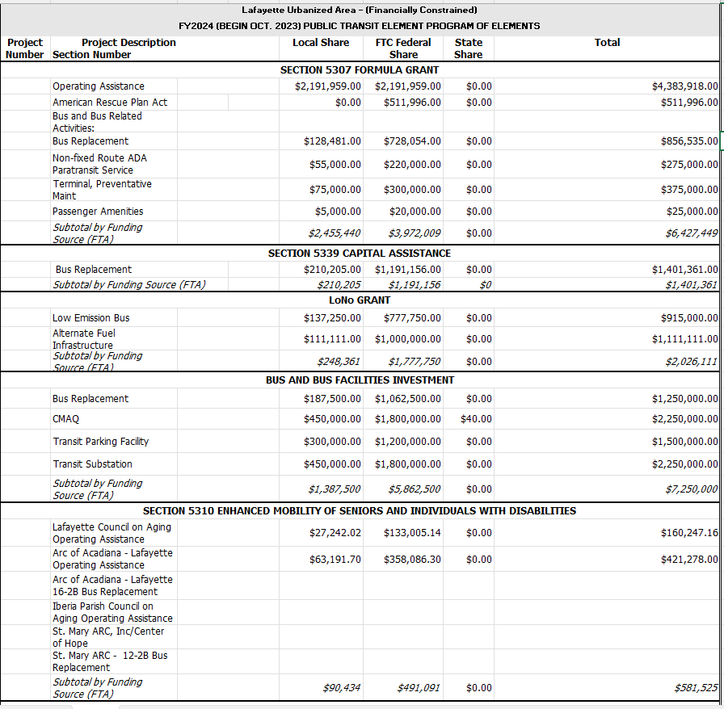
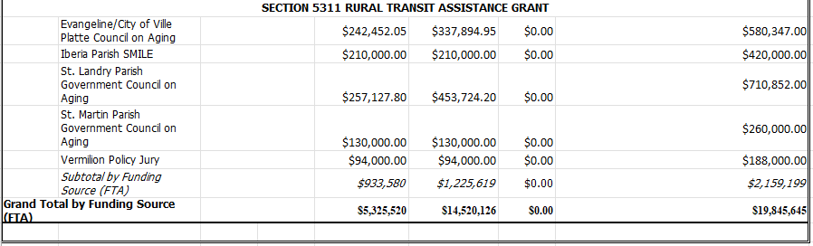
TRANSPORTATION IMPROVEMENT PROGRAM
Lafayette Urbanized Area – (Financially Constrained)
FY2025 (BEGIN OCT. 2024) PUBLIC TRANSIT ELEMENT PROGRAM OF ELEMENTS
Project Number | Project Description | Section Number | Local Share | FTC Federal Share | State Share | Total
SECTION 5307 FORMULA GRANT
 | Operating Assistance |  | $1,734,170.00 | $1,734,170.00 | $0.00 | $3,468,340.00
 | Bus and Bus Related Activities:
 | Bus Replacement |  | $250,005.00 | $1,416,695.00 | $0.00 | $1,666,700.00
 | Non-fixed Route ADA Paratransit Service |  | $56,105.50 | $224,422.00 | $0.00 | $280,527.50
 | Terminal, Preventative Maint |  | $71,407.00 | $285,628.00 | $0.00 | $357,035.00
 | Passenger Amenities |  | $5,100.50 | $20,402.00 | $0.00 | $25,502.50
 | Planning |  | $5,000.00 | $20,000.00 | $0.00 | $25,000.00
 | Subtotal by Funding Source (FTA) |  | $2,121,788.00 | $3,701,317.00 |  | $5,823,105.00
SECTION 5339 CAPITAL ASSISTANCE
 | Bus Replacement |  | $91,809.00 | $520,251.00 | $0.00 | $612,060.00
 | Subtotal by Funding Source (FTA) |  | $91,809.00 | $520,251.00 | $0.00 | $612,060.00
RURAL SECTION 5339 BUS & BUS FACILITIES
 | ADA Vehicles |  | $37,500.00 | $212,500.00 | $0.00 | $250,000.00
 | Bus Replacement |  | $277,500.00 | $1,572,500.00 | $0.00 | $1,850,000.00
 | Subtotal by Funding Source (FTA) |  | $315,000.00 | $1,785,000.00 | $0.00 | $2,100,000.00
LoNo GRANT
 | Low Emission Bus |  | $138,669.92 | $739,572.90 | $0.00 | $924,466.13
 | Alternate Fuel Infrastructure |  | $5,100.50 | $45,904.50 | $0.00 | $51,005.00
 | CNG Facility Renovation |  | $25,502.50 | $229,522.50 | $0.00 | $255,025.00
 | Subtotal by Funding Source (FTA) |  | $169,272.92 | $1,014,999.90 |  | $1,230,496.13
BUS AND BUS FACILITIES INVESTMENT
 | Bus Replacement |  | $191,268.75 | $765,075.00 | $0.00 | $956,343.75
 | CMAQ |  | $450,000.00 | $1,800,000.00 | $0.00 | $2,250,000.00
 | Transit Parking Facility |  | $306,030.00 | $1,224,120.00 | $0.00 | $1,530,150.00
 | Transit Substation |  | $459,045.00 | $1,836,180.00 | $0.00 | $2,295,225.00
 | Subtotal by Funding Source (FTA) |  | $1,406,343.75 | $5,625,375.00 |  | $7,031,718.75
SECTION 5310 ENHANCED MOBILITY OF SENIORS AND INDIVIDUALS WITH DISABILITIES
 | Lafayette Council on Aging Operating Assistance |  | $23,349.75 | $132,315.25 | $0.00 | $155,665.00
 | LARC, Inc. |  | $12,501.90 | $70,844.10 | $0.00 | $83,346.00
 | Arc of Acadiana |  | $23,349.75 | $132,315.25 | $0.00 | $155,665.00
 | Subtotal by Funding Source (FTA) |  | $59,201.40 | $335,474.60 |  | $394,676.00
SECTION 5311 RURAL TRANSIT ASSISTANCE GRANT
 | Evangeline/City of Ville Platte Council on Aging-Operating |  | $103,500.00 | $103,500.00 | $0.00 | $207,000.00
 | Iberia Parish SMILE-Operating |  | $92,000.00 | $92,000.00 | $0.00 | $184,000.00
 | St. Landry Parish Government Council on Aging-Operating |  | $57,000.00 | $57,000.00 | $0.00 | $114,000.00
 | St. Martin Parish Government Council on Aging-Operating |  | $70,500.00 | $70,500.00 | $0.00 | $141,000.00
 | St. Martin Parish Government Council on Aging-Capital |  | $12,501.90 | $70,844.10 | $0.00 | $83,346.00
 | Vermilion Policy Jury |  | $32,500.00 | $32,500.00 | $0.00 | $65,000.00
 | Subtotal by Funding Source (FTA) |  | $368,001.90 | $426,344.10 | $0.00 | $794,346.00
Grand Total by Funding Source (FTA) |  |  | $4,439,607.97 | $12,888,510.60 |  | $17,374,341.88

TRANSPORTATION IMPROVEMENT PROGRAM
Lafayette Urbanized Area – (Financially Constrained)
FY2026 (BEGIN OCT. 2025) PUBLIC TRANSIT ELEMENT PROGRAM OF ELEMENTS
Project Number | Project Description Section Number |  |  | Local Share | FTC Federal Share | State Share | Total
SECTION 5307 FORMULA GRANT
 | Operating Assistance |  |  | $1,736,000.00 | $1,736,000.00 | $0.00 | $3,472,000.00
 | Bus and Bus Related Activities:
 | Bus Replacement |  |  | $114,828.90 | $650,697.10 | $0.00 | $765,526.00
 | Non-fixed Route ADA Paratransit Service |  |  | $100,000.00 | $400,000.00 | $0.00 | $500,000.00
 | Terminal, Preventative Maintenance |  |  | $337,500.00 | $1,350,000.00 | $0.00 | $1,687,500.00
 | Passenger Amenities |  |  | $67,500.00 | $270,000.00 | $0.00 | $337,500.00
 | Planning |  |  | $6,250.00 | $25,000.00 | $0.00 | $31,250.00
 | Subtotal by Funding Source (FTA) |  |  | $2,362,079 | $4,431,697 |  | $6,793,776
SECTION 5339 CAPITAL ASSISTANCE
 | Bus Rehabilitation |  |  | $64,972.20 | $259,888.80 | $0.00 | $324,861.00
 | Subtotal by Funding Source (FTA) |  |  | $64,972 | $259,889 |  | $324,861
LoNo GRANT
 | Low Emission Bus |  |  | $140,294.10 | $794,999.90 | $0.00 | $935,294.00
 | Alternate Fuel Infrastructure |  |  | $5,555.50 | $49,999.50 | $0.00 | $55,555.00
 | CNG Facility Renovation |  |  | $27,777.70 | $249,999.30 | $0.00 | $277,777.00
 | Subtotal by Funding Source (FTA) |  |  | $173,627 | $1,094,999 |  | $1,268,626
BUS AND BUS FACILITIES INVESTMENT
 | Bus Replacement |  |  | $247,058.70 | $1,399,999.30 | $0.00 | $1,647,058.00
 | Transit Parking Facility |  |  | $312,500.00 | $1,250,000.00 | $0.00 | $1,562,500.00
 | Transit Substation |  |  | $475,000.00 | $1,900,000.00 | $0.00 | $2,375,000.00
 | Subtotal by Funding Source (FTA) |  |  | $1,034,559 | $4,549,999 |  | $5,584,558
SECTION 5310 ENHANCED MOBILITY OF SENIORS AND INDIVIDUALS WITH DISABILITIES
 | Lafayette Council on Aging Operating Assistance |  |  | $23,349.75 | $132,315.25 | $0.00 | $155,665.00
 | LARC, Inc. |  |  | $12,501.90 | $70,844.10 | $0.00 | $83,346.00
 | Arc of Acadiana |  |  | $23,349.75 | $132,315.25 | $0.00 | $155,665.00
 | Subtotal by Funding Source (FTA) |  |  | $59,201.40 | $335,474.60 |  | $394,676.00
SECTION 5311 RURAL TRANSIT ASSISTANCE GRANT
 | Evangeline/City of Ville Platte Council on Aging-Operating |  |  | $103,500.00 | $103,500.00 | $0.00 | $207,000.00
 | Iberia Parish SMILE-Operating |  |  | $92,000.00 | $92,000.00 | $0.00 | $184,000.00
 | St. Landry Parish Government Council on Aging-Operating |  |  | $57,000.00 | $57,000.00 | $0.00 | $114,000.00
 | St. Martin Parish Government Council on Aging-Operating |  |  | $70,500.00 | $70,500.00 | $0.00 | $141,000.00
 | St. Martin Parish Government Council on Aging-Capital |  |  | $12,501.90 | $70,844.10 | $0.00 | $83,346.00
 | Vermilion Policy Jury |  |  | $32,500.00 | $32,500.00 | $0.00 | $65,000.00
 | Subtotal by Funding Source (FTA) |  |  | $368,002 | $426,344 |  | $794,346
Grand Total by Funding Source (FTA) |  |  |  | $3,762,440 | $9,898,403 |  | $13,660,843

5.4 DODT LINE-ITEM ELEMENT

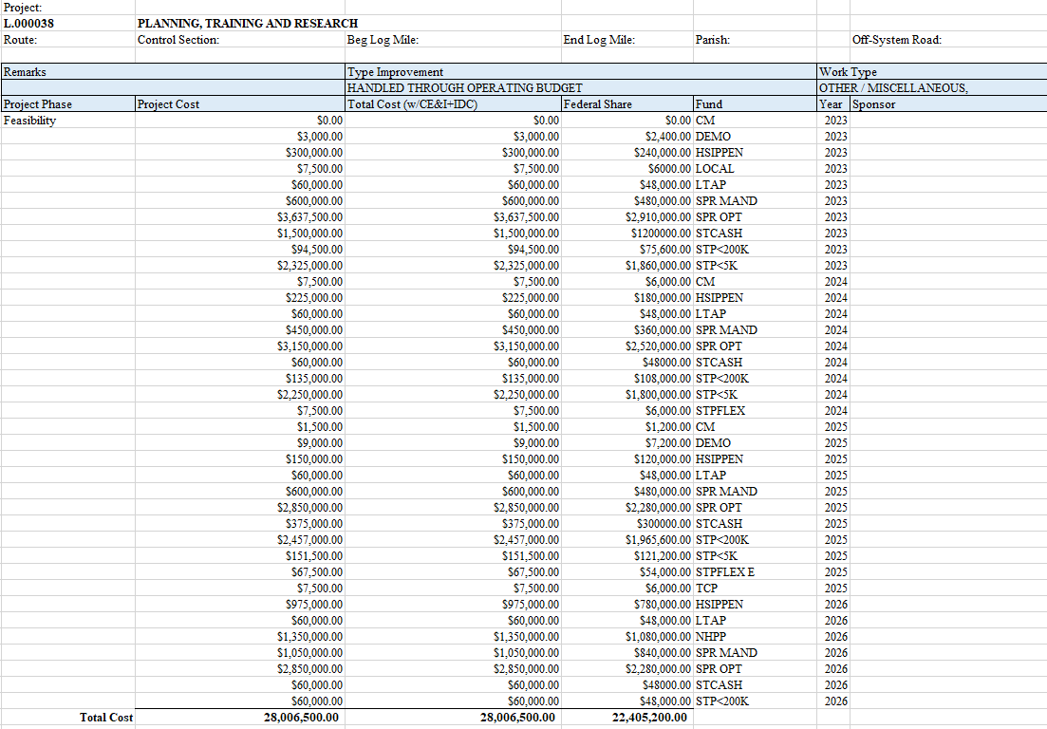
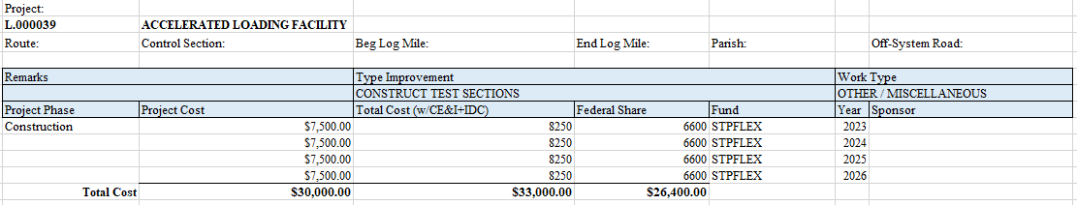

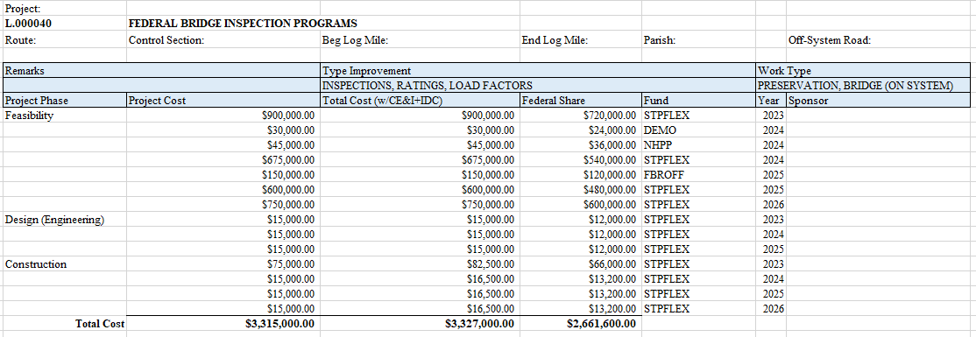
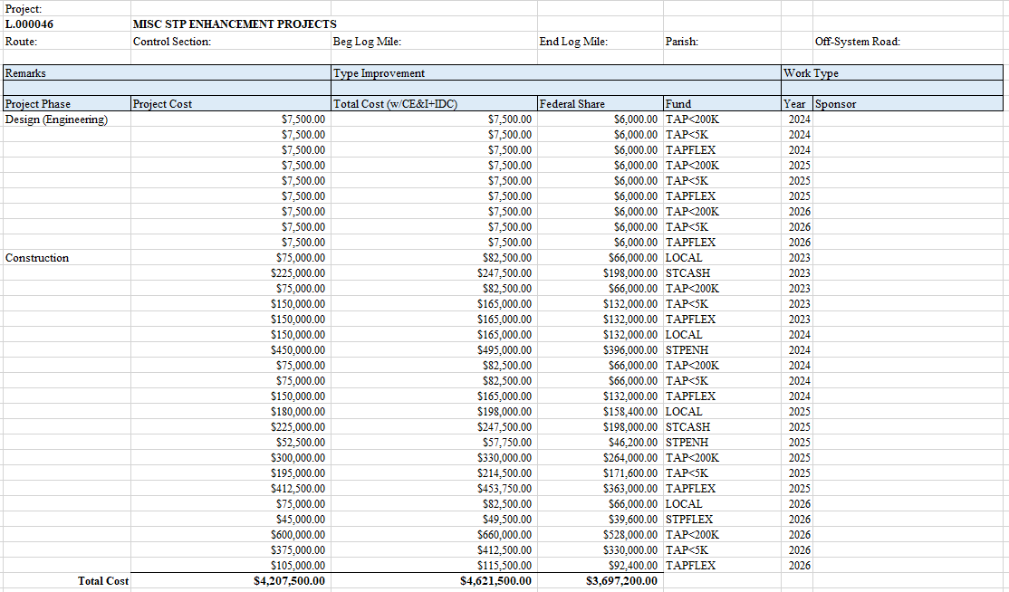

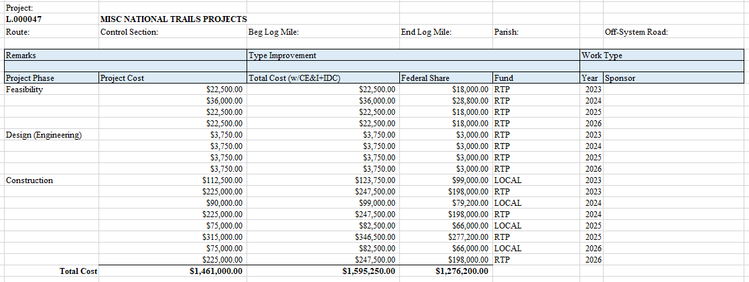

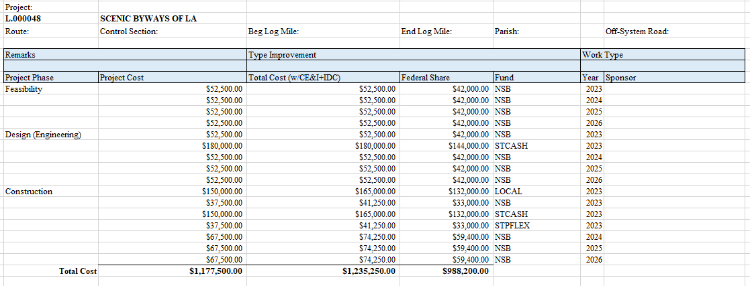

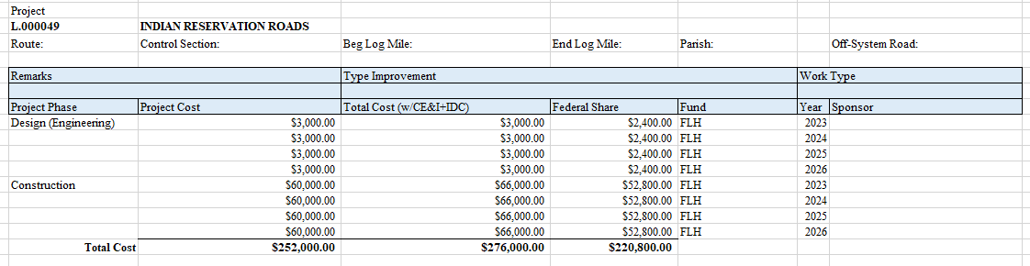

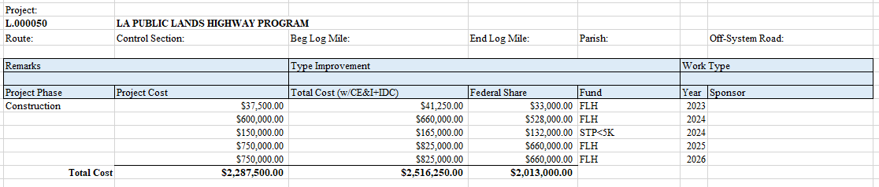

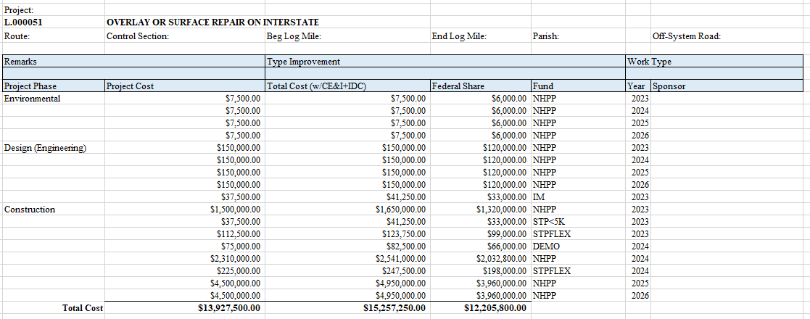

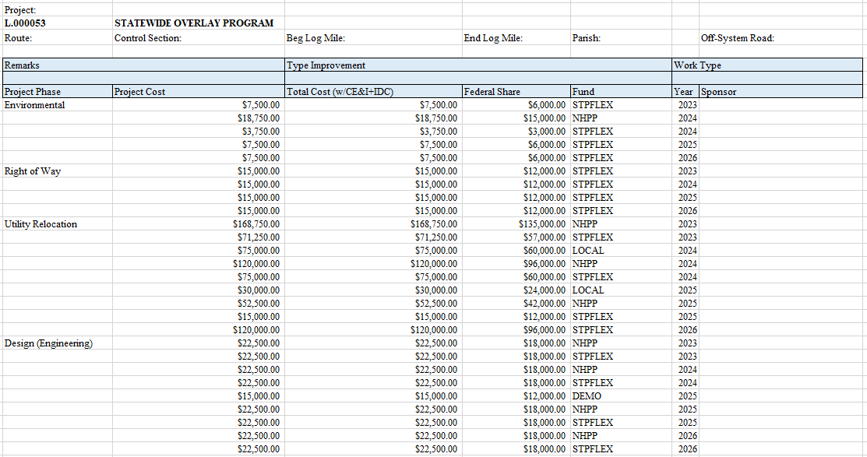

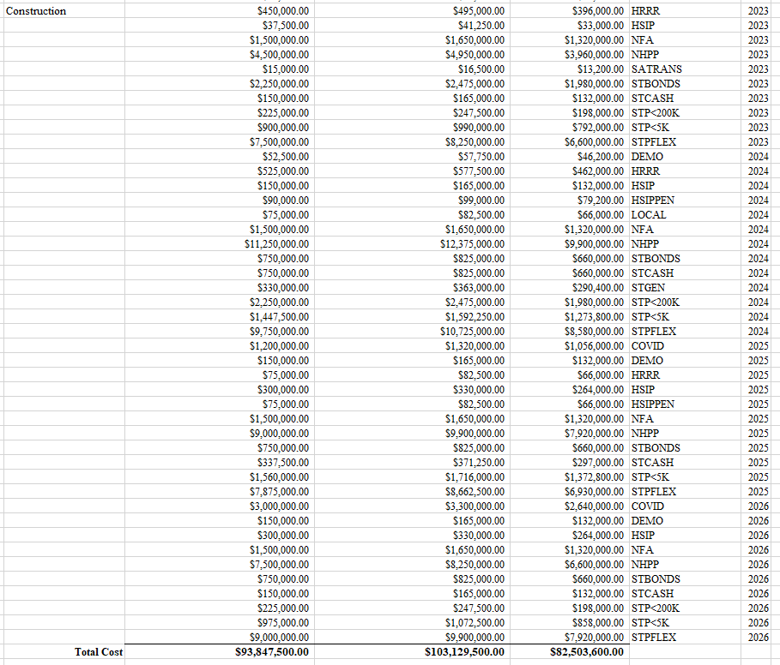

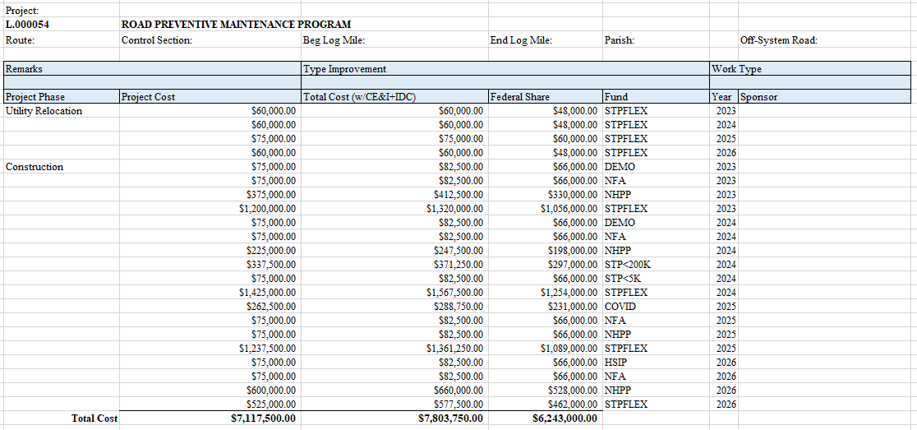

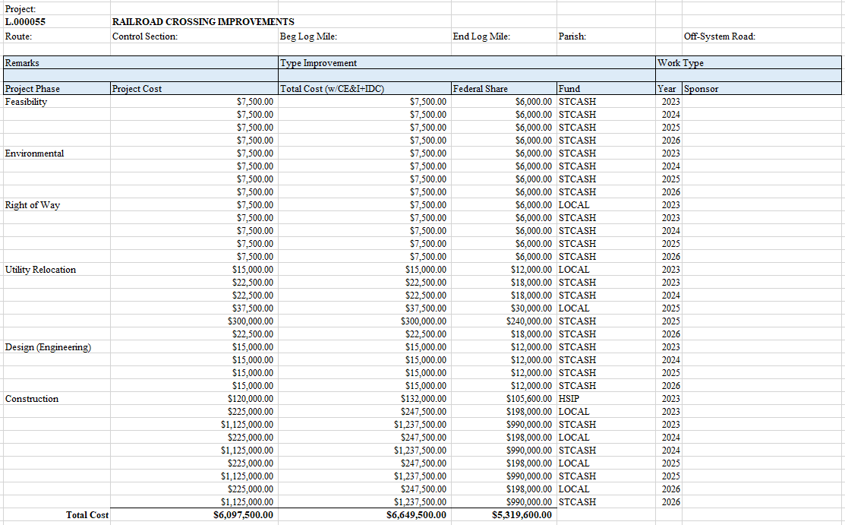

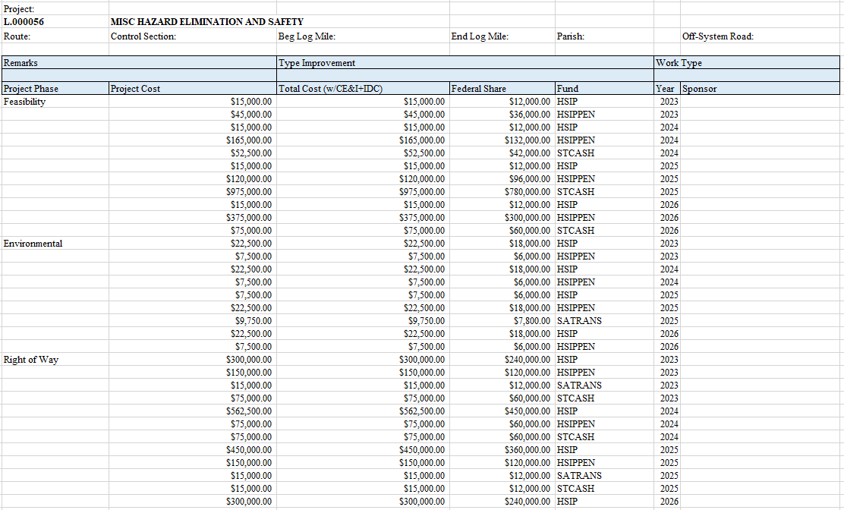

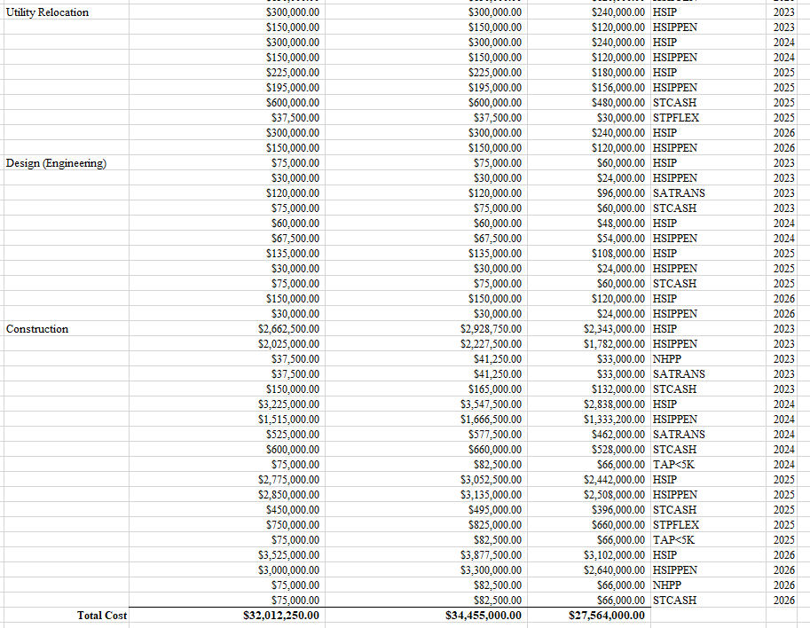
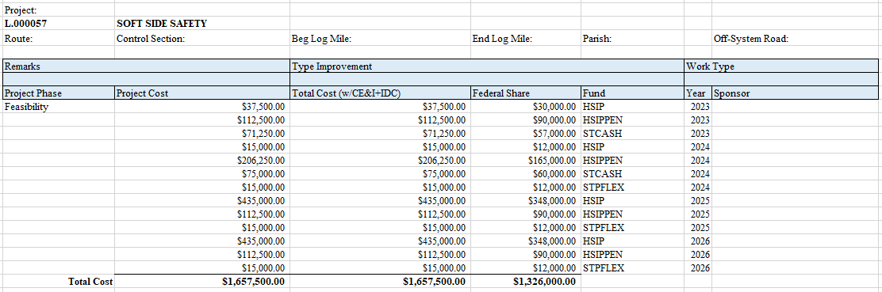

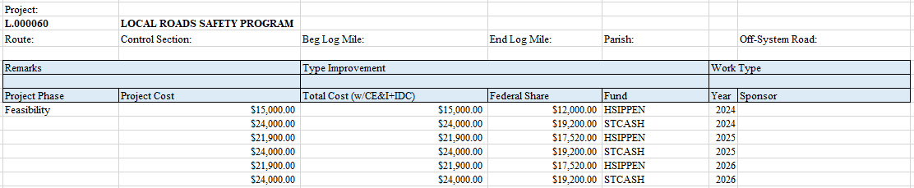
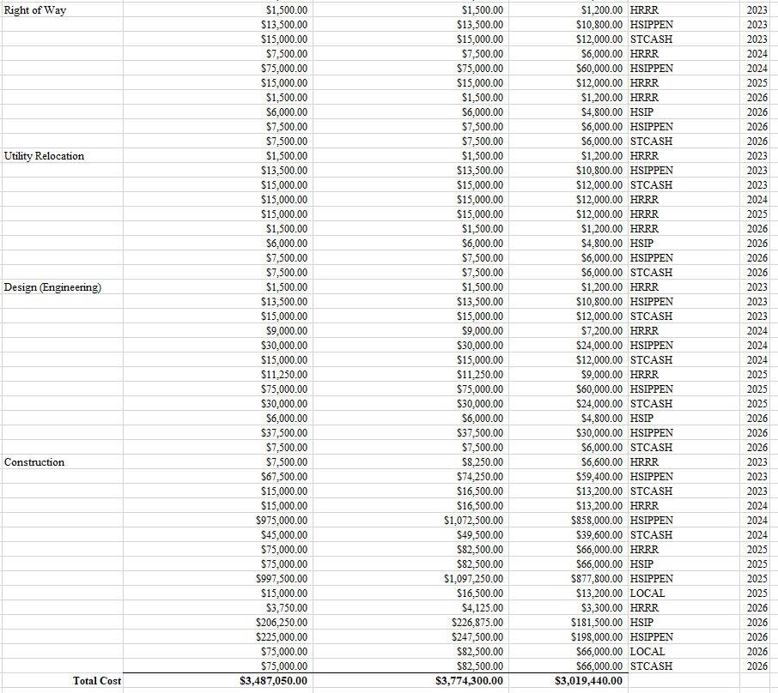

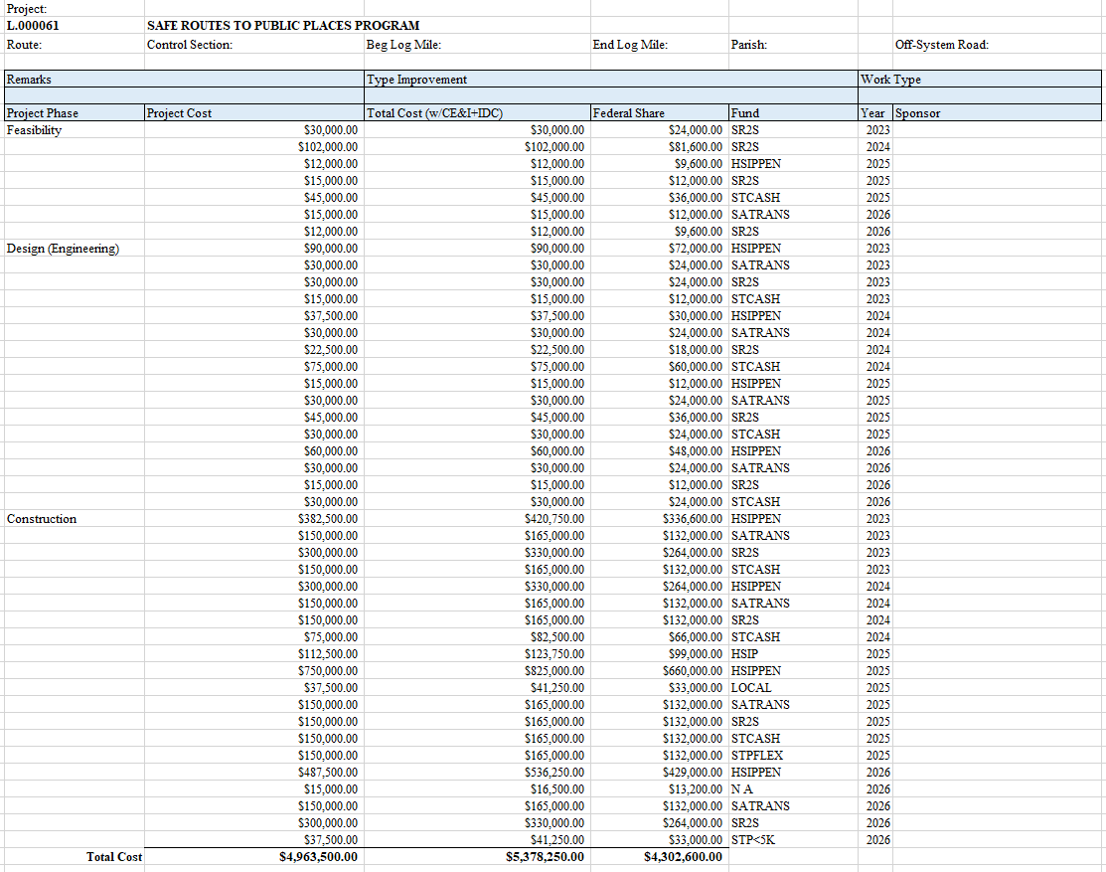

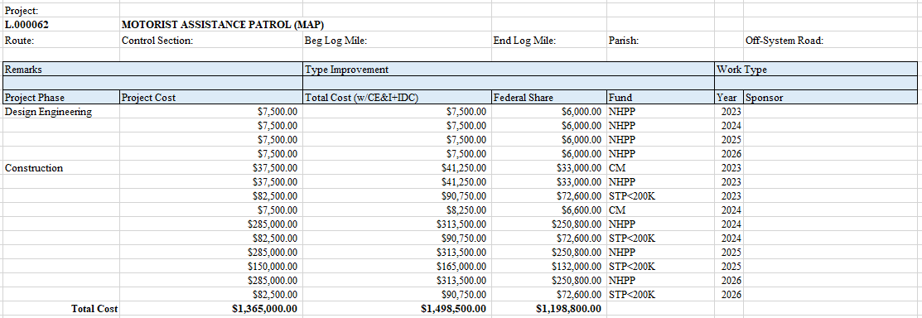

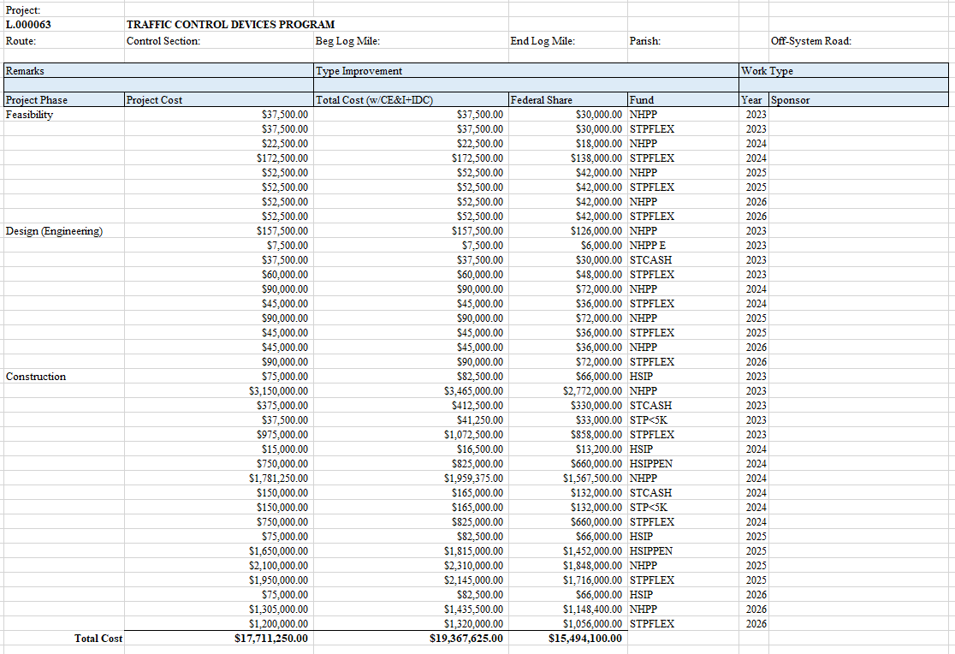

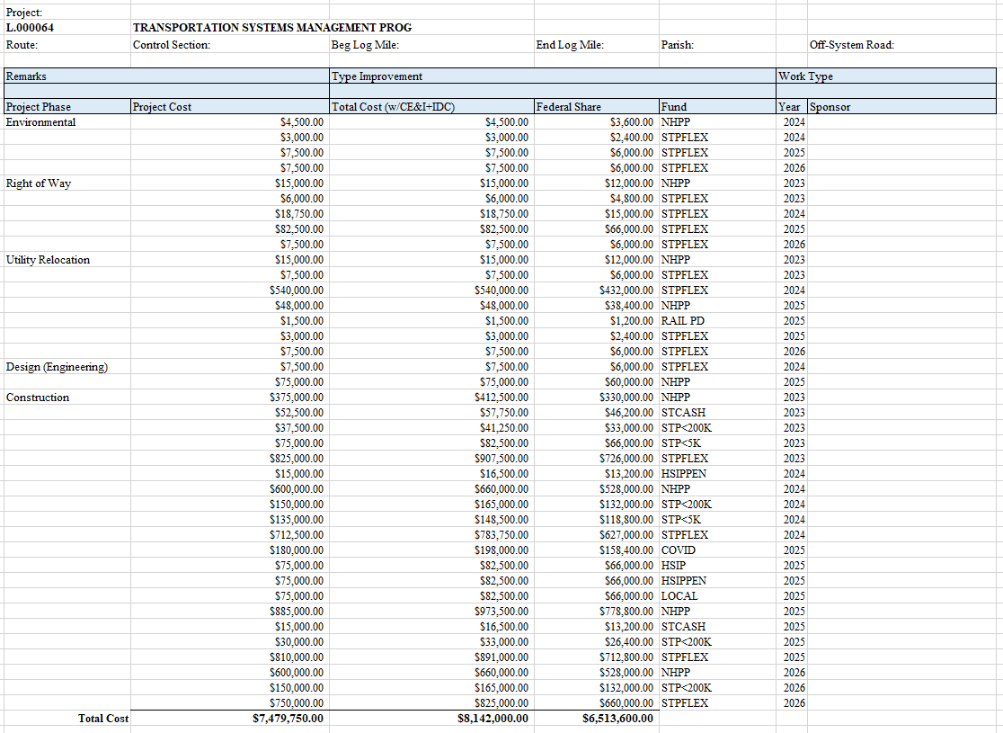

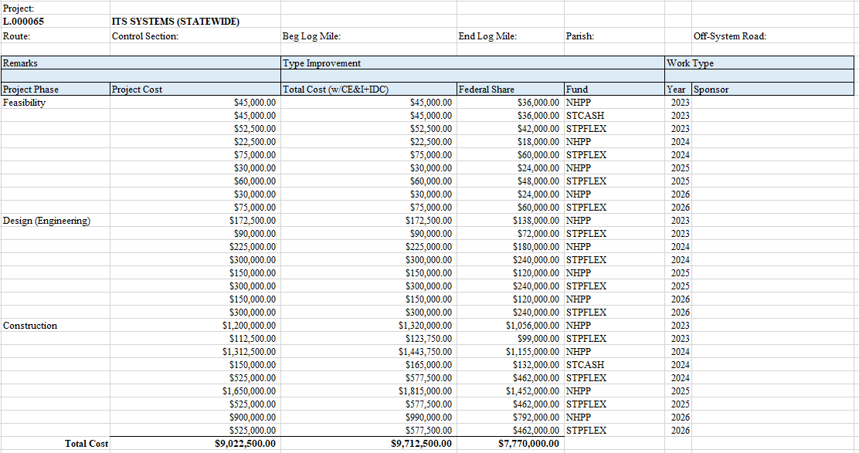

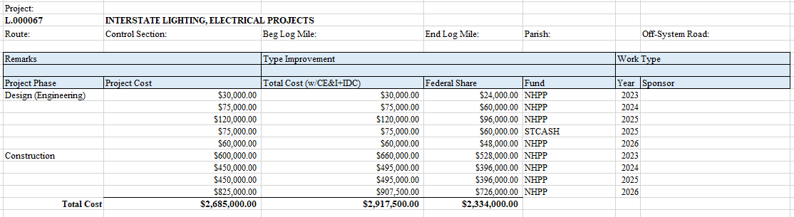

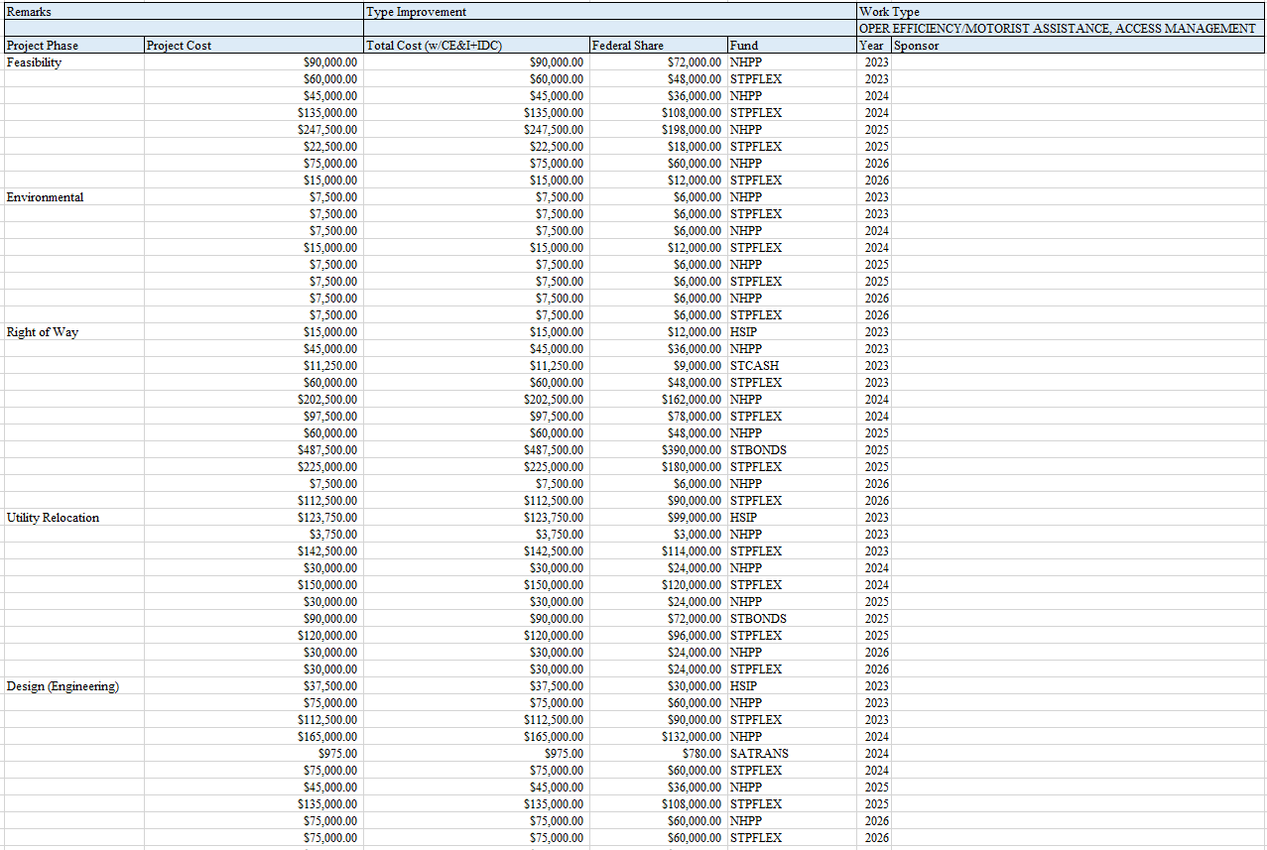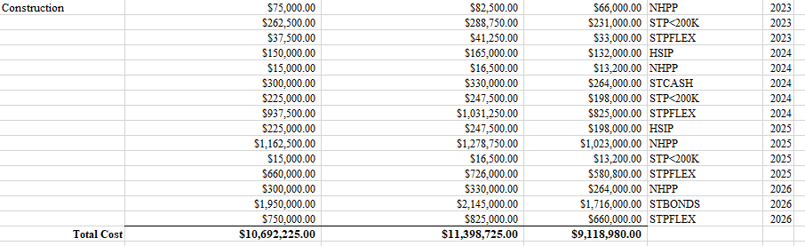

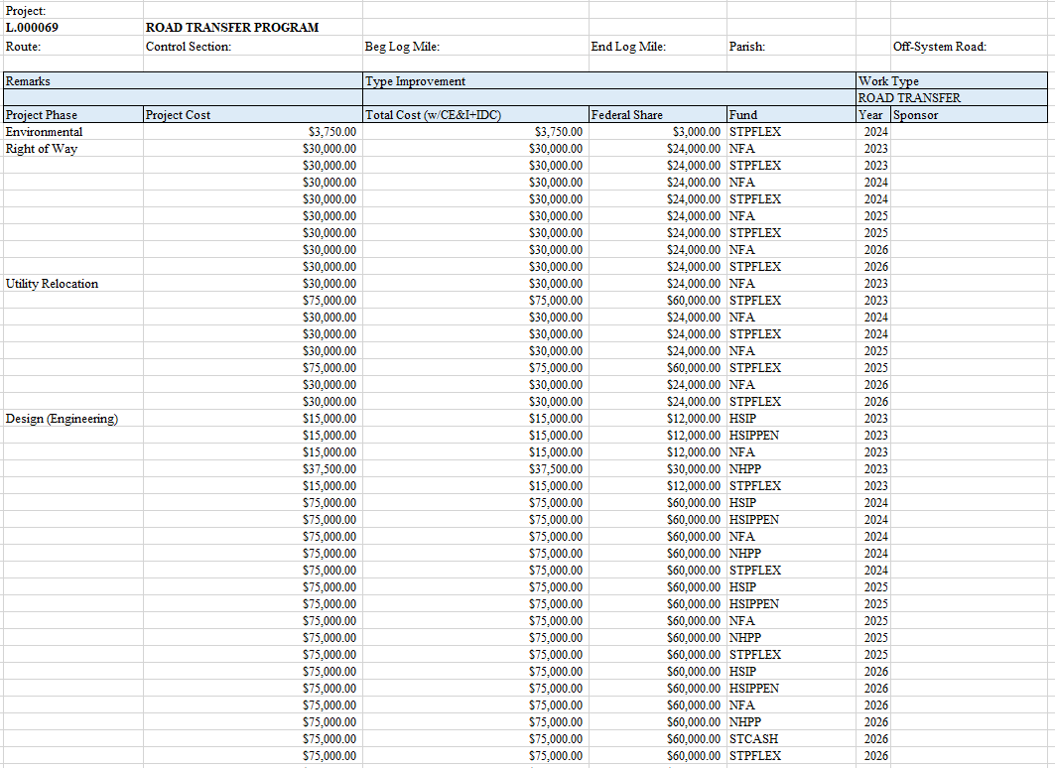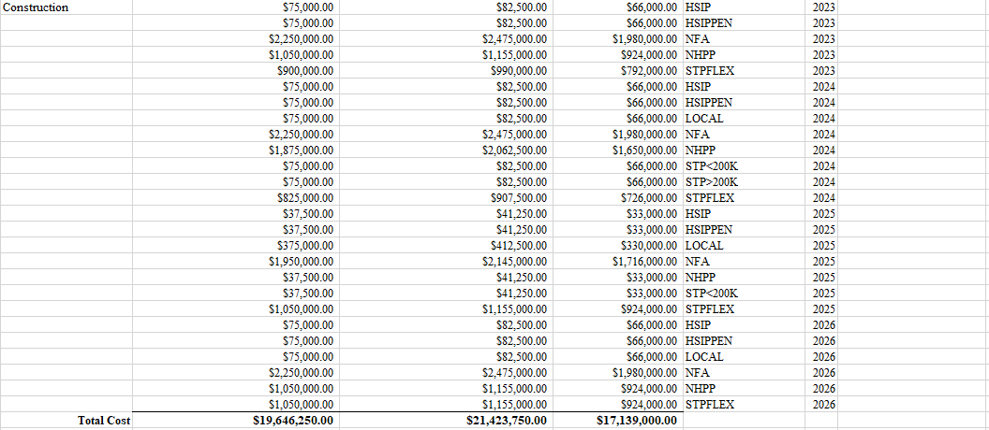

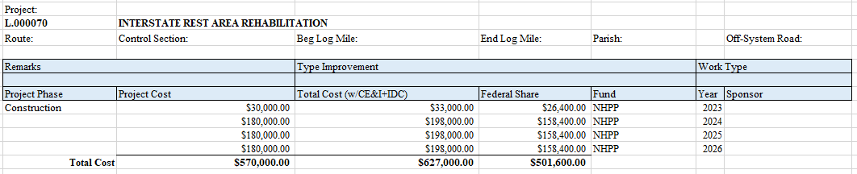
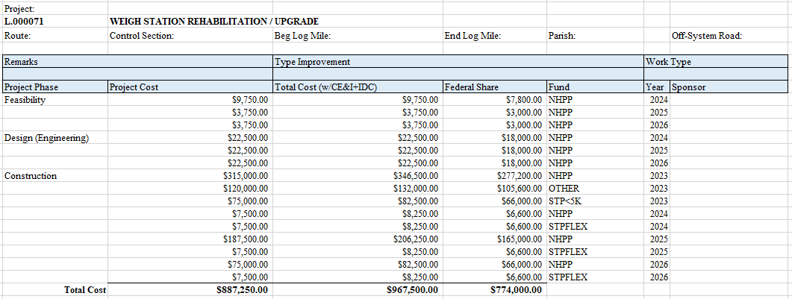
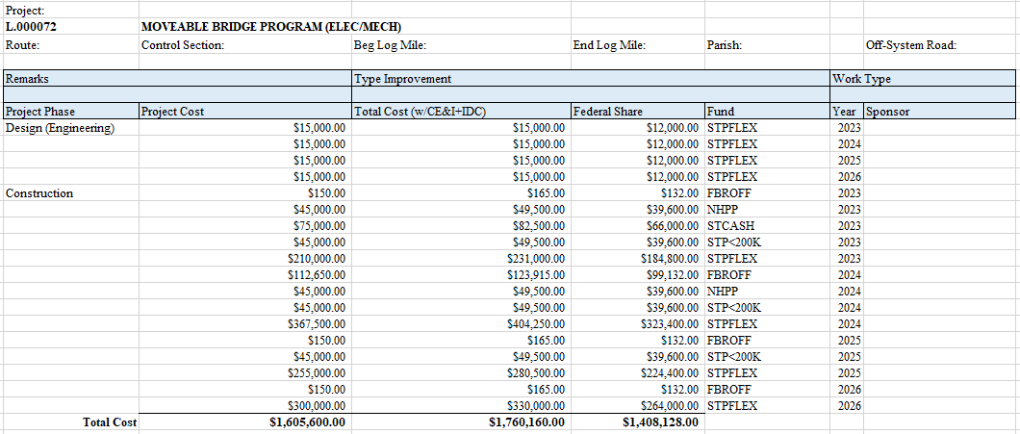
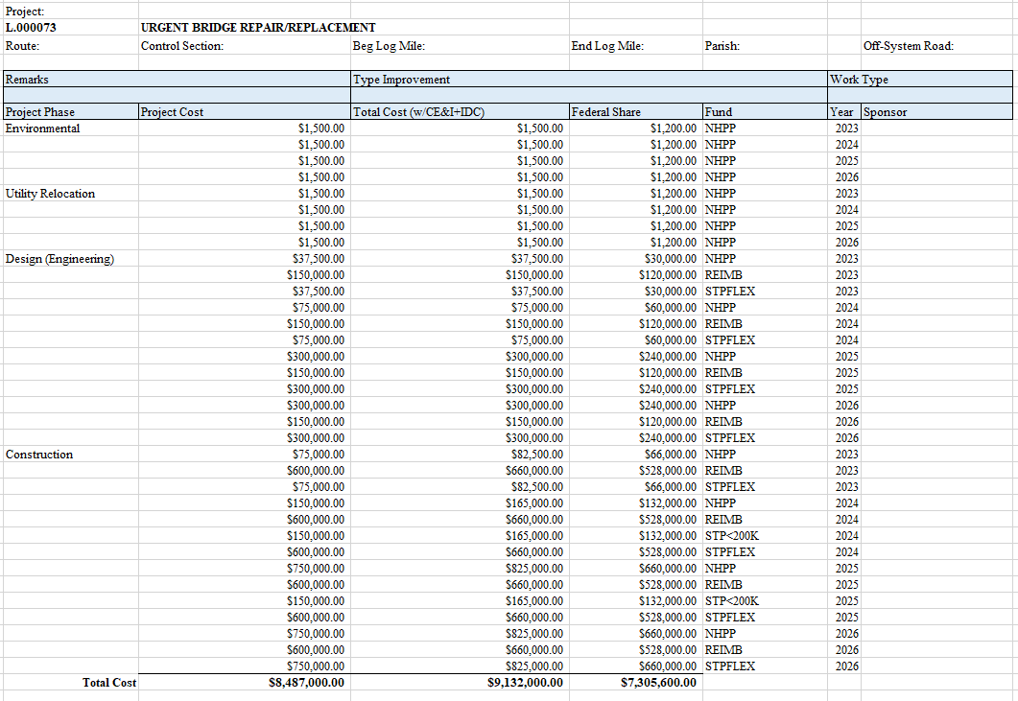
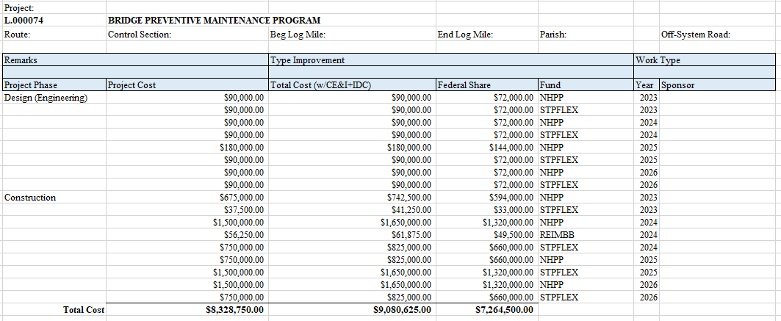
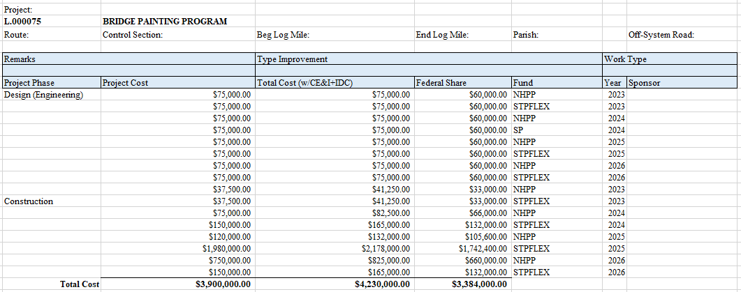

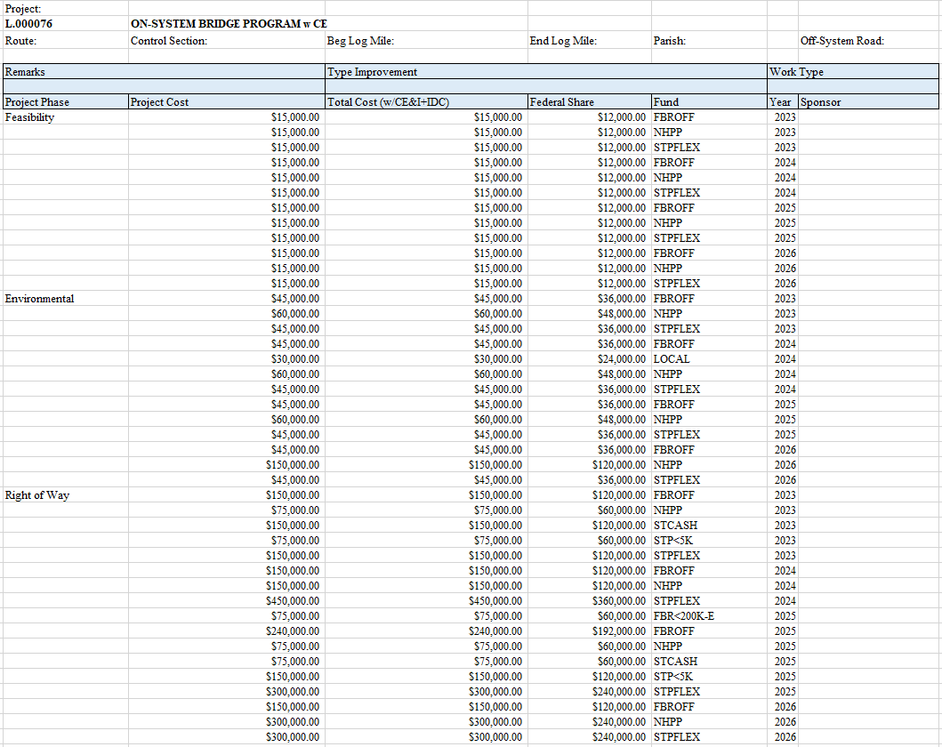
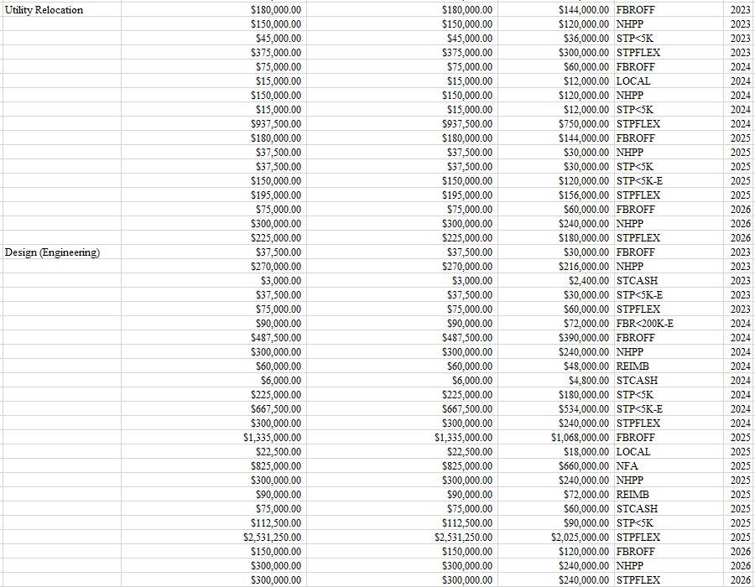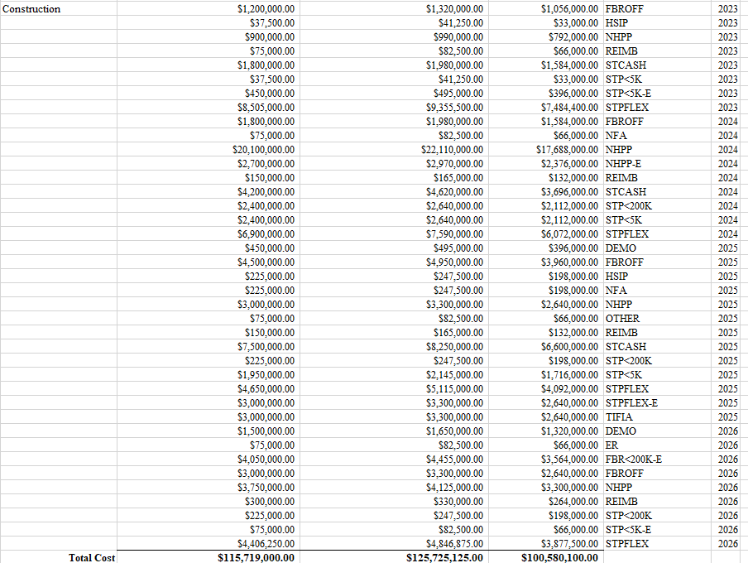

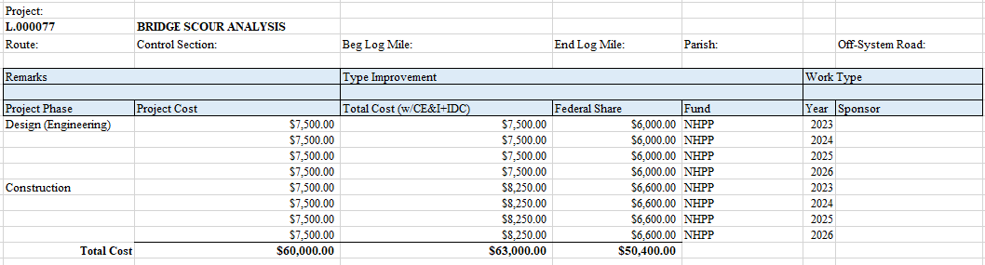

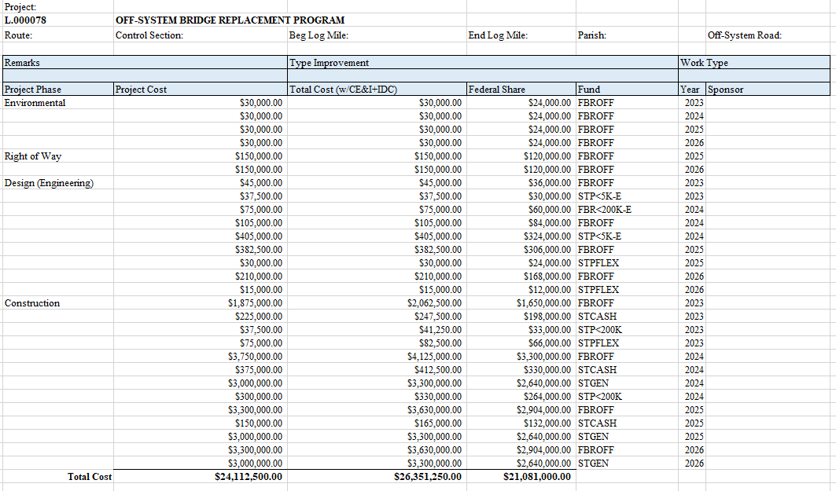

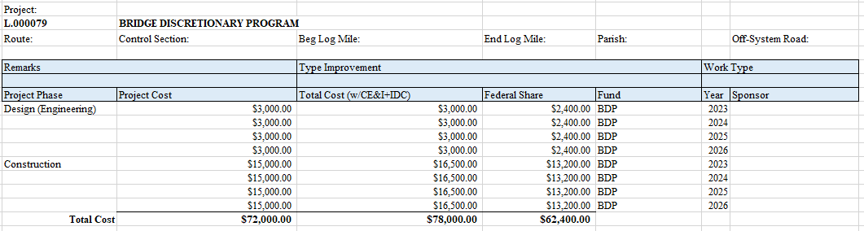

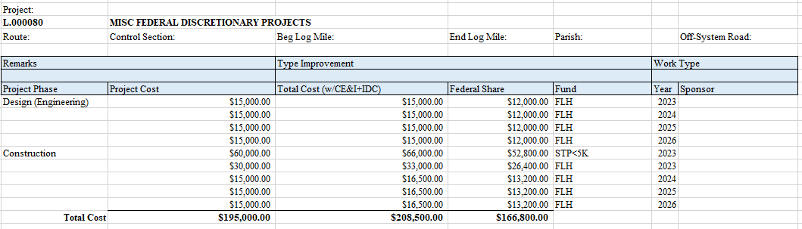

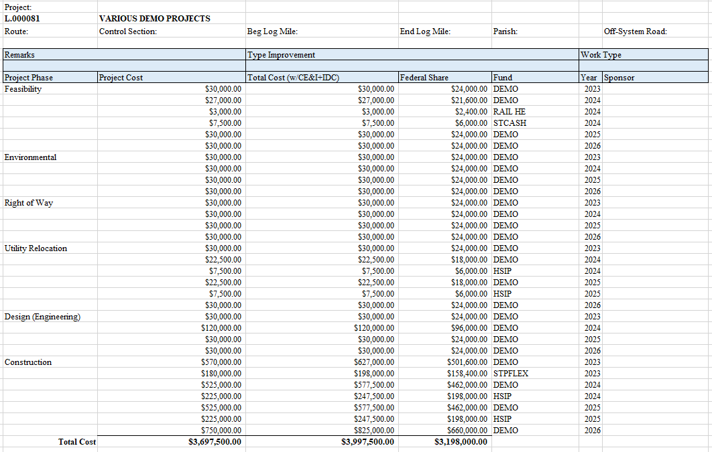

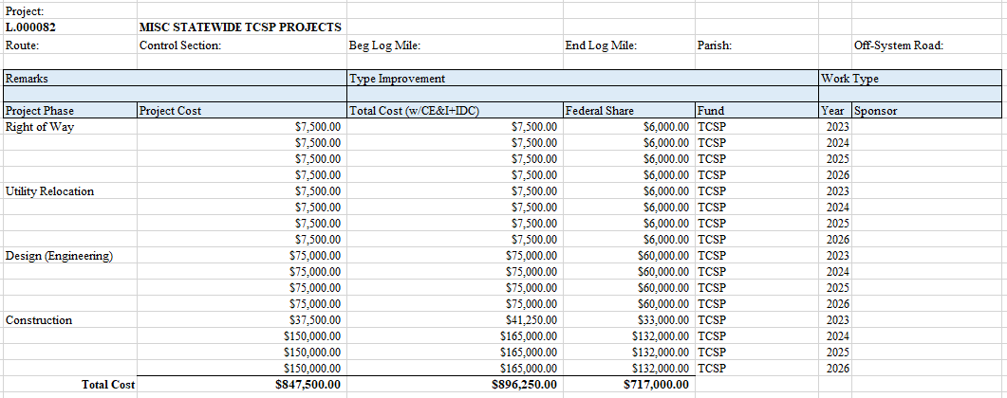

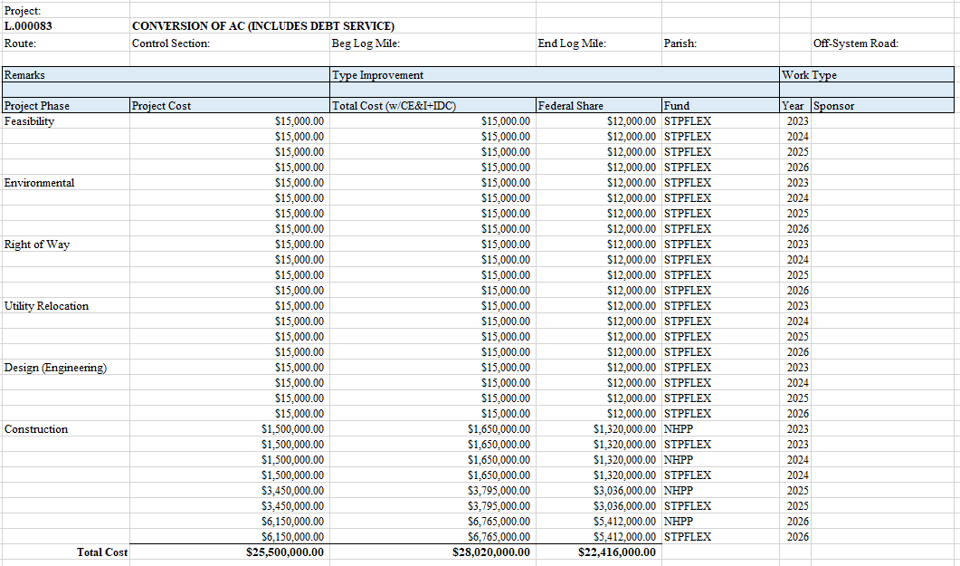

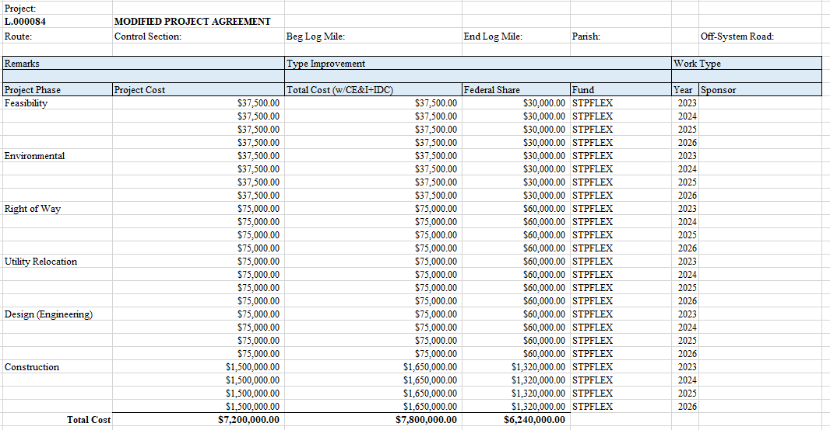
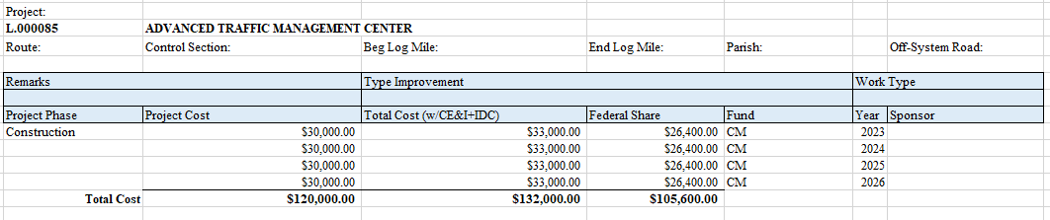
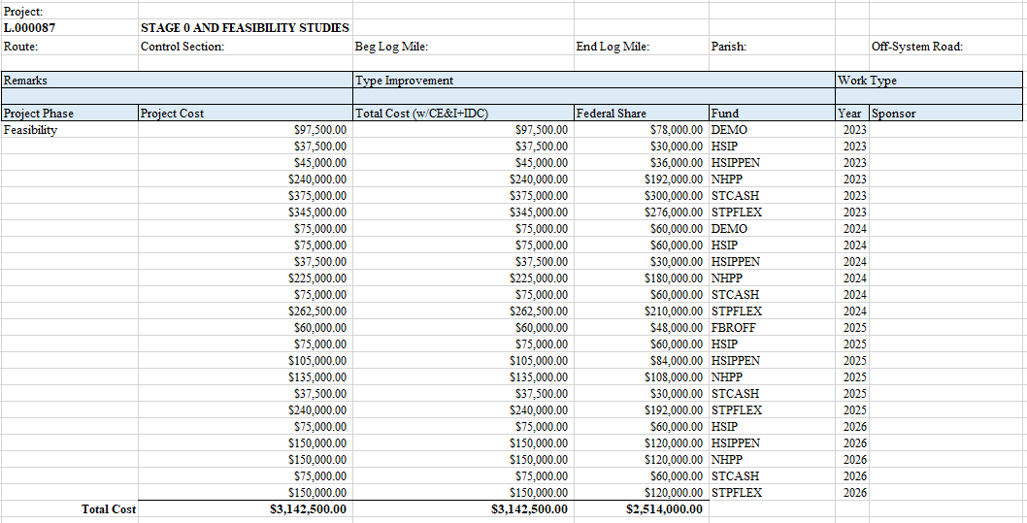
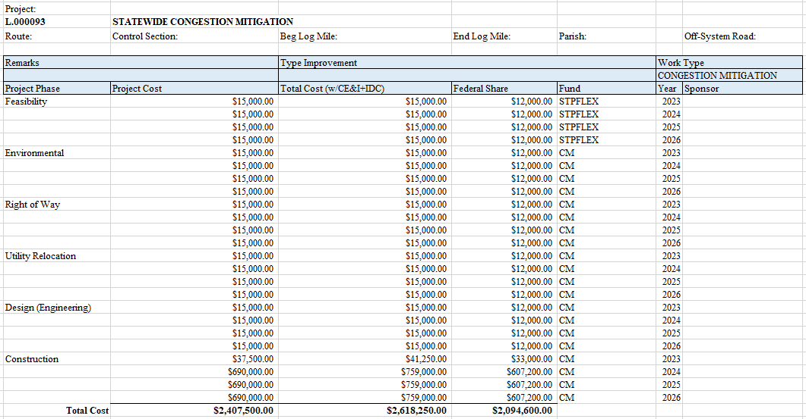
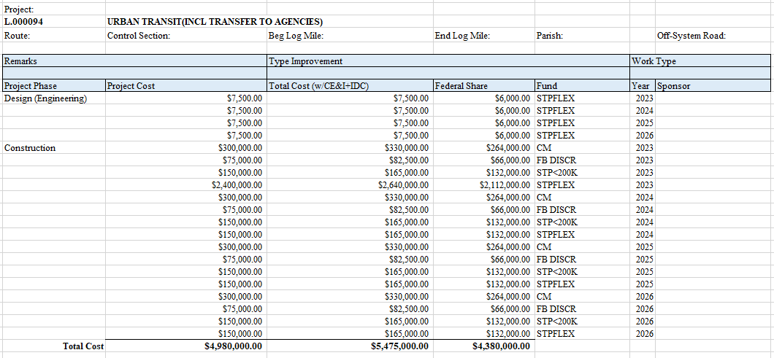
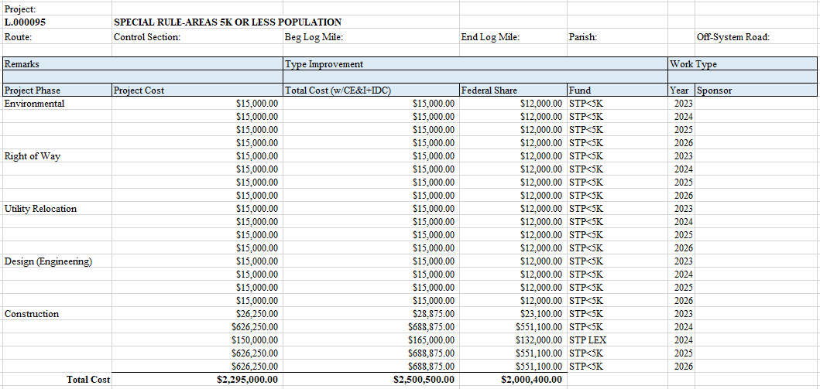
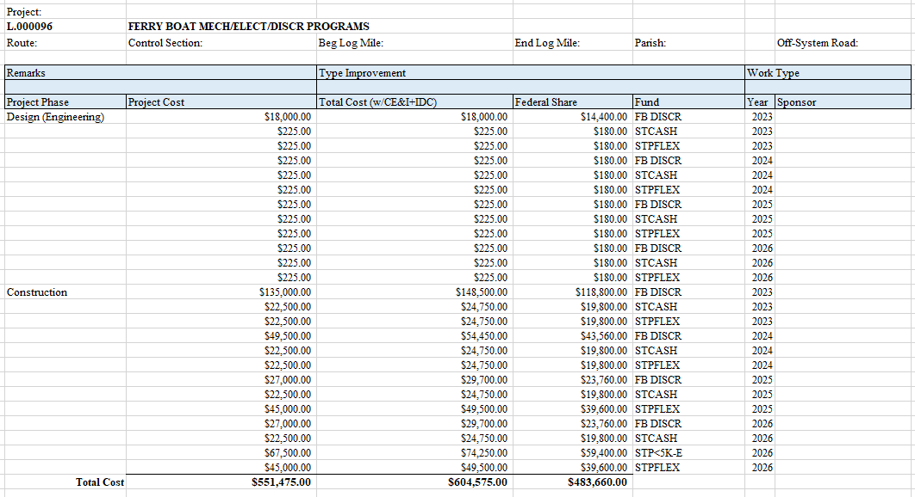

Appendix A: TPC Resolutions
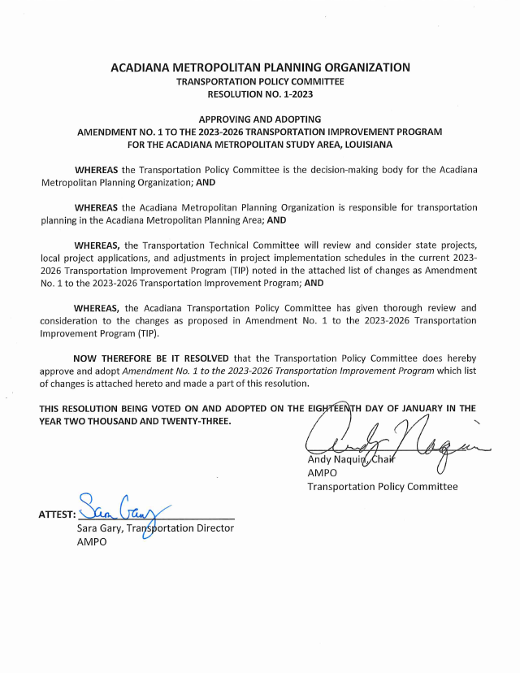

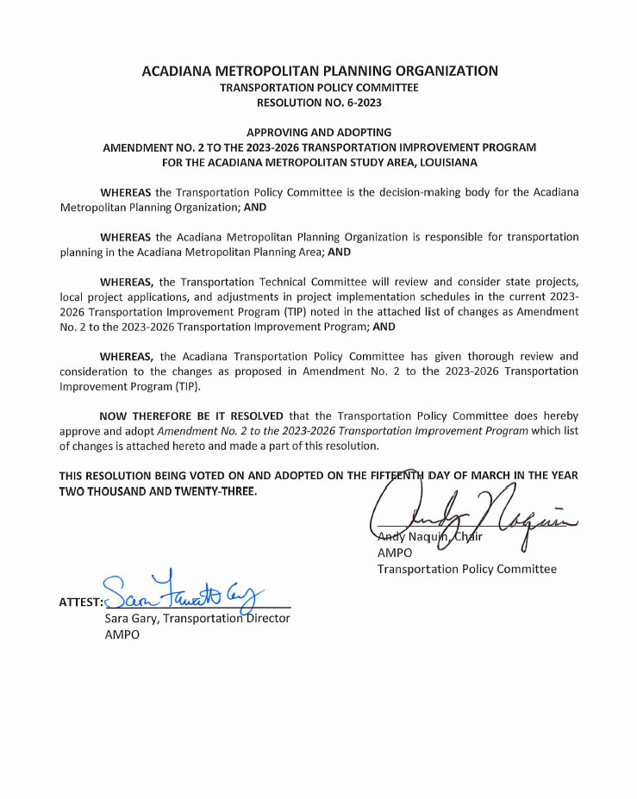

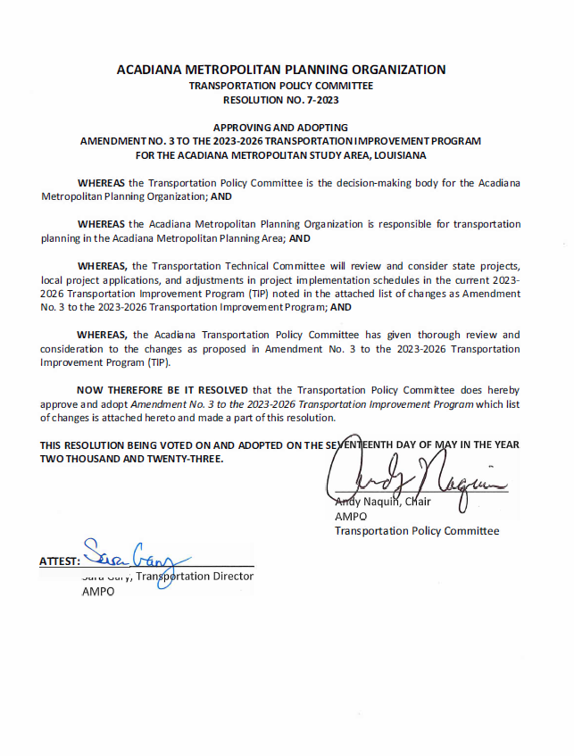

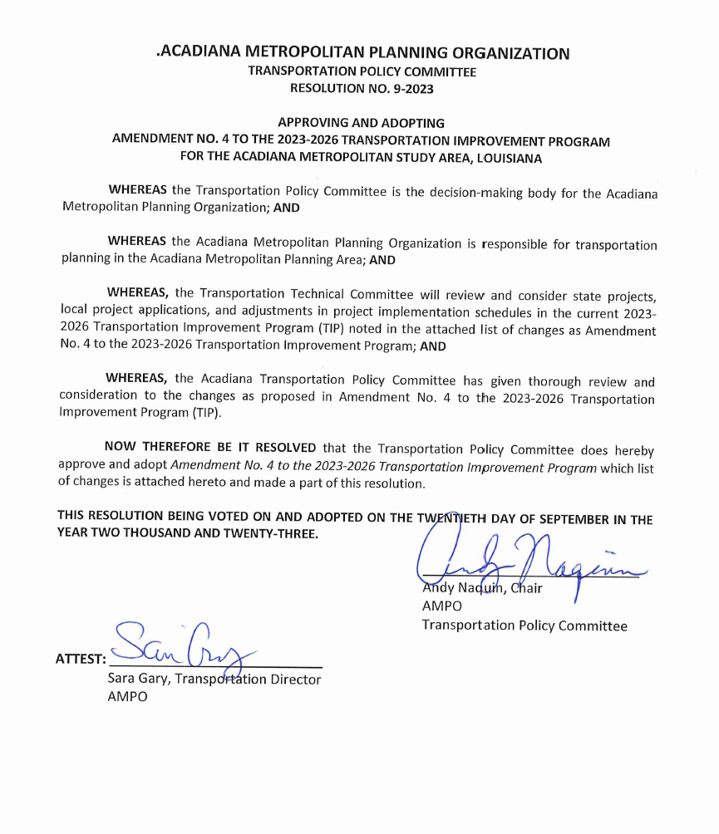

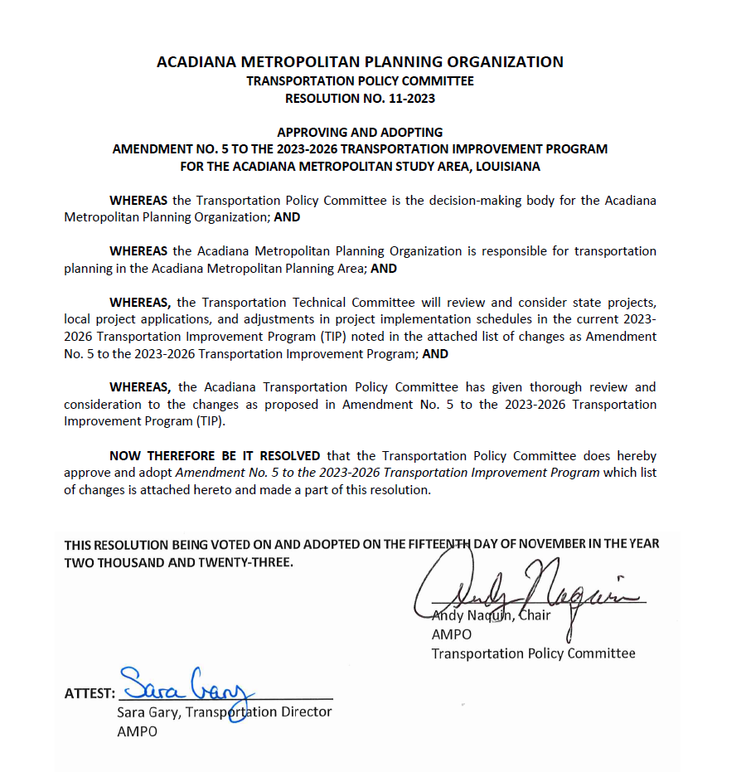

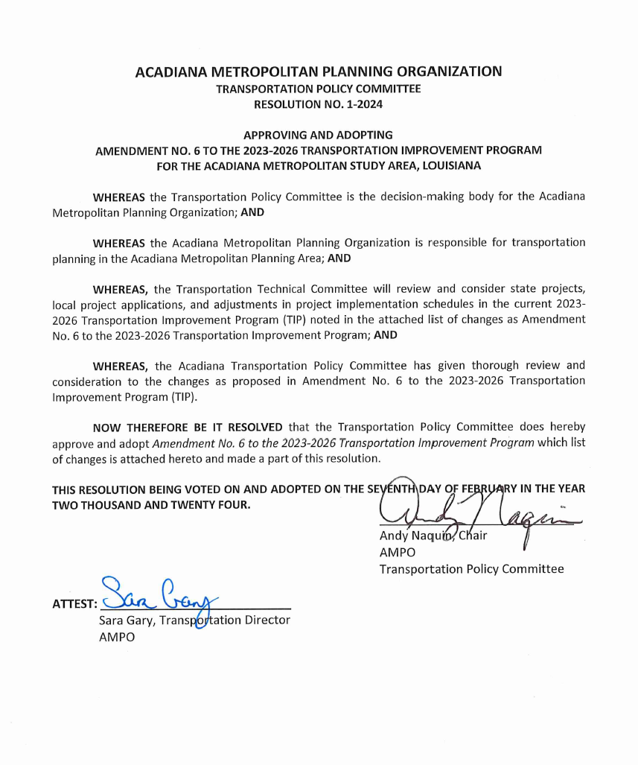

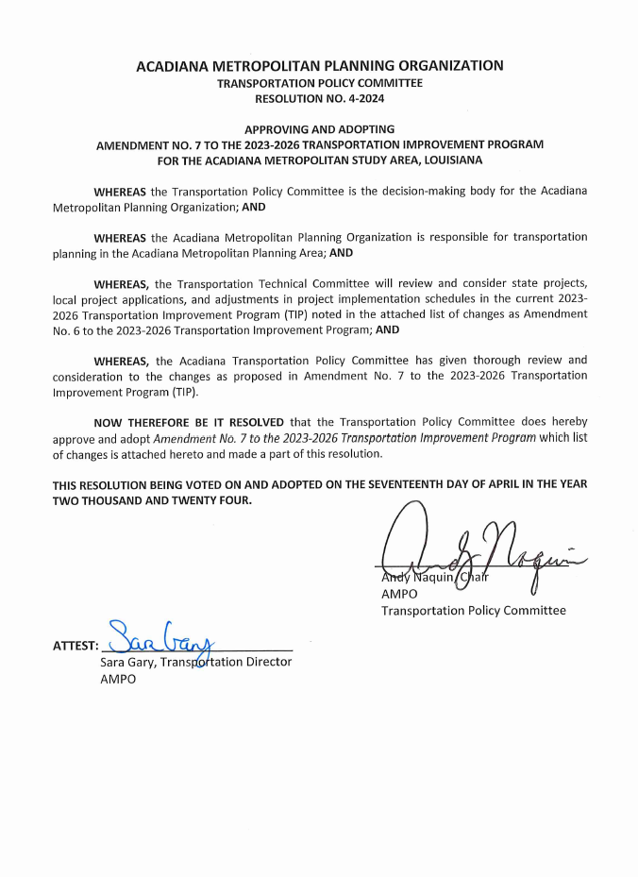

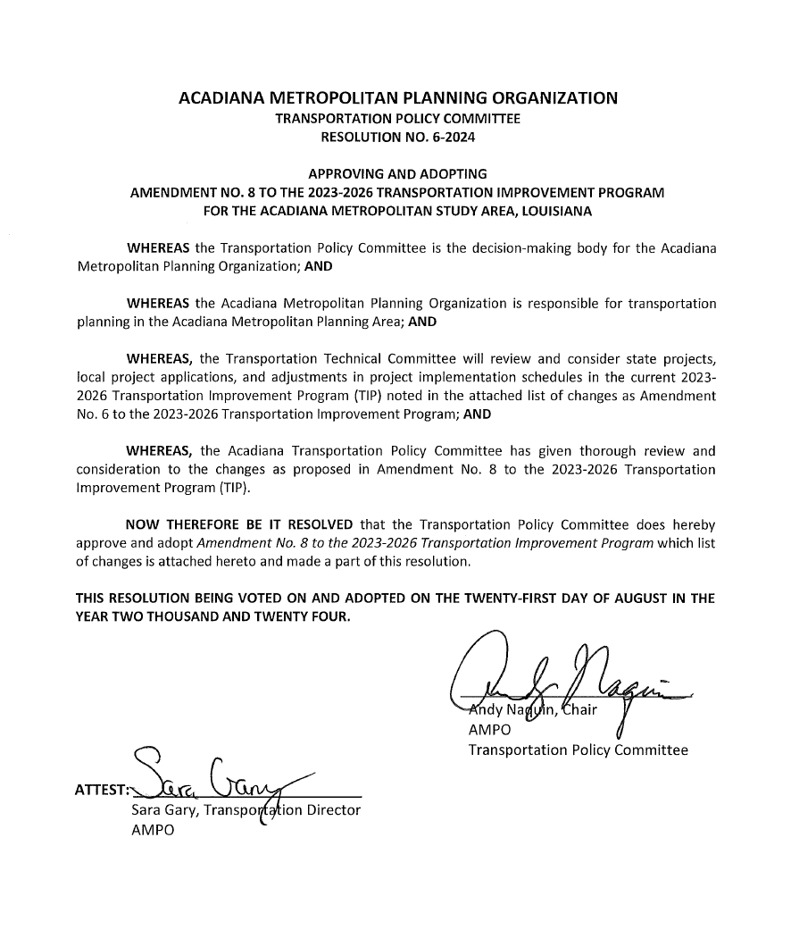
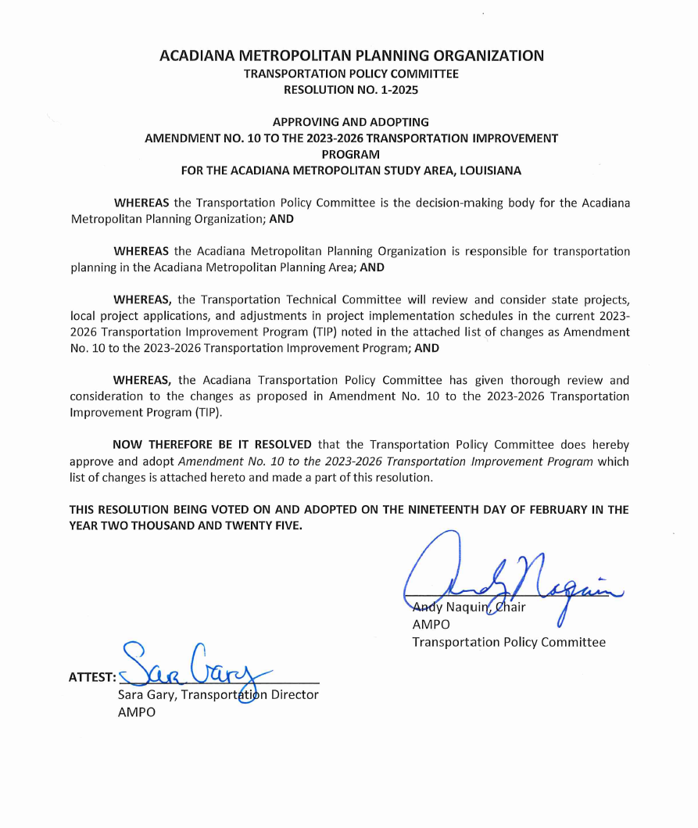

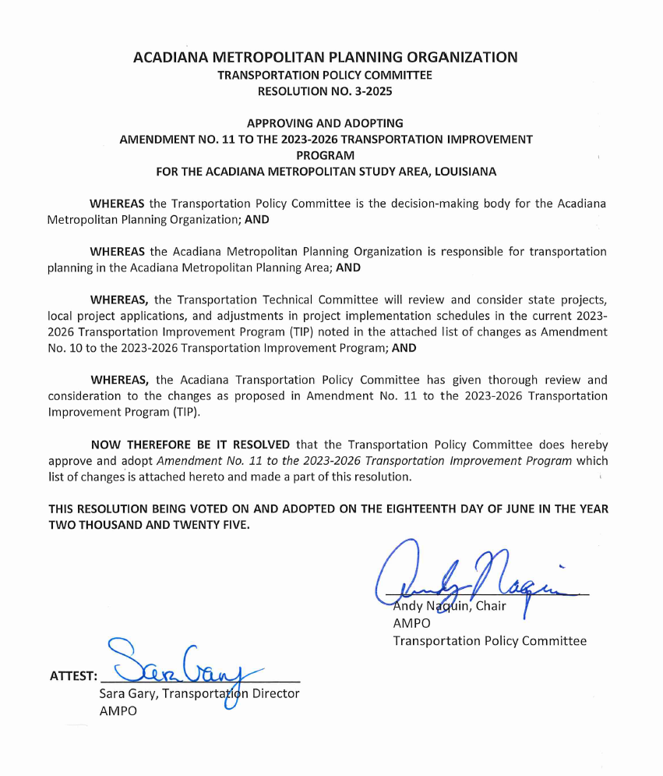

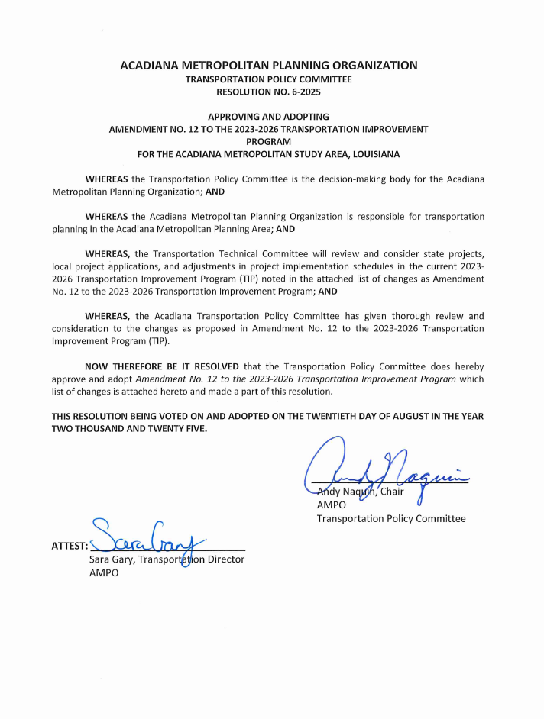

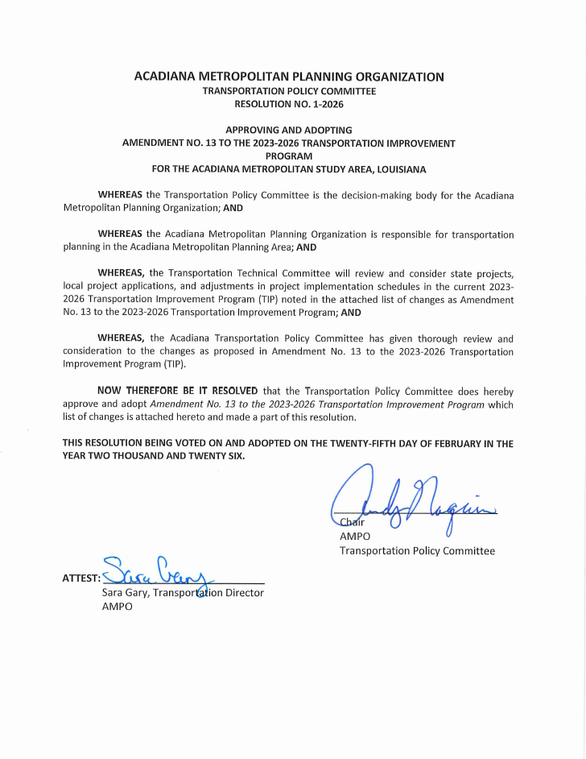

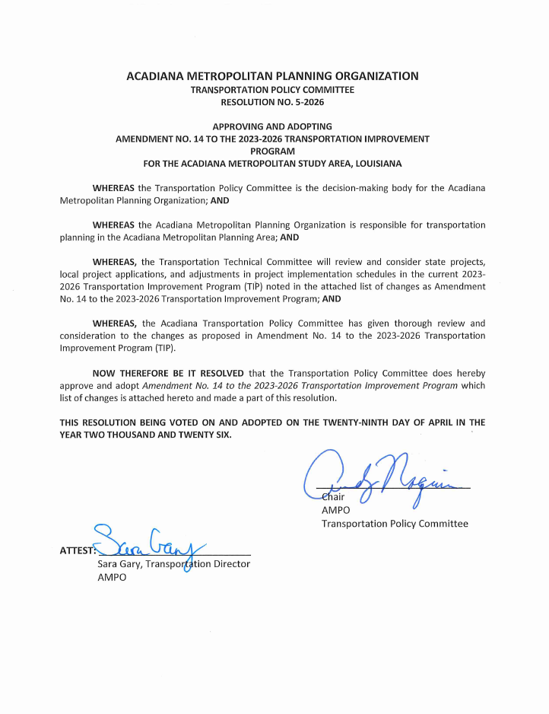

Appendix B: TPC and TTC Membership
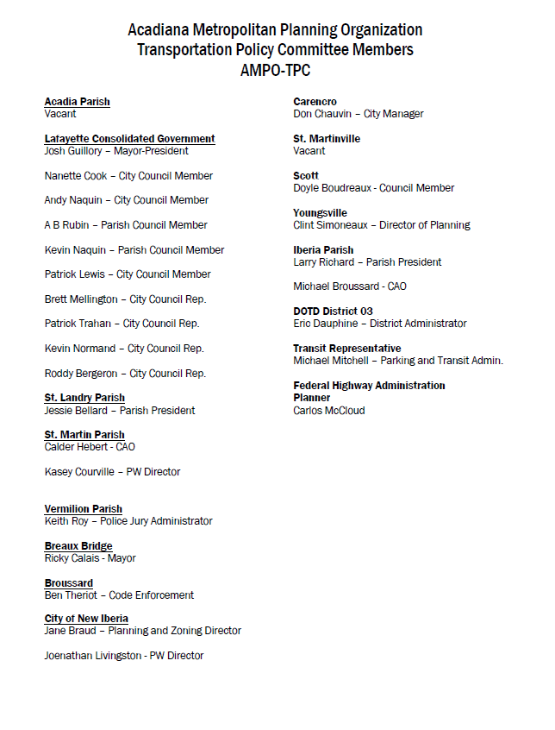
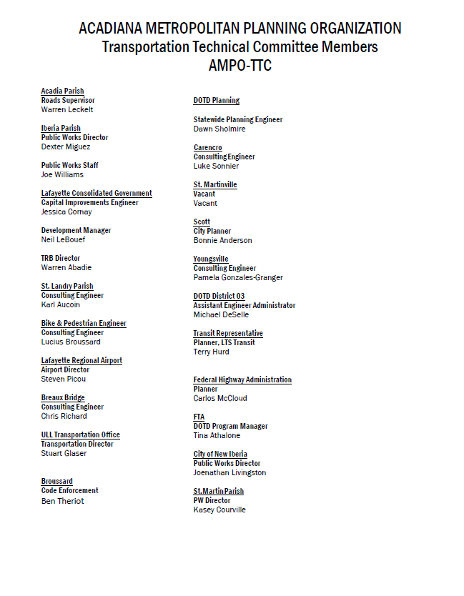

Appendix C: TIP Projects Performance Targets Connection
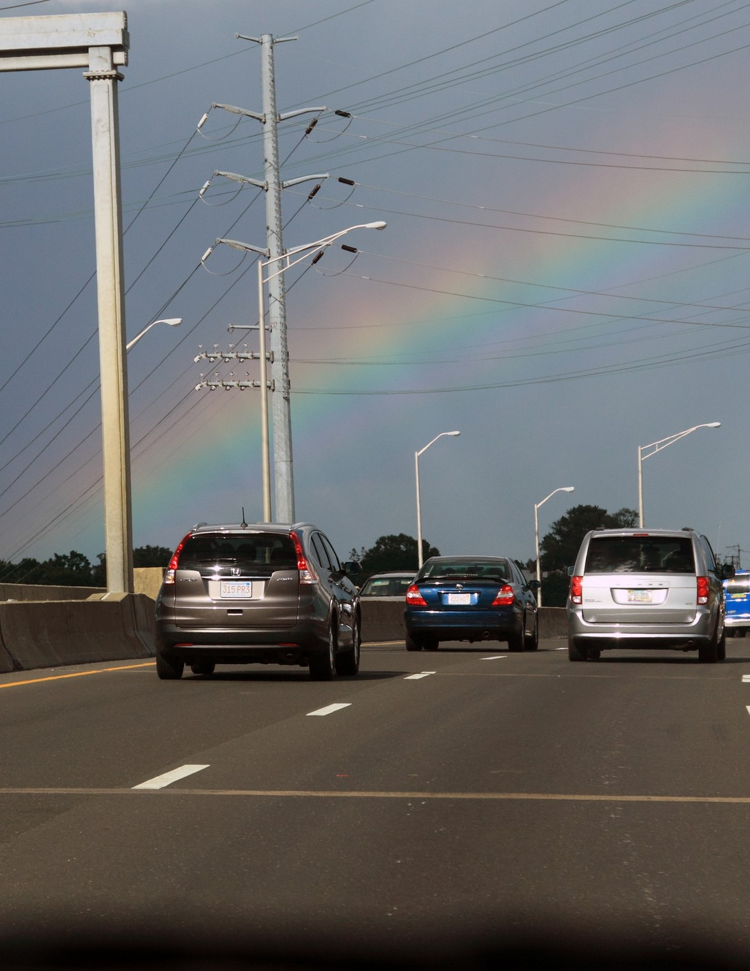


Acadiana MPO
Systems Performance Report

Table of Contents

Introduction
Highway Safety
Pavement and Bridge Condition
Travel Time Reliability Index

Transit Asset Management

Introduction

To assist MPOs and State DOTs in the transportation investment process, the Federal Transit Administration (FTA) and the Federal Highway Administration (FHWA) have established goals and objectives for MPOs and DOTs to utilize when programming federal transportation funds. The goals and objectives are enumerated through the use of performance measure targets.

The targets require a significant amount of data in order to evaluate project decisions. The Louisiana Department of Transportation and Development (DOTD) has taken on the role of collecting the data and providing assistance to the MPO to set the targets.

The first target set in 2017 was the Highway Safety targets, 5 different numbers to be revised and adopted on an annual basis. Following targets were set in Pavement and Bridge Condition (4 targets), Travel Time Reliability (3 Targets), Transit Asset Management (6 Targets), and Transit Safety (7 Targets).

The data inputs used in the project development process include crash data., both raw numbers and normalized by traffic volume, pavement and bridge condition expressed in GIS, the National Performance Management Research Data Set, and asset condition data from Lafayette Consolidated Government. The MPO uses this data when assisting local governments in project development when evaluating and prioritizing projects for inclusion in the MPO's Surface Transportation Program (STP) funding allocation.


This effort is moving the MPO towards "Performance Based Planning Process" or PBPP, where data inputs drive the project development process with the goal of achieving specific targets. The data contained in this report is part of the Long-Range Transportation Plan that guides the allocation of federal funding in the MPO area.






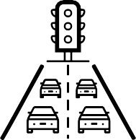

Scorecard

Category
Performance Measure
Benchmark
Status

Safety 49
Fatalities - 50
99
Serious Injuries- 98
26
Non-Motorized - 24
1.42
Fatality Rate - 1.439
2.86

Serious Injury Rate - 2.832

Pavement and Bridge Condition
20% Good Condition: Non- Interstate NHS, 2 Year
20% Poor Condition: Non- Interstate NHS, 2 Year

44%

19.2%

20% Good Condition: Non- Interstate NHS, 4 Year
20% Poor Condition: Non- Interstate NHS, 4 Year

Scorecard
Category Performance Measure Benchmark* Target Status

Travel Time Reliability
Travel Time Reliability for Interstate (% of Person Miles Reliable): 90%
Travel Time Reliability for Non Interstate (% of Person Miles Reliable): 90%
100%

94.5%

1.12

Transit Asset Management
Truck reliability index for Interstate (Level of Truck Travel time Reliability): 1.3
Percent of Buses
within a particular asset class that have met or exceeded their Useful Life Benchmark , 2020-2023: 25% in 2019 to 15% in 2023
Percent of Cutaway buses
within a particular asset class that have met or exceeded their Useful Life Benchmark , 2020-2023: 25% in 2019 to 10% in 2023
Percent of Service Automobiles
within a particular asset class that have met or exceeded their Useful Life Benchmark , 2020-2023: 15% in 2019 to 10% in 2023
Percent of Administration facilities
with a condition rating below 3.0 on the FTA Transit Economic Requirements Model (TERM) Scale, 2020 - 2023: 10% in 2019 to 1% in 2023
Percent of Maintenance facilities
with a condition rating below 3.0 on the FTA Transit Economic Requirements Model (TERM) Scale, 2020 - 2023: 20% in 2019 to 5% in 2023
Percent of Passenger facilities
with a condition rating below 3.0 on the FTA Transit Economic Requirements Model (TERM) Scale, 2020 - 2023: 10% in 2019 to 1% in 2023

Scorecard
Category Performance Measure Benchmark* Target Status

Transit Safety
Transit Fatalities - 0

Rate of Transit Fatalities - 0
Transit Serious Injuries - 0
Rate of Transit Serious Injuries - 0
Safety Events - 0
Rate of Safety Events -
0
Mean Distance between Major Mechanical Failure - 88,376

Meeting or Exceeding Target
No Progress or Data for Target
Not Meeting Target

Highway Safety

Since 2018, the MPO has set a 1% reduction in overall fatal and serious injuries and non-motorized fatal and serious injuries, and a 1% reduction in the rate of fatal and serious injuries, utilizing a tool provided by LA-DOTD that allows MPOs to set their own targets for the MPO area.

Every year, the data is reviewed and presented to the MPO Committees on the progress towards reaching these safety targets. in 2018, 2019, and 2020, the MPO met the target for Fatalities and Fatality Rate. The MPO did not meet the goal for Non-Motorized, Serious Injury or Serious Injury Rate for 2018 and 2019.

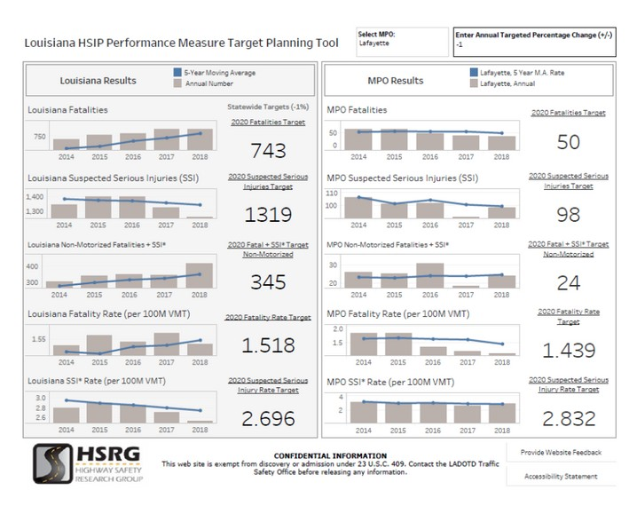
Fatalities

The number of fatalities in the subject year
Serious Injuries

The number of serious injuries in the subject year
Non-Motorized

The number of fatal and serious injuries of non- motorized roadway users in the subject year
Fatality Rate

The rate of fatalities per 100 Million Vehicle Miles Traveled in the subject year

Serious Injury Rate

The rate of serious injuries per 100 Million Vehicle Miles Traveled in the subject year

2021 Highway Safety Targets

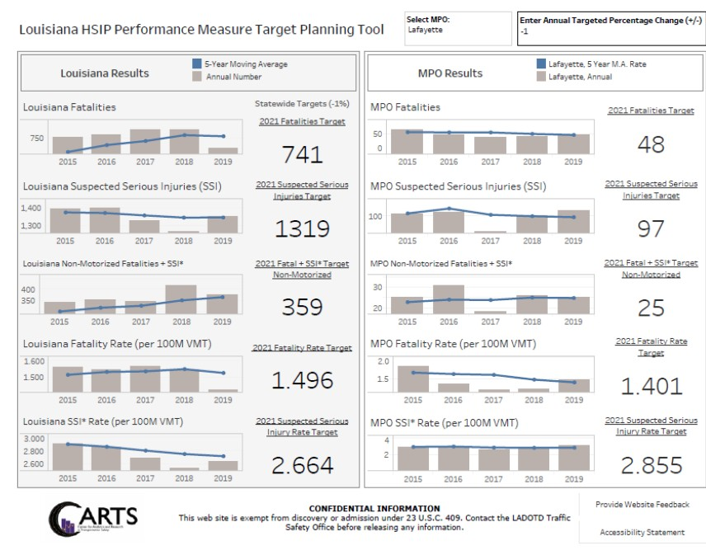

Highway Safety Projects and Countermeasure Implementation

The MPO reviews all STP projects for integration of Proven Safety Countermeasures, such as signal light timing to facilitate pedestrian crossings and walkways. The MPO and LA DOTD also has several projects with safety as the primary purpose of the project.



Source: FHWA

Reduced Left-Turn Conflict Intersections

H.010353 US 167: ACCESS MANAGEMENT
(LFT TURN LNS) is an Highway Safety Improvement Program project to close and convert two-way crossovers along US 167 to restricted crossing signalized U-turns.



Source: FHWA


Source: FHWA

Roundabouts
H.012792 LA. 675 @ Airport Rd. Roundabout, H.012869 LA 182 (UNIV) @ LA 723
(RENAUD), Mills @ LA 98 Roundabout, La 93 @ Eraste Landry Roundabout, and LA 724/Fieldspan @ Landry Roundabout are projects to convert stop-controlled intersections to roundabouts.

Rumble Strips and Curve Delineation
H..013823 DIST.03 RUMBLESTRIPS (SOUTH and H.012800 LOCAL ROADS
HFST (LAFAYETTE) are two projects in the MPO area addressing roadway departure crashes on the local and state roadway system.

Pavement and Bridge Condition

The MPO is required to monitor the pavement and bridge for the National Highway System roadways in the MPO area. The MPO chose to adopt the LA DOTD targets for pavement and bridge condition. The targets are the percentage of roadways and bridges in Good and Poor condition in 2- and 4-year increments.

The MPO first adopted the targets in 2018 through the year 2022. The 2050 MTP uses revised year up to 2026.

Condition
Percentage of Roadways/Bridges
Good | Interstate System,  4 Year 10%
Poor | Interstate System,  4 Year 4%
Good | Non-Interstate NHS,  2 Year 20%
Poor | Non-Interstate NHS,  2 Year 20%
Good | Non-Interstate NHS,  4 Year 20%
Poor | Non-Interstate NHS,  4 Year 20%
Good | NHS Bridges,  2 Year 35%
Poor | NHS Bridges,  2 Year 9.9%
Good | NHS Bridges,  4 Year 30%
Poor | NHS Bridges,  4 Year 9.9%

Roadway Type and Year

Interim Pavement Condition Data

I N T E R S T A T E
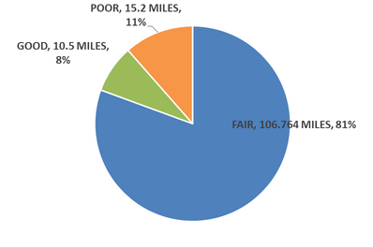
Percentage of Good, Fair and Poor by Lane Miles

S T A T E N O N - I N T E R S T A T E
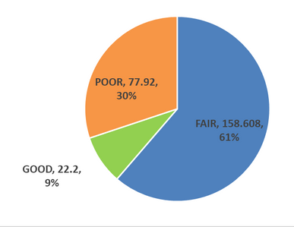
Percentage of Good, Fair and Poor by Percentage

LOCAL NHS ROADS
Percentage of Good, Fair and Poor by Lane Miles
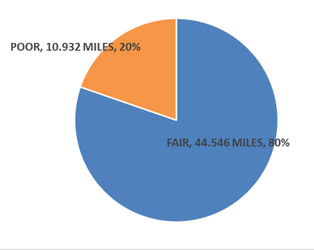

Pavement and Bridge Condition Projects

The MPO, LA DOTD, and local governments have developed several projects with the aim of improving pavement quality on the National Highway System.

H.011832 CAMERON ST. OVERLAY





This MPO project will be a complete overlay of US 90/Cameron Street through the City of Scott.

H.010353 US 167: ACCESS MANAGEMENT (LFT TURN LNS)
Although the primary purpose of the project is safety, this project will also include a complete overlay of several miles of the NHS roadway in the MPO area.

H.012980.6 LA 3073 Limits: US 167 - Kaliste Saloom Road
This project is a panel replacement project on the LA DOTD owned section of Ambassador Caffery.


Lafayette Consolidated Government Concrete Panel Replacement Projects on Local NHS
Lafayette Consolidated Government maintains a proactive concrete panel replacement program where local NHS routes on Congress, Kaliste, and the local section of Ambassador Caffery are kept at a high level of good pavement condition.

Pavement Condition Map
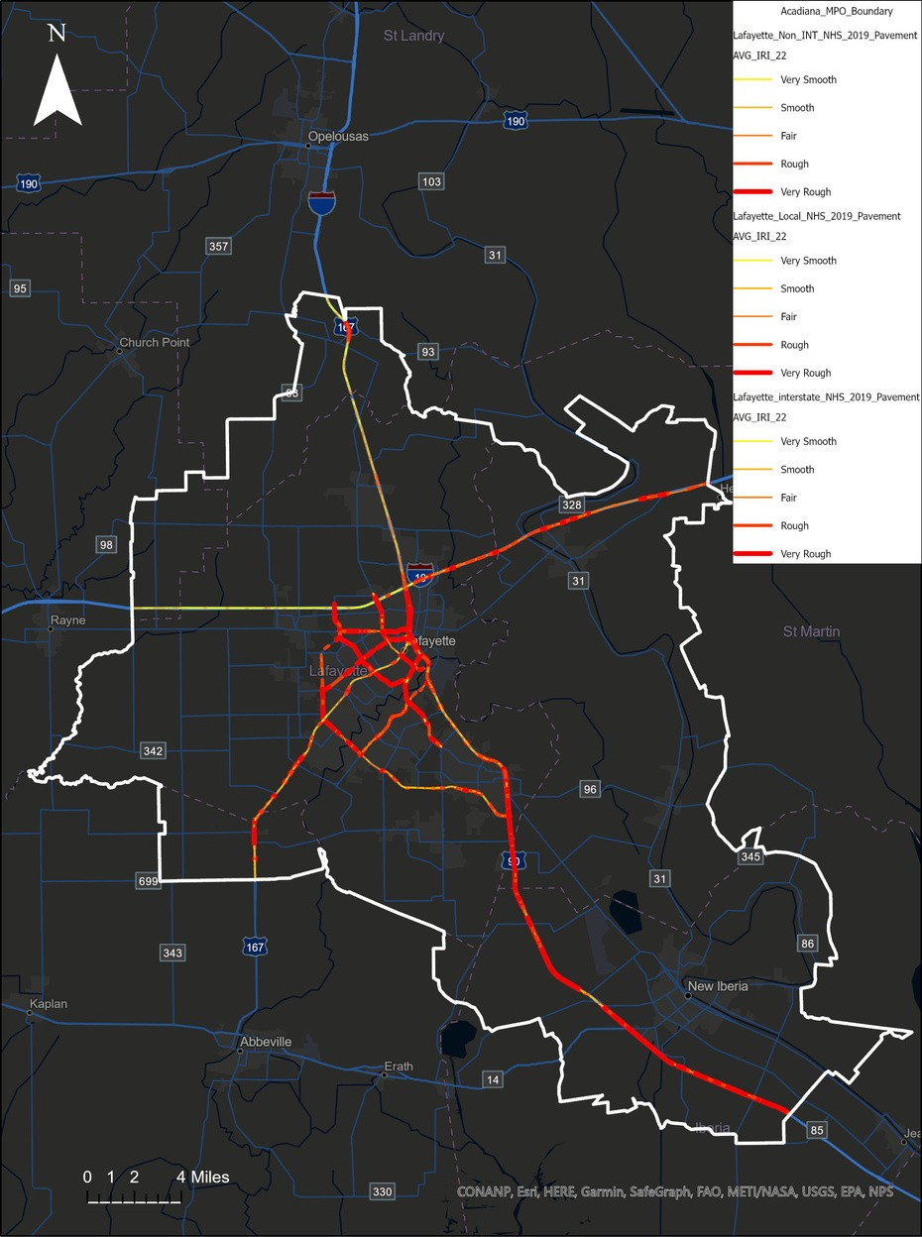

Bridge Condition Map
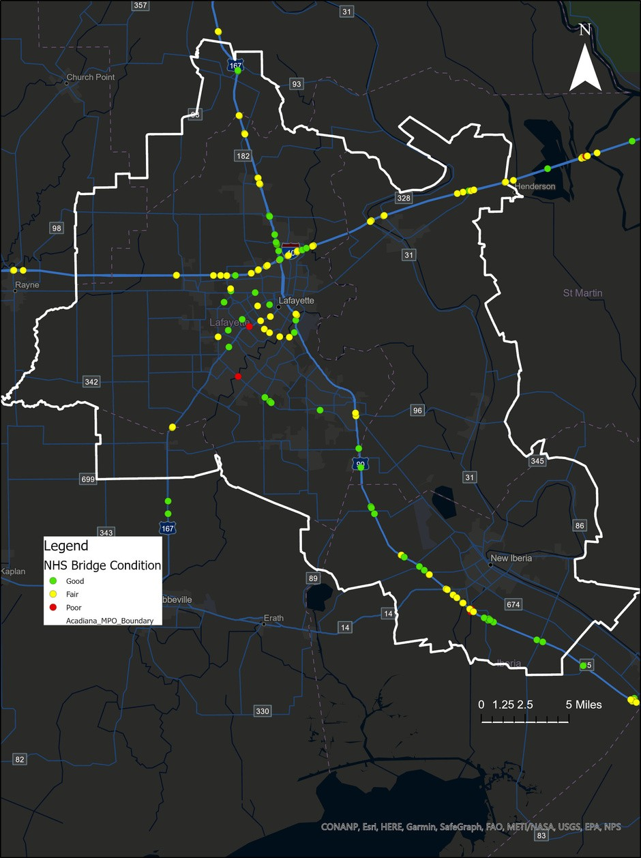

Travel Time Reliability

The MPO has set its own targets for Travel Time Reliability for Person Miles Reliable on the Interstate and Non-Interstate NHS and the Truck Travel Time Reliability Index using the National Performance Management Research Data Set.

The MPO set the targets in 2018 in 2- and 4-year increments. The MPO has surpassed the targets every year since the targets were set, in one case reaching 100%, the highest level of measurement. The Truck Travel Time Reliability Index is set at 1.3, and the Acadiana MPO area measured 1.12 in 2019.

The primary project keeping this measure at a high level is the FASTLANE funded I-10 widening project through Lafayette and St. Martin Parish. This project is widening 15 miles of interstate through the MPO area.

The STP-funded Adaptive Signal Control project through the City of Lafayette will improve travel times on the state and local NHS through the use of adaptive signal technology to dynamically control traffic signal timing based on real-time traffic conditions.

Person Miles Reliable Targets
100%
Travel Time Reliability on Interstate System

100

75

50
94.5%
Travel Time Reliability on Non- Interstate NHS

25

0
Target 2020 Target 2022 Non-Interstate Interstate

Truck Travel Time Reliability Index Target

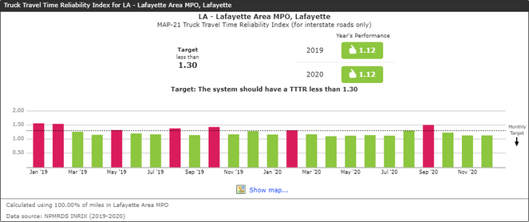

NPMRDS Dashboards

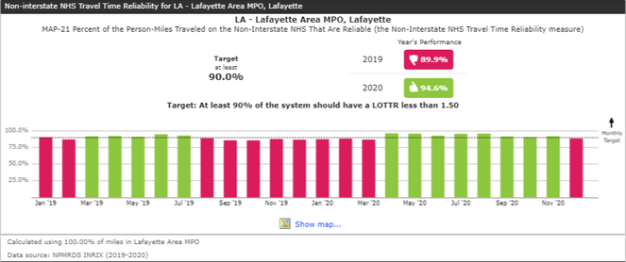

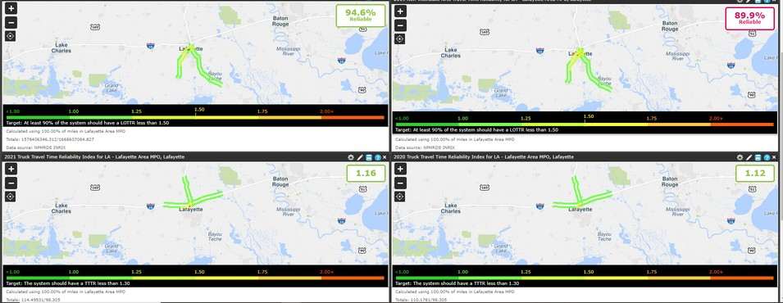

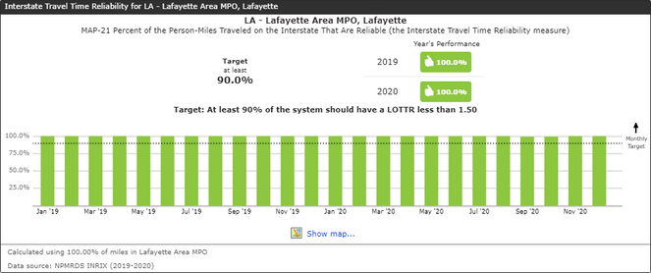

Transit Asset Management

The Acadiana MPO has one fixed route transit provider, the Lafayette Transit System . It is a division of the department of Public Works under the Lafayette Consolidated Government. The service area is centered on the city of Lafayette. Pre-COVID, Lafayette Transit operated from 5:15 AM to 6:45 PM with 13 buses on 12 routes. It also operated 4-night routes from 6:30 PM to 10:30 PM. The fleet consists of about 25 low floor buses. The system is a hub and spoke pulsed system with mostly 30-minute headways operating out of a central downtown multimodal terminal. The system also utilizes an FTA funded vehicle maintenance facility a short distance away. The main assets are the bus fleet, a maintenance facility, an administrative facility, and the main downtown terminal. The MPO adopted the targets in 2018. The MPO has several capital transit projects in its STP program that will assist LTS in maintaining its asset management goals.

25

20

15

10

5

0
Bus
Cutaway Bus
Service Auto
Administration
Maintenance
Passenger Facilities

Percent of vehicles
within a particular asset class that have met or exceeded their Useful Life Benchmark , 2020- 2023

Percent of facilities
with a condition rating below 3.0 on the FTA Transit Economic Requirements Model (TERM) Scale, 2020 - 2023

2020 2021 2022 2023

Transit Safety

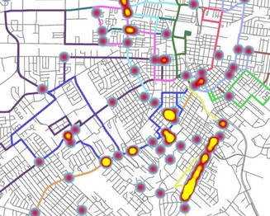
Lafayette Transit System, Lafayette Consolidated Government, and the Acadiana MPO adopted the Public Transportation Agency Safety Plan in 2020, The plan has several important functions:
Develops and documents Safety Management Systems in the plan
Controls risk
Detects and corrects safety problems in a timely manner
Shares and analyzes safety data Measures safety performance

As part of the plan adoption process, the MPO analyzed transit and pedestrian crash locations to assist LTS in the safety planning process. This will maintain the success of the LTS system in reaching its targets.

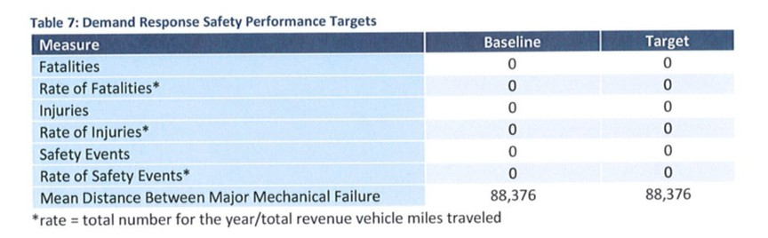

Transit Asset and Safety Management in PBPP

The MPO is coordinating with LTS on implementation of the Asset Management and Safety targets, which can often work in conjunction.

An Example of PBPP in Action


Through the annual target setting process for rolling stock, City Transit Agency finds that X model bus fleet has exceeded its Useful Life Benchmark.


This initiates a Safety Risk Assessment through the SMS process, City Transit Agency with the MPO’s technical assistance finds that there are a high number of pedestrian injuries along bus route Y due to high levels of pedestrian and vehicle traffic and fleet X also has an obsolete radio system.




The agency proposes a safety mitigation of moving the bus stops and modifying bus operator training to reduce the safety risk, in addition to purchasing new rolling stock with newer radio system.



City Transit Agency shares TAM and safety investment priorities and performance targets with State and MPO.




The MPO leads a process to determine that the high safety risk bus route should be converted to a different operation, with new buses purchased for the transit system to replace the fleet over its Useful Life Benchmark

Appendix D: Funding Programs

FEDERAL HIGHWAY / TRANSIT CORE FUNDING PROGRAMS

IIJA HIGHWAY FUNDING PROGRAMS

Interstate Maintenance (IM) – The Interstate Maintenance (IM) program provides funding for resurfacing, restoring, rehabilitating and reconstructing (4R) most routes on the Interstate System.

Eligible Use of Funds:
Projects on routes on the Interstate System, except those added under 23 USC 103(c)(4)(A) that were not previously designated future Interstate under former 23 UCS 139(b), as well as any segments that become part of the Interstate System under Section 1105(e)(5) of ISTEA are eligible for funding. Construction of additional Single Occupancy Vehicle (SOV) lanes continues to be ineligible for IM program funds.

IM program funds may not be used on a facility where tolls are being collected under the Interstate System Reconstruction and Rehabilitation Pilot Program or the Interstate System Construction Toll Pilot Program.

National Highway system (NHS) – The program provides funding for improvements to rural and urban roads that are part of the NHS, including the Interstate System and designated connections to major intermodal terminals. Under certain circumstances, NHS funds may also be used to fund transit improvements in NHS corridors.

Eligible Use of Funds:

Expands NHS eligibility to include the following activities:
- Environmental restoration and pollution abatement
- Control of terrestrial and aquatic noxious weeds and establishment of native species

Surface Transportation Program (STP)

Program purpose

The Surface Transportation Program (STP) provides flexible funding that may be used by States and localities for projects to preserve and improve the conditions and performance on any Federal-aid highway, bridge and tunnel projects on any public road, pedestrian and bicycle infrastructure, and transit capital projects, including intercity bus terminals.

Statutory citation(s): IIJA §1108; 23 USC 133 Sub allocation
50% of a State's STP apportionment (after TA and SPR set-asides) is to be obligated in the following areas in proportion to their relative shares of the State's population--
- Urbanized areas with population greater than 200,000 – This portion is to be divided among those areas based on their relative share of population, unless the Secretary approves a joint request from the State and relevant MPO(s) to use other factors.
- Areas with population greater than 5,000 but no more than 200,000 – Projects in these areas are to be identified for funding by the State in consultation with regional planning organizations, if any.
- Areas with population of 5,000 or less

The remaining 50% may be used in any area of the State.

Federal share: Determined in accordance with 23 USC 120, including a special rate for certain safety projects and a new provision for increased Federal share for projects incorporating Innovative Project Delivery. Exceptions to 23 USC 120 are provided for certain freight projects, workforce development, training, and education activities, and Appalachian development highway system projects. (See "Federal Share" fact sheet).

Eligible activities

STP eligibilities are continued, with some additions and modifications. Eligibilities are described below, with changes emphasized:
- Construction, reconstruction, rehabilitation, resurfacing, restoration, preservation, or operational improvements for highways, including designated routes of the Appalachian Development Highway System (ADHS) and local access roads under 40 USC 14501.
- Replacement, rehabilitation, preservation, protection, and anti-icing/deicing for bridges and tunnels on any public road, including construction or reconstruction necessary to accommodate other modes.
- Construction of new bridges and tunnels on a Federal-aid highway.
- Inspection and evaluation of bridges, tunnels and other highway assets as well as training for bridge and tunnel inspectors.
- Capital costs for transit projects eligible for assistance under chapter 53 of title 49, including vehicles and facilities used to provide intercity passenger bus service.
- Carpool projects, fringe and corridor parking facilities and programs, including electric and natural gas vehicle charging infrastructure, bicycle transportation and pedestrian walkways, and ADA sidewalk modification.
- Highway and transit safety infrastructure improvements and programs, installation of safety barriers and nets on bridges, hazard eliminations, mitigation of hazards caused by wildlife, railway-highway grade crossings.
- Highway and transit research, development, technology transfer.
- Capital and operating costs for traffic monitoring, management and control facilities and programs, including advanced truck stop electrification.
- Surface transportation planning.
- Transportation alternatives --newly defined, includes most transportation enhancement eligibilities. [See separate "Transportation Alternatives" fact sheet]
- Transportation control measures.
- Development and establishment of management systems.
- Environmental mitigation efforts (as under National Highway Performance Program).
- Intersections with high accident rates or levels of congestion.
- Infrastructure-based ITS capital improvements.
- Environmental restoration and pollution abatement.
- Control of noxious weeds and establishment of native species.
- Congestion pricing projects and strategies, including electric toll collection and travel demand management strategies and programs.
- Recreational trails projects.
- Construction of ferry boats and terminals.
- Border infrastructure projects.
- Truck parking facilities.
- Development and implementation of State asset management plan for the NHS, and similar activities related to the development and implementation of a performance-based management program for other public roads.
- Surface transportation infrastructure modifications within port terminal boundaries, only if necessary to facilitate direct intermodal interchange, transfer, and access into and out of the port.
- Construction and operational improvements for a minor collector in the same corridor and in proximity to an NHS route if the improvement is more cost-effective (as determined by a benefit- cost analysis) than an NHS improvement and will enhance NHS level of service and regional traffic flow.

Workforce development, training, and education activities are also an eligible use of STP funds. [§1109; 23 USC 504(e)]

Location of Projects

In general, STP projects may not be on local or rural minor collectors. However, there are a number of exceptions to this requirement. A State may use up to 15% of its rural sub allocation on minor collectors. Other exceptions include: ADHS local access roads, bridge and tunnel replacement and rehabilitation (not new construction), bridge and tunnel inspection, carpool projects, fringe/corridor parking facilities, bike/pedestrian walkways, safety infrastructure, Transportation Alternatives, recreational trails, port terminal modifications, and minor collectors in NHS corridors.
Program features

Off-System Bridge

•States are required to obligate a portion of funds (not from sub allocated amounts) for bridges not on Federal-aid highways (off-system bridges). The amount is to be not less than 15% of the State's FY 2009 Bridge Program apportionment. The Secretary, after consultation with State and local officials, may reduce a State's set-aside requirement if the State has insufficient off-system bridge needs.
•Credit for off-system bridges -- For projects to replace or rehabilitate deficient off-system bridges funded wholly by State/local sources, any amounts spent post-enactment that are in excess of 20% of project costs may be credited to the non-Federal share of eligible bridge projects in the State.

Rural minor collectors

Special rule allows States to use up to 15% of funds sub allocated for areas with a population of 5,000 or less on rural minor collectors. The Secretary may suspend permission if the State is using the authority excessively.

Bridge and tunnel inspection standards

If a State is in noncompliance with bridge/tunnel inspection standards established by the Secretary, a portion of STP funds must be used to correct the problem. [§1111; 23 USC 144(h)(5)]

Performance

The STP supports national performance goals, but there are no measures tied specifically to this program.

Highway Safety Improvement Program (HSIP)

Program purpose

IIJA continues the Highway Safety Improvement Program (HSIP) to achieve a significant reduction in traffic fatalities and serious injuries on all public roads, including non-State-owned public roads and roads on tribal lands. The HSIP requires a data-driven, strategic approach to improving highway safety on all public roads that focuses on performance.

Statutory citation(s): IIJA §1112; 23 USC 130 and 148 eligible use of funding

A highway safety improvement project is any strategy, activity or project on a public road that is consistent with the data-driven State Strategic Highway Safety Plan (SHSP) and corrects or improves a hazardous road location or feature or addresses a highway safety problem. IIJA provides an example list of eligible activities, but HSIP projects are not limited to those on the list.

Workforce development, training, and education activities are also an eligible use of HSIP funds. [§1109; 23 USC 504(e)]

Program features

The primary features of the current HSIP are retained, including the requirement for a comprehensive, data driven, SHSP that defines State safety goals and describes a program of strategies to improve safety. To obligate HSIP funds, a State must develop, implement and update a SHSP, produce a program of projects or strategies to reduce identified safety problems, and evaluate the SHSP on a regular basis.
The SHSP remains a statewide coordinated plan developed in cooperation with a broad range of multidisciplinary stakeholders.

States are required to have a safety data system to perform problem identification and countermeasure analysis on all public roads, adopt strategic and performance-based goals, advance data collection, analysis, and integration capabilities, determine priorities for the correction of identified safety problems, and establish evaluation procedures.

Implementation

States will administer the HSIP, with appropriate oversight by the Office of Safety and the FHWA Division Office. The program also includes a clear linkage between behavioral State safety programs (NHTSA-funded §31102; 23 USC 402) and the SHSP.

Performance

Within 18 months of enactment, the Secretary, in consultation with States, MPOs, and other stakeholders, is directed to publish a rulemaking establishing measures for the States to use to assess serious injuries and fatalities per vehicle mile traveled and number of serious injuries and fatalities.

[§1203; 23 USC 150(c)]

States will establish targets for these measures within 1 year of the final rule on national performance measures. [§1203; 23 USC 150(d)]

Carbon Reduction Program

Program Purpose

The IIJA established the Carbon Reduction Program (CRP), which provides funds for projects designed to reduce transportation emissions, defined as carbon dioxide (CO2) emissions from on-road highway sources.

Statutory Citations

§ 11403; 23 U.S.C. 175

Program Features

Carbon Reduction Strategy
Requires each State, in consultation with any MPO designated within the State, to– [§ 11403; 23 U.S.C. 175(d)] develop a carbon reduction strategy not later than 2 years after enactment; [§ 11403; 23 U.S.C. 175(d)(1)] and update that strategy at least every four years; [§ 11403; 23 U.S.C. 175(d)(3)]

Requires the carbon reduction strategy to– support efforts–and identify projects and strategies–to support the reduction of transportation emissions;

at the State's discretion, quantify the total carbon emissions from production, transport, and use of materials used in the construction of transportation facilities in the State; and
be appropriate to the population density and context of the State, including any MPO designated within the State. [§ 11403; 23 U.S.C. 175(d)(2)]

Allows the carbon reduction strategy to include projects and strategies for safe, reliable, and cost-effective options to reduce traffic congestion by facilitating the use of alternatives to single-occupant vehicle trips, including public transportation facilities, pedestrian facilities, bicycle facilities, and shared or pooled vehicle trips within the State or an area served by the relevant MPO;

facilitate use of vehicles or modes of travel that result in lower transportation emissions per person-mile traveled as compared to existing vehicles and modes; and
facilitate approaches to the construction of transportation assets that result in lower transportation emissions as compared to existing approaches. [§ 11403; 23 U.S.C. 175(d)(2)(B)]

Requires FHWA to review the State's process for developing its carbon reduction strategy and certify that the strategy meets statutory requirements; and
at the request of a State, provide technical assistance in the development of the strategy. [§ 11403; 23 U.S.C. 175(d)(4) and (5)]

National High Priority Program (NHPP)

Program purpose

The NHPP provides support for the condition and performance of the National Highway System (NHS), for the construction of new facilities on the NHS, and to ensure that investments of Federal-aid funds in highway construction are directed to support progress toward the achievement of performance targets established in a State's asset management plan for the NHS.

Statutory citation(s): IIJA §1106; 23 USC 119 Eligible activities

NHPP projects must be on an eligible facility and support progress toward achievement of national performance goals for improving infrastructure condition, safety, mobility, or freight movement on the NHS, and be consistent with Metropolitan and Statewide planning requirements. Eligible activities include:
- Construction, reconstruction, resurfacing, restoration, rehabilitation, preservation, or operational improvements of NHS segments.
- Construction, replacement (including replacement with fill material), rehabilitation, preservation, and protection (including scour countermeasures, seismic retrofits, impact protection measures, security countermeasures, and protection against extreme events) of NHS bridges and tunnels.
- Bridge and tunnel inspection and evaluation on the NHS and inspection and evaluation of other NHS highway infrastructure assets.
- Training of bridge and tunnel inspectors.
- Construction, rehabilitation, or replacement of existing ferry boats and facilities, including approaches, that connect road segments of the NHS.
- Construction, reconstruction, resurfacing, restoration, rehabilitation, and preservation of, and operational improvements for, a Federal-aid highway not on the NHS, and construction of a transit project eligible for assistance under chapter 53 of title 49, if the project is in the same corridor and in proximity to a fully access-controlled NHS route, if the improvement is more cost- effective (as determined by a benefit-cost analysis) than an NHS improvement, and will reduce delays or produce travel time savings on the NHS route and improve regional traffic flow.
- Bicycle transportation and pedestrian walkways.
- Highway safety improvements on the NHS.
- Capital and operating costs for traffic and traveler information, monitoring, management, and control facilities and programs.
- Development and implementation of a State Asset Management Plan for the NHS including data collection, maintenance and integration, software costs, and equipment costs.
- Infrastructure-based ITS capital improvements.
- Environmental restoration and pollution abatement.
- Control of noxious weeds and establishment of native species.
- Environmental mitigation related to NHPP projects.
- Construction of publicly owned intracity or intercity bus terminals servicing the NHS.

Workforce development, training, and education activities are also an eligible use of NHPP funds. [§1109; 23 USC 504(e)]

Location of projects

NHPP funds may only be used for projects on or associated with the NHS as described above under "Eligible activities." An exception is provided under certain circumstances for non-NHS highway or transit projects in an NHS corridor.

Program features

Enhanced National Highway System

Under IIJA, the enhanced NHS is composed of approximately 220,000 miles of rural and urban roads serving major population centers, international border crossings, intermodal transportation facilities, and major travel destinations. It includes:
•The Interstate System.
- All principal arterials (including those not previously designated as part of the NHS) and border crossings on those routes.
•Intermodal connectors -- highways that provide motor vehicle access between the NHS and major intermodal transportation facilities.
•STRAHNET -- the network of highways important to U.S. strategic defense.
•STRAHNET connectors to major military installations.

[§1104; 23 USC 103]

Asset management

Within 18 months of enactment, the Secretary is directed to publish a rulemaking establishing the process for States to use in developing a risk-based, performance-based asset management plan for preserving and improving the condition of the NHS. States are encouraged to include all infrastructure assets within the right-of-way corridor. The plan must include at least the following:
•Summary list, including condition, of the State's NHS pavements and bridges
•Asset management objectives and measures
•Performance gap identification
•Lifecycle cost and risk management analysis
•Financial plan
•Investment strategies

Each State's process must be reviewed and recertified at least every 4 years. If certification is denied, the State has 90 days to cure deficiencies. If a State has not developed and implemented an asset management plan consistent with requirements by the beginning of the 2nd fiscal year after the establishment of the process, the Federal share for NHPP projects in that fiscal year is reduced to 65%.

Minimum pavement and bridge conditions

•Interstate conditions --The Secretary will establish a minimum level of condition for Interstate pavements, which may vary by geographic region. If, during two consecutive reporting periods, Interstate pavement conditions in a State fall below the minimum set by the Secretary, the State must, at a minimum, devote the following resources to improve Interstate pavement conditions during the following fiscal year (and each year thereafter if the condition remains below the minimum): ◦NHPP funds in an amount equal to the State's FY 2009 Interstate Maintenance (IM) apportionment, to increase by 2% per year for each year after FY 2013.
- Funds transferred from the STP (not from sub allocated amounts) to the NHPP in an amount equal to 10% of the amount of the State's FY 2009 IM apportionment.

•Bridge conditions – IIJA establishes a minimum standard for NHS bridge conditions. If more than 10% of the total deck area of NHS bridges in a State is on structurally deficient bridges for three consecutive years, the State must devote NHPP funds in an amount equal to 50% of the State's FY 2009 Highway Bridge Program apportionment to improve bridge conditions during the following fiscal year (and each year thereafter if the condition remains below the minimum).

Bridge and tunnel inspection standards

If a State is in noncompliance with bridge and tunnel inspection standards established by the Secretary, a portion of NHPP funds must be used to correct the problem. (See "Bridge and Tunnel Inspection" fact sheet). [§1111; 23 USC 144(h)(5)] Performance
Within 18 months of enactment, the Secretary, in consultation with States, MPOs, and other stakeholders, is directed to publish a rulemaking establishing:
•Minimum standards for States to use in developing and operating bridge and pavement management systems.
•Performance measures for Interstate and NHS pavement condition, NHS bridge condition, and Interstate and NHS performance.
•Minimum conditions for Interstate pavements – may vary geographically.
•Data elements necessary to collect and maintain standardized data to carry out a performance- based approach.

[§1203; 23 USC 150(c)]

States are required to establish targets for these measures within 1 year of the final rule on national performance measures. [§1203; 23 USC 150(d)]
•States will report to DOT on progress in achieving targets within 4 years of enactment and then every 2 years [§1203; 23 USC 150(e)] and MPOs will report to DOT on progress in their Metropolitan Transportation Plan (4 or 5 year frequency). [§1201; 23 USC 134(i)]
•If a State does not meet or make significant progress toward targets for 2 consecutive reporting periods, the State must document in its next report the actions it will take to achieve the targets. [§1106; 23 USC 119(e)(7)]

Non-Federal Aid (NFA) – Funds may be derived from state or local sources for transportation projects. Generally, state-funded projects shown in the TIP are bond-funded projects.

IIJA TRANSIT FUNDING COMPONENTS

Section 5307 Urbanized Area Formula Program

  - Apportionment directly to urbanized areas over 200,000 in population;
  - Funds distributed to transit systems ("designated recipients") through each urbanized areas Metropolitan Planning Organization (MPO);
  - In urbanized areas with over 200,000 population, funds are allocated based on multi-tiered formula including: 1) Population and Population Density; 2) Bus Revenue Vehicle Miles; 3) Fixed Guideway Revenue Vehicle Miles; 4) Fixed Guideway Route miles; and 5) Incentive Tier Based on Bus/Fixed Guideway Passenger Miles and Operating Costs;
  - Funds may be used for eligible capital and/or preventive maintenance activities for areas of 200,000 or more in population;
  - Transit enhancements now certification rather than set-aside;
  - IIJA allows for additional sources of local funds to be used as local match for 5307 projects. The newly eligible sources include advertising and concessions revenue, social services contract revenue, and revenue bonds proceeds.

Sections 5339 Discretionary Capital Investment Programs

  - Apportioned directly to transit systems;
  - Private non-profit and private providers of public transportation may be sub recipients;
  - Must be used to 1) maintain, modernize and/or improve fixed guideway systems; 2) provide the federal share of new fixed guideway projects, including the design and/or construction of new or extensions to existing fixed guideway systems; and 3) fund the replacement, rehabilitation and purchase of buses and related equipment and the construction of bus related facilities.
  - Funds are apportioned based on statutory formula or earmarks.

Section 5310 Elderly and Persons with Disabilities Formula Program

  - Capital and Purchase of Service assistance for the purchase of vehicles and services for the elderly and individuals with disabilities;
  - Services primarily provided by private not-for-profit organizations or governmental entities;
  - Intended primarily for private not-for-profit organizations;
  - Public organizations that coordinate services for the elderly and individuals with disabilities or that can certify that no not-for-profit organizations are readily available that can provide service may also be eligible to receive program funding;
  - Beginning in FY 2007 projects shall be included in a locally developed human
service transportation coordination plan;
  - FTA Apportionment directly to states;
  - Allocation based on each state's share of the nation's elderly and disabled population;
  - Non-DOT federal funds can be used as matching funds.

Appendix E: TIP Financial Summary

